Pumpkin Competition- 18th October 2024
Raising funds for Friends of Holly Hill
Fancy entering our pumpkin competition to potentially win some amazing prizes?
For £1 entry you could be in with the chance of winning
- Trampoline park voucher
- Soft play voucher
- Swimming voucher
- Chocolate
- And so much more

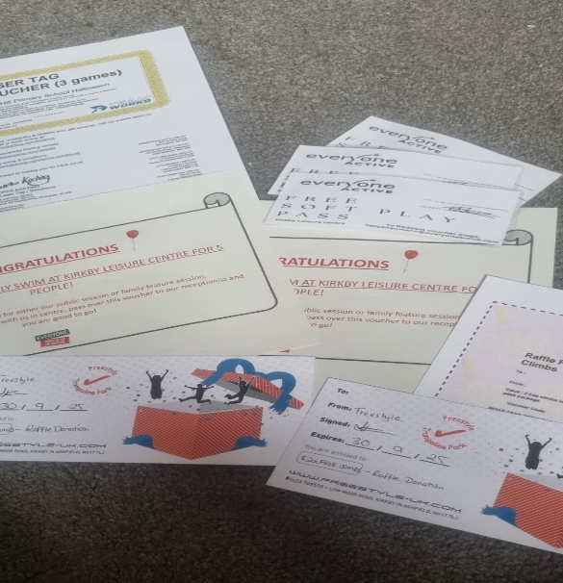

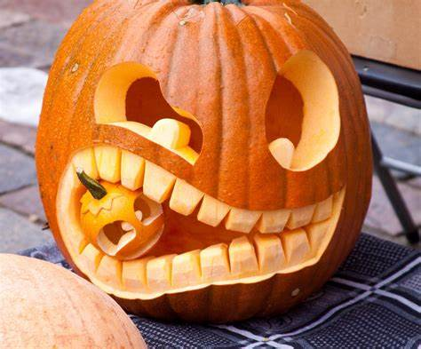
Please take your pumpkins to your classroom with your £1 donation on the morning of 18th October. They will then be judged, and the winners given their prizes. Don’t forget to put your name on your pumpkin!

Good Luck!
Happy Carving :D
Prizes for 1st, 2nd and 3rd winners in:
- Early Years
- Year 1 and year 2
- Year 3 and Year 4
- Year 5 and Year 6

