We are very excited to share with you our Christmas plans for 2024. Once again, we have planned a Christmas to remember for the children at Holly Hill.
A huge thank you to our wonderful Friends of Holly Hill fundraising mums who have helped to organise, and are covering the cost of, the majority of our plans so we are able to keep the cost to parents as low as possible.
This timetable outlines everything that is happening and what you need to remember when – we all know how crazy it gets at this time of year so I hope this helps!
Mrs. Steed x
DATE | EVENT | WHAT DO I NEED TO REMEMBER?
Wednesday 11th December | CHRISTINGLE MAKING WORKSHOPS AND SERVICE  The children will learn about the Christingle, make their own to bring home (if the sweets last that long!) and attend a Christingle service in school led by Reverend Lee from St. Helen’s Church. | An orange (KS1 and KS2 children only) | 
Thursday12th December | NURSERY AND FS2 CHRISTMAS SHOW, 10AM & 2PM  The cutest show in town – our Nursery and FS2 children present “The Snowman”. Tissues at the ready! | 10am and 2pm  Book your tickets - letter already sent home  Raffle tickets and refreshments on sale before performances and donation buckets to FOHH – bring change! | 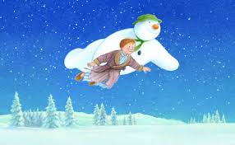
w/b 16th December | CHRISTMAS JUMPERS  Children are welcome to wear their Christmas jumpers on Monday and Friday. | Wear Christmas jumpers | 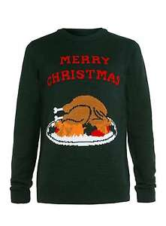
Monday 16th December | KEY STAGE 1 CHRISTMAS SHOW, 10AM & 2pm  Our Year 1 and 2 children will perform a truly wonderful version of the nativity when they present “It’s a baby”. | 10am and 2pm  Book your tickets - letter already sent home  Raffle tickets and refreshments on sale before performances and donation buckets to FOHH – bring change! | 
Tuesday 17th December | WHOLE SCHOOL PARTY DAY  All classes will get a disco session in the hall as well as games and lots of fun in their classrooms.  Party food will be provided. | Wear party clothes  (Disco, party food and prizes paid for by FOHH) | 
Wednesday 18th December | PANTO DAY  The whole of Holly Hill will head to Derby Arena to see their ‘Cinderella’ pantomime. | Pay for your child’s ticket  Children must wear uniform for this trip.  Remember: The buses are not due back at school on this day until 5pm.  Nursery is closed to all children on this day.  After school club will not be open on this day. | 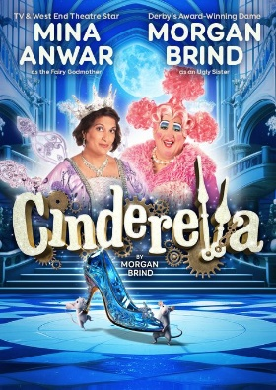
Thursday 19th December | POLAR EXPRESS DAY  Come to school in your pyjamas for a day of Christmas movies, including Polar Express of course, and hot chocolate.  AND, A VISIT FROM SANTA  All children will get a chance to visit Santa in his inflatable grotto!  AND, CHRISTMAS DINNER DAY  Last year we served a record breaking 200 Christmas dinners – can we break our record this year and serve more Christmas dinners than ever before? | Come to school in your pyjamas for a day of Christmas movies, including Polar Express of course, and hot chocolate.  Nothing (funded by Friends of Holly Hill)  Pay dinner money (30 hours Nursery and KS2 children - £2.95) | 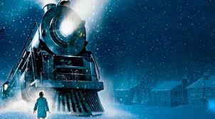    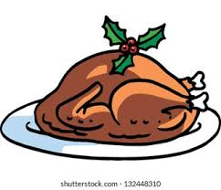
Friday 20th December | KEY STAGE 2 CHRISTMAS SHOW, 10AM & 2pm  Our Key Stage 2 children will get you feeling festive with a variety of Christmas songs performed in the Junior hall. | Book your tickets when the letter comes home  Raffle tickets on sale before performances and donation buckets to FOHH – bring change! | 
CHRISTMAS CARDS | Children may bring Christmas cards in for their friends if they wish to.  Post boxes will be available for children to put cards in on each corridor so please ensure names and classes are clearly written on the envelopes.
OTHER KEY DATES | - Friday 20th December – BREAK FOR CHRISTMAS  - Monday 6th January – INSET DAY  - Tuesday 7th January – CHILDREN RETURN TO SCHOOL

