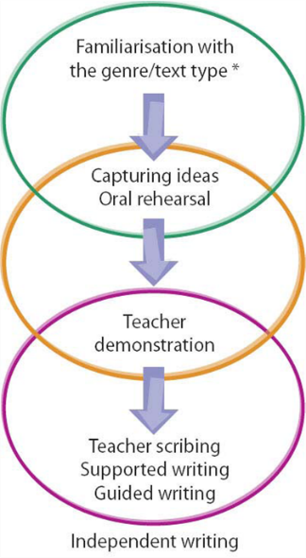
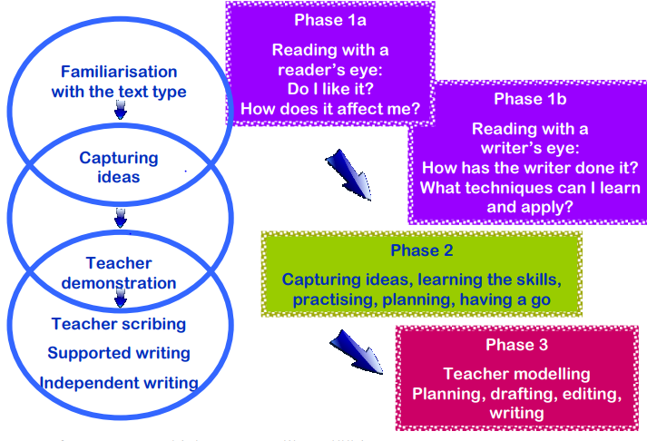
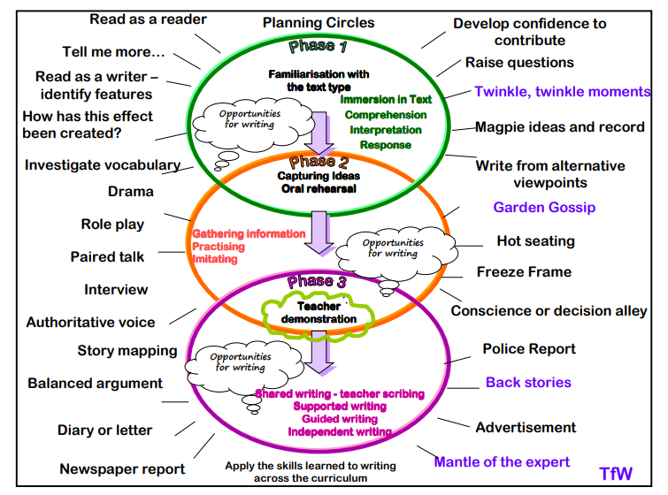

Imitate
Innovate
Independent application
Foundation Stage
Story Invention | Hook and Tell the story | Pull out key vocab and learn with pictures / drama | Short-burst writing using vocab | Specific vocab teaching
Story Invention | Learn the Story  Exploratory play/oracy | Learn the Story  Exploratory Play/ oracy  Story Map as a class | Change the class map and innovate (oracy) | Shared writing of a new version of the story
Story Invention | Modelled writing  Children Writing/ Telling | Modelled writing  Children Writing/ Telling | Modelled writing  Children Writing/Telling | Modelled writing  Children Writing/Telling

Key Stage One
Story Invention  (story/ clip/picture) | Creative Hook | Text Immersion  Book Talk/ Vocabulary | Text Immersion  Oracy- Drama/ writing in role | Text Immersion  Short-burst writing (Grammar link)
Text Immersion  Short-burst writing (Grammar link) | Text Immersion  Short-burst writing | Read as a Reader/ Read as a writer  Create a toolkit | Short-burst writing to practice using toolkit | Explore the pattern of the story
Plan innovated writing  Story Mountain/ box up/ story map | Modelled Writing/  Shared Writing | Independent Writing | Independent Writing | Independent Writing (this can be extended)

Key Stage Two

Creative Hook | Text Immersion  Book Talk/ Vocabulary teaching | Text Immersion | Text Immersion | Text Immersion  Grammar teaching/ short-burst
Short-burst writing to rehearse grammar in context | Read as a Reader/ Read as a write  Toolkit co-construction | Short-burst Writing to practice toolkit | Gathering ideas  Planning (Box-up innovation) | Writerly Research-Gathering language  Short-burst writing to develop ideas
Shared Writing | Feedback and targeted teaching  Shared / modelled writing | Feedback and targeted teaching  Shared/ modelled writing | Feedback and targeted teaching  Shared / modelled writing | Planning for Independent Writing
Independent Writing | Independent writing | Independent writing | Independent writing | Editing session / Publishing

