Holly Hill Primary and Nursery School
English Policy

1. Subject Intent

General Statement
At Holly Hill we believe that English is fundamental to the overall development of the child and their access to the whole curriculum. A quality English curriculum should develop children’s passion for Reading, Writing, Speaking and Listening. Our English curriculum provides the children with purposeful reading, writing and speaking opportunities which are driven by high quality texts and rich vocabulary.

The English curriculum at Holly Hill enables children to speak and write fluently so that they can communicate their ideas and emotions to others and through their reading and listening, others can communicate with them. Through Reading in particular, pupils have a chance to develop culturally, emotionally, intellectually, socially and spiritually. Our children ‘learn to read’, predominantly in Key Stage One, and they ‘read to learn’ as they progress through Key Stage Two. Reading also enables pupils both to acquire knowledge and to build on what they already know. All the skills of language are essential to participating fully as a member of society.

Through our English curriculum we make links to our whole school curriculum intent statement. The aspects which are particularly significant to English are:

- Rich vocabulary and quality texts
- Preparation for adult life and work
- Balance of knowledge and skills
- Emotional well-being and healthy relationships
- Diversity
- Experiences and opportunities

Specific Aims

The National Curriculum outlines the following aims for English:

Children will:
- read easily, fluently and with good understanding
- develop the habit of reading widely and often, for both pleasure and information
- acquire a wide vocabulary, an understanding of grammar and knowledge of linguistic conventions for reading, writing and spoken language
- appreciate our rich and varied literary heritage
- write clearly, accurately and coherently, adapting their language and style in and for a range of contexts, purposes and audiences
- use discussion in order to learn; they should be able to elaborate and explain clearly their understanding and ideas
- are competent in the arts of speaking and listening, making formal presentations, demonstrating to others and participating in debate

At Holly Hill the English curriculum is designed so that we meet the National Curriculum aims through a progression of skills and knowledge taught using the texts and genres below:

EYFS:

See EYFS Development Matters statements (appendix 1).

KS1/ KS2:

CYCLE A (Appendix 2)

CYCLE B (Appendix 3)

Rationale

At Holly Hill, texts are carefully selected for their year group suitability, challenge and content. These texts drive specific focus aspects of the curriculum. For example, in KS1, ‘Vlad and The Great Fire of London’ is chosen as a vehicle for strengthening the history teaching and to allow for the reading and writing of purposeful diary entries.
In KS2, the text ‘Hugo Cabret’ has been selected to drive the Clockwork topic which leads to action, newspaper and explanation writing. Mechanical devices are made within Design Technology and an exciting visit to an automaton museum creates a stimulating, purposeful and worthwhile experience for the children. High quality texts within English lessons are our vehicles for learning with enjoyment, engagement and purpose.
Text types and genres are organised to ensure coverage and progression across the key phases. Year group specific genres allow subject areas to be taught in a cross-curricular manner and to be text driven.
In the Foundation Stage, core books are selected to be age appropriate and appealing for our youngest children and to drive the EYFS key areas.
KS1 texts have been selected to ensure a balance of modern, classic and prize-winning picture books. There is an emphasis on fiction to capture the young imagination and to allow for exciting text immersion sessions. We do, however, ensure that there is a fair representation of fiction and non-fiction. Vocabulary development is a key consideration when our texts are selected.
Throughout KS2, texts become progressively more challenging and include an increasing number of novels, allowing for the very close and essential reading and writing link. At Holly Hill, Reading and Writing go hand in hand and along with the spoken word, form our holistic English curriculum.
Our children are immersed in text and saturated in speaking and listening experiences before embarking on the writing journey.

2. Implementation

Because at Holly Hill Primary and Nursery we understand that learning takes place when there is a change to long-term memory, we outline the key knowledge for a unit of work on a knowledge organiser. In English, key knowledge is knowledge that relates directly to the National Curriculum attainment targets.

Who will deliver the subject?
Class teachers deliver English sessions daily. Teaching Assistants support within sessions where possible and collectively children are targeted to achieve their optimum potential in English. We recognise that English is a core subject within the National Curriculum thus there are five allocated English sessions per week. Further English focused sessions will be linked to our Foundation subjects. Children also receive daily phonics/ reading sessions. Phonics is taught daily in the Foundation Stage and Year 1 and Grammar/ Spelling is taught both discreetly and contextually in Year 2 and across KS2.
We have daily reading sessions. These are taught predominantly using a whole class model in KS2. In the Foundation Stage and KS1, children receive three reading sessions per week which link directly to our Little Wandle SSP.

Is there a scheme in place? Why has this been chosen?
We have adopted the Little Wandle SSP for Foundation and KS1 and use the Babcock Spelling programme from Year 3 – Year 6 to ensure that spelling is taught consistently and systematically and that our good Foundation/ KS1 Phonics practice continues across the whole of the primary phase. Letter Join is our whole school handwriting scheme which has been selected to strengthen the children’s ability to form letters carefully and neatly and ensure consistency. Letter join clearly maps out the correct fonts and sequence in which to teach our children well-needed handwriting skills.

What makes an effective teaching sequence?

In English we use the following teaching sequence:

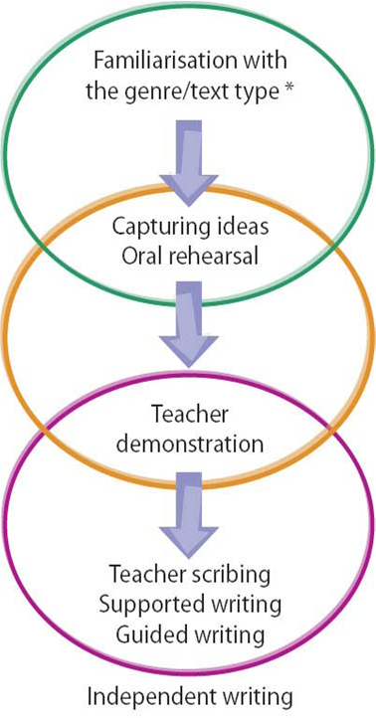

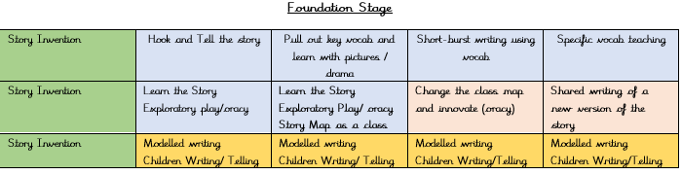

KS1

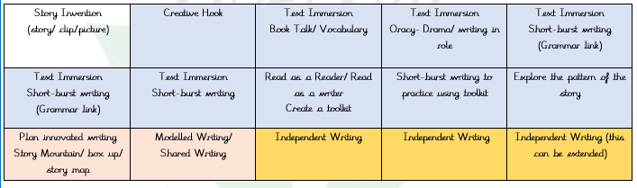

KS2

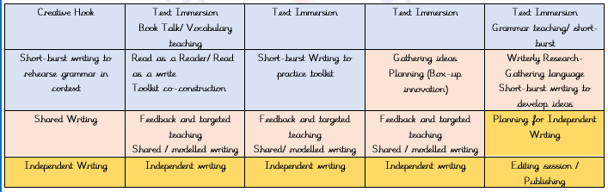

Teachers plan for a unit of work using the sequence above with text immersion/ familiarisation, capturing ideas - techniques such as drama/ story mapping and this leads into the teacher demonstrating the writing. The children gradually progress towards independent writing, which is collated in our Writing books.

In Reading, we use a structure whereby the teacher models reading and skills such as inference and vocabulary teaching occurs at the point also. Children gradually take over the reading and work towards independent reading. A variety of questions are then linked to the session to allow the children to be assessed.

Teaching Methods

Reading
In the Foundation Stage and KS1, our phonics sessions teach children to look at the letters of a word and segment it into their component sounds, before blending these sounds back together to read the entire word. Primarily, we teach the skill of decoding which is the ability to apply knowledge of letter-sound relationships, including knowledge of letter patterns, to correctly pronounce written words.
When teaching comprehension skills in KS1 and predominantly in KS2, we teach the following strategies: activating prior knowledge, generating and answering questions, making inferences, prediction, summarising and visualisation.

Writing
In writing we teach the children a combination of transcription and compositional skills. Children are immersed in core texts and a model text where they learn to imitate a piece. They then practice their writing skills where they innovate and progress towards inventing their own written pieces. Teachers model writing, involve the children in shared and guided writing and lead them towards independent writing.

Learning Environment
For Reading/ Writing we use working walls to allow the children to reinforce and consolidate children’s English knowledge and understanding. English working walls allow the children to visualise the reading and writing processes and to provide a reminder of vocabulary that has been collated throughout the sequence of work.

SEND
Sensory, Physical and Medical

In English, some children experience difficulties with fine motor development and therefore may require support to improve grip/ muscle strength and dexterity. From the very early stages of education, we ensure that the children are immersed in a wealth of activities to ensure progress in this area. Examples include picking up small objects with tools, using programmes such as Dough Disco and squeezing malleable objects. We also provide children with pencil grips throughout KS1 and 2 when and where required. Sloped writing boards are used by some children to elevate the position of the paper when writing. This encourages children to write whilst seated in the optimum position for writing - feet on the floor, head up and back straight. Technology can be used to support recording, through typing and/or speech to text software.

Cognition and Learning

In English, barriers could include difficulties with the processing of information and following a sequence of work in English. Reading, Writing and Speaking and Listening may be particularly difficult for some children. To support children with Cognition and Learning needs at Holly Hill, we ensure that English work is differentiated to ensure the child can access the learning in order to make progress. Sufficient time is provided to ensure that children are able to complete their task. Time breaks are also offered as a way of breaking down the English task in hand. Vocabulary is pre-taught to ensure that children are able to access challenging texts and word banks and working walls allow the children to have language at their fingertips during the writing process. Writing frames are provided to ensure that children are not fazed by a blank piece of paper. Overlays are used for children to accommodate any visual stress that a child may encounter. Clicker is used to remove any difficulties that children may have with putting pen to paper and this programme also allows children to articulate what they want to write. We strongly believe that if children cannot say it, they cannot write it. Children working significantly below expected levels will be assessed using an alternative system e.g. BSqaured and PIVATS,

Social, Emotional and Mental Health

In English, barriers could include being overwhelmed with the content of work. It could also be a difficult subject matter in the texts being used. Children may find the social aspect of English challenging and may require support when asked to work in groups of whole class scenarios. Stress levels could be increased by the complex reading and writing processes.
To support children with Social, Emotional and Mental Health needs in English strategies include providing TA/ Teacher support to ensure the children are suitably guided through the complex processes of Reading and Writing. Understanding individual experiences and traumas to avoid the selection of certain books and subject matter is essential. Teacher recognition of how mental health could be negatively impacted upon and working with children and families to put individual programmes in place, could avoid unnecessary anxiety linked to English lessons. Built in sensory breaks for certain children are part of our English curriculum.

Communication and Interaction

In English, barriers could include difficulties with speech and language, working and communicating within groups, drama tasks and comprehending new vocabulary and understanding meaning within contexts.
To support children with Communication and Interaction needs in English, strategies could include pre-teaching essential and challenging vocabulary, paired and small group work with trusted peers, visual aids, signing, timers, task boxes and Now and Next boards.
Children with communication and interaction needs may need Colourful Semantics to be able to understand the semantics of sentences. Different finished products may be needed to accommodate some children’s special interests with the same learning outcomes.

3. Impact

Assessment
In English, we ensure progression through the use of the National Curriculum expectations.

We utilise our feedback policy to formatively assess children on a daily basis, informing children of their strengths and areas to improve. English lessons follow a clear sequence begins with speaking, listening and reading leading into writing. Children work towards a written piece across a two/ three unit and explore a range of genres and purposes for writing.

In Reading, we assess termly using NFER tests and SATs at the end of each key stage. Writing is assessed using the Teacher Assessment Frameworks at the end of each key stage and in interim years using our school TAFs. In the Foundation Stage and Key Stage One, we use the assessments outlined in the Little Wandle SSP.

Monitoring and Evaluation

Evidence of work can be found in the children’s English, Writing and foundation subject books as we are passionate about children writing in all areas of the curriculum. Reading diaries contain evidence of the children’s home, class reading and spellings.
The English lead uses a combination of evidence from book looks, learning walks, environment checks and end of unit data to monitor the standards and inform the School Development Plan accordingly.

What does the impact of English look like at Holly Hill?

By the end of EYFS, pupils will be able to listen attentively, listen to stories and respond to prompts and ideas. They should be able to follow instructions to carry out activities and express their ideas about fictional and real-life events. Children should be using the past, present and future forms of language.
They should be using phonics to decode words and read simple sentences. They should be able to discuss what has been read and use their phonics knowledge to write simple words and sentences.

By the end of KS1, pupils will be able to read books written at an age-appropriate interest level. They should be able to read them accurately and at a speed that is sufficient for them to focus on understanding what they read rather than on decoding individual words. They should be able to decode most new words outside their spoken vocabulary, making a good approximation to the word’s pronunciation.
Pupils should be able to write down their ideas with a reasonable degree of accuracy and with good sentence punctuation. Pupils’ spelling of common words should be correct, including common exception words and other words that they have learnt. Pupils should spell words as accurately as possible using their phonic knowledge and other knowledge of spelling, such as morphology and etymology.

By the end of KS2, pupils’ Reading and Writing should be sufficiently fluent and effortless for them to manage the general demands of the curriculum in year 7, across all subjects and not just in English. They should be able to reflect their understanding of the audience for and purpose of their writing by selecting appropriate vocabulary and grammar. Pupils should be consciously controlling sentence structure in their writing and understand why sentences are constructed as they are. Pupils should understand nuances in vocabulary choice and age-appropriate, academic vocabulary. This involves consolidation, practice and discussion of language.

Reviewed September 2025

