For local authority safeguarding advice contact:
Cheryl Stollery – 0115 8041047
For concerns about adults in school contact:
Eva Callaghan - 0115 8041272

In some circumstances appropriate emergency action may be taken and a case may be referred directly to children’s social care or the police.
MASH: 0300 500 8090
Online MASH referral
Emergency Duty Team: 0300 456 4546

If you are concerned about a child you must put the concern in writing on CPOMS. If it a matter of urgency, it must also be verbally reported to:
Mrs. Steed, Mrs. Watson,
Mrs Cordon, Mrs. Keegans or
Mrs Leal
Designated Safeguarding leads are
Mrs. L Steed 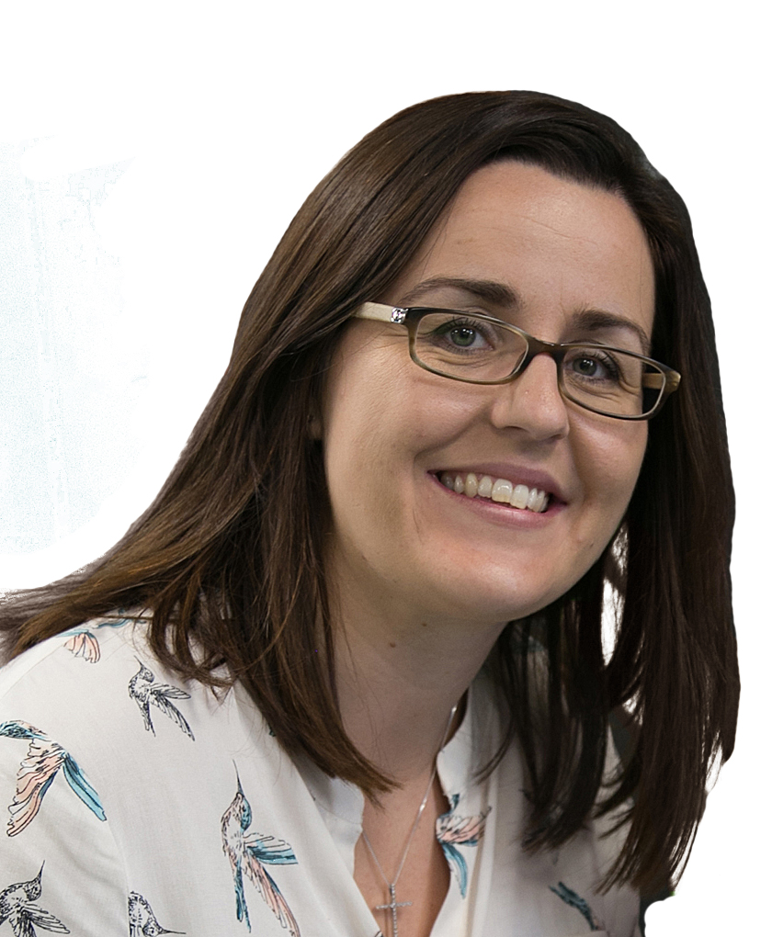
Mrs. T Watson 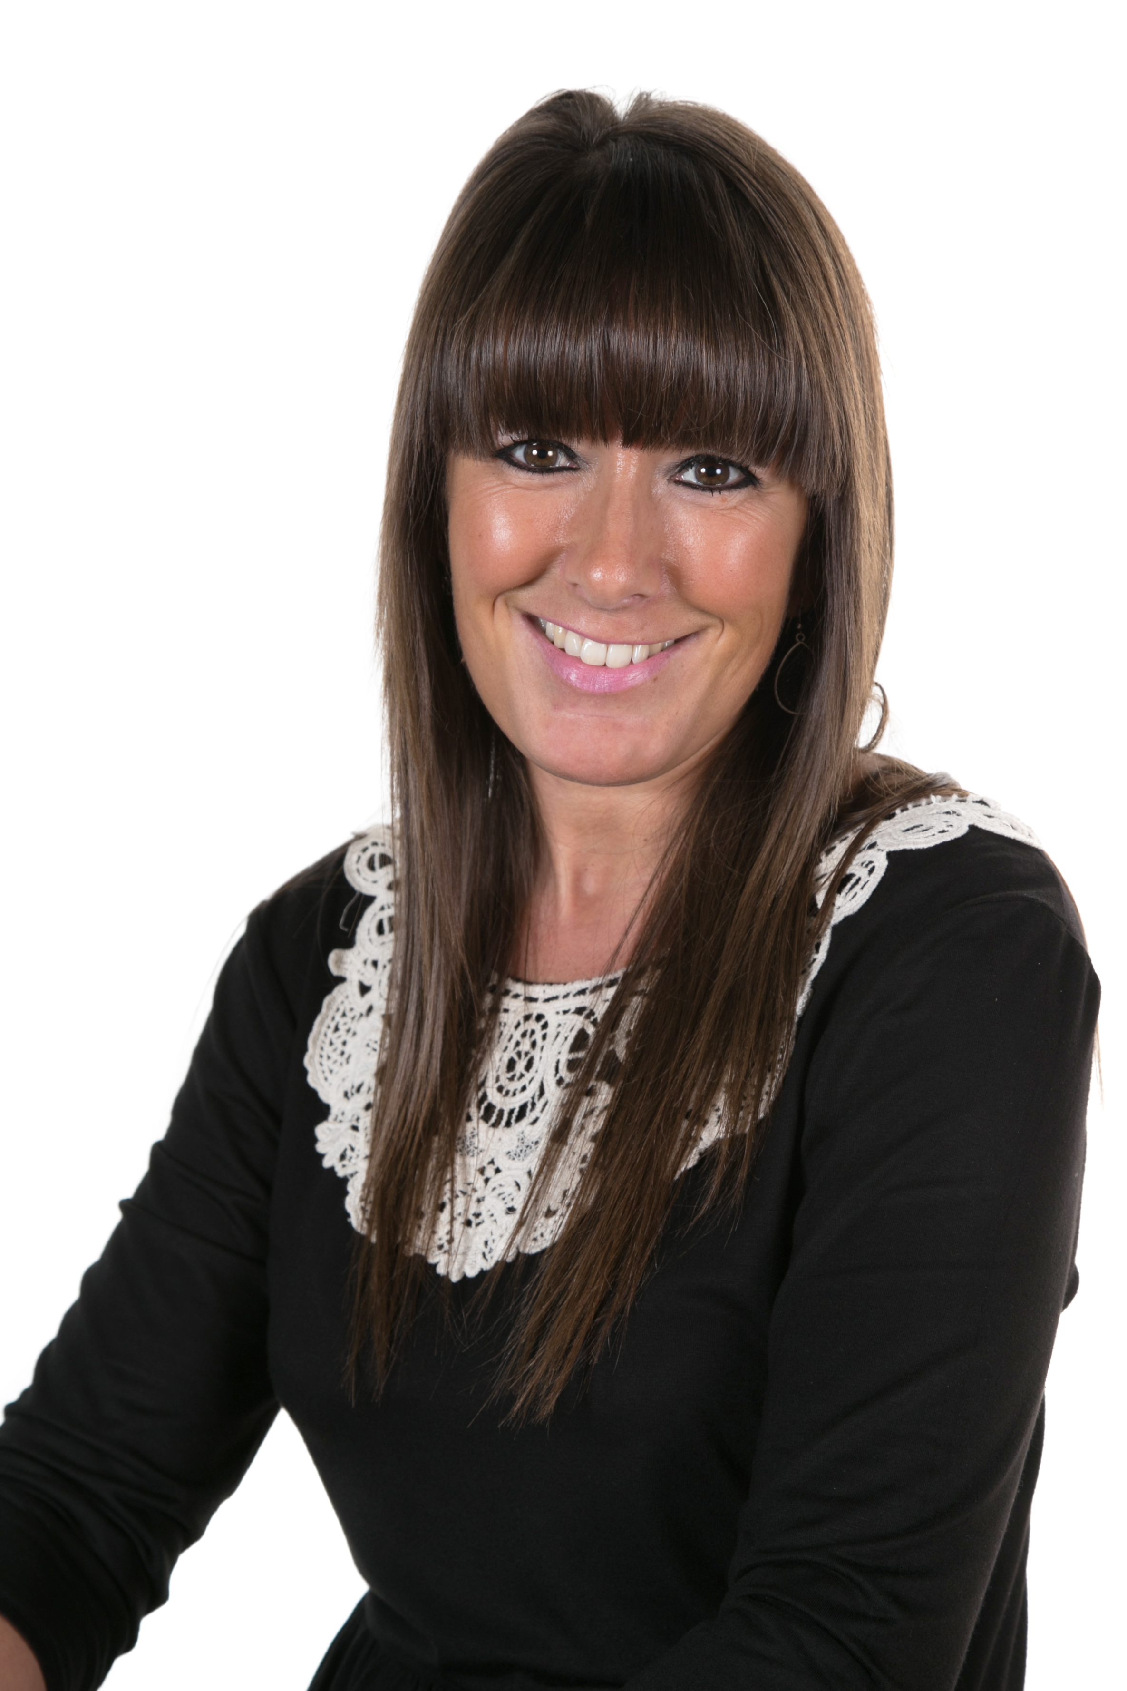
Mrs. L Keegans 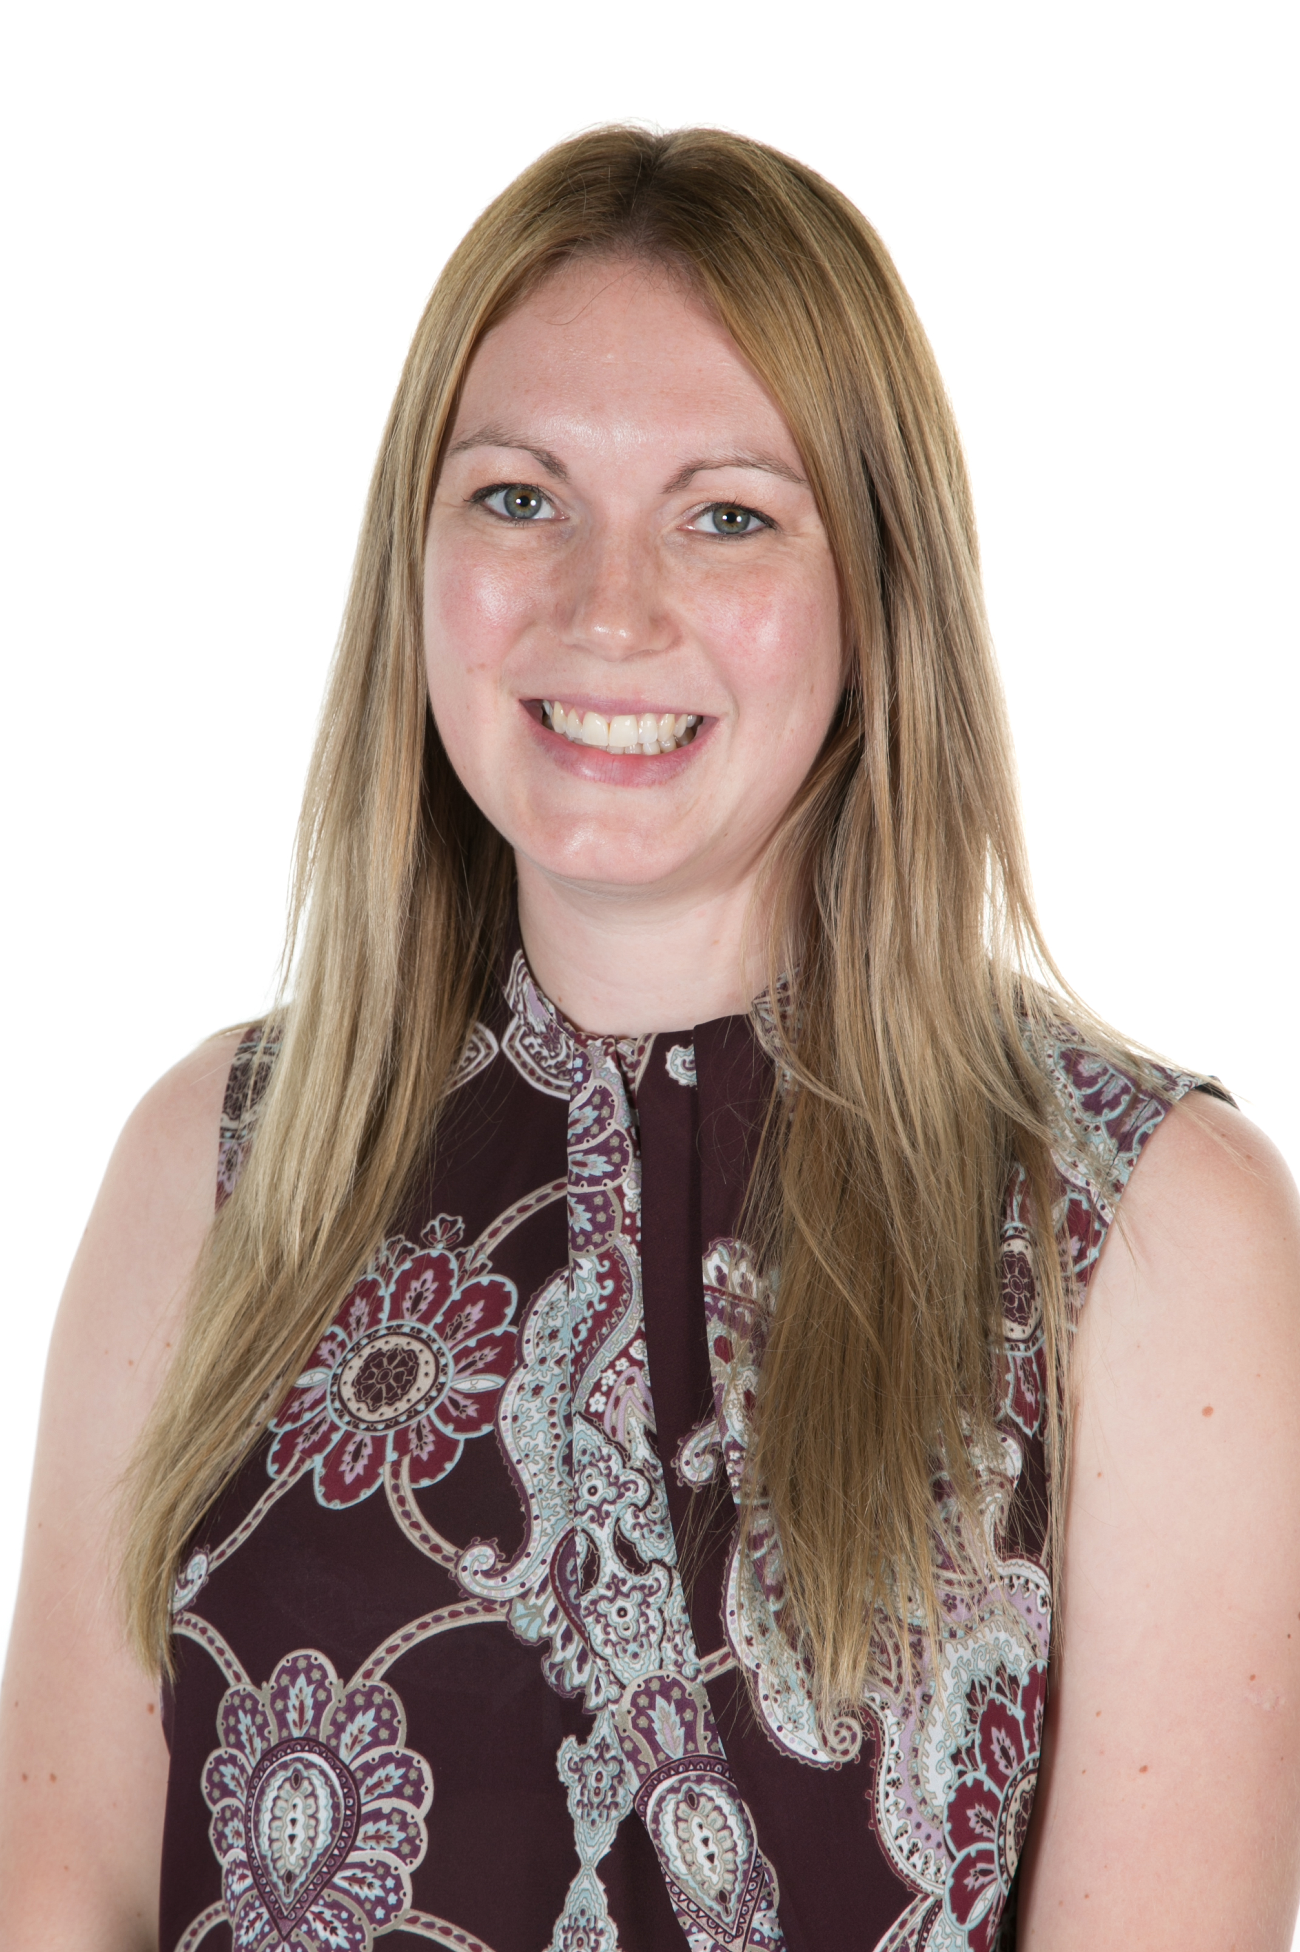
Mrs E Cordon 
Mrs J Leal 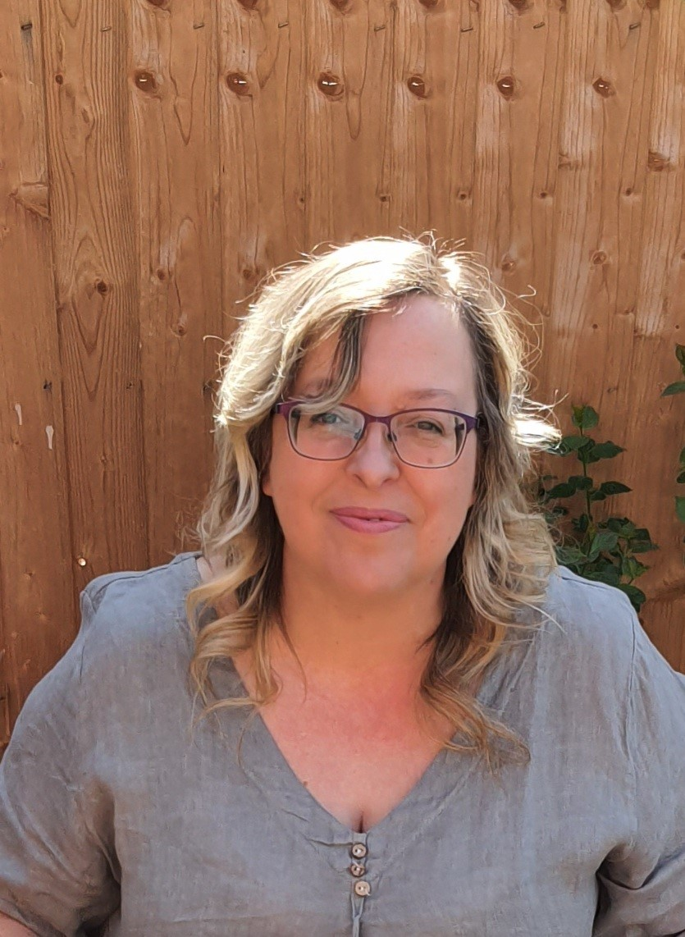

Link Governor: Mrs. E Carlisle

Designated Safeguarding lead to review the concern and decide on the next steps.

Decision made to refer the concern to social services.
Decision made to monitor the concern.
Decision made to discuss the concern with parents/carers.
Monitor Discuss Refer
Class teacher to monitor the situation with the child and record any further concerns on CPOMS chronology.
Once discussed with parents, DSL decides whether to continue monitoring or refer to social services.
DSL discusses with a senior teacher or Head and agree to refer the case to social care.

At all stages of the process, Holly Hill staff remain child focused.
The child’s circumstances are kept under review to ensure that the child’s circumstances improve.
The child’s best interests must always come first.
Record
Social care referrals:
0300 500 8090
Early Help Unit:
0115 804 1248
Prevent/Channel referrals:
101 Ext 2962/2963

DSLs will record actions on CPOMS. It is your responsibility to discuss this with the DSL if you are unclear and unsure about the action taken.

ALWAYS:
-think the unthinkable
-remember it could happen here

