Pupil premium strategy statement, 2021 - 22

This statement details our school’s use of pupil premium (and recovery premium for the 2021 to 2022 academic year) funding to help improve the attainment of our disadvantaged pupils.

It outlines our pupil premium strategy, how we intend to spend the funding in this academic year and the effect that last year’s spending of pupil premium had within our school.

School overview
Detail | Data
School name | Holly Hill Primary and Nursery School
Number of pupils in school | 321
Proportion (%) of pupil premium eligible pupils | 36%
Academic year/years that our current pupil premium strategy plan covers (3 year plans are recommended) | September 2021 – July 2024
Date this statement was published | October 2021
Date on which it will be reviewed | July 2022
Statement authorised by | Mrs. Leanne Steed
Pupil premium lead | Mrs. Leanne Steed and Miss Lucy Fretwell
Governor | Abbie Teale
Funding overview
Detail | Amount
Pupil premium funding allocation this academic year | £147, 060
Recovery premium funding allocation this academic year | £16, 240
Pupil premium funding carried forward from previous years (enter £0 if not applicable) | £0
Total budget for this academic year  If your school is an academy in a trust that pools this funding, state the amount available to your school this academic year | £163, 300

Part A: Pupil premium strategy plan

Statement of intent
When making decisions about using Pupil Premium funding it is important to consider the context of the school, the subsequent challenges faced and research conducted by the EEF. In line with the EEF guidance, our strategy takes a three-tiered approach ensuring that we are meeting the needs of the ‘whole’ child. Our strategy has also been informed by the work of Marc Rowland in “Addressing Educational Disadvantage in Schools and Colleges”.
Marc Rowland states a number of barriers to learning for disadvantaged children and at Holly Hill we find these to be the most common:
- Limited vocabulary
- Under-developed oral language
- Poor self-regulation and self-perception
- Lack of access to high quality early years provision
At Holly Hill, we also find that, in some cases, our disadvantaged children have:
- Attendance and punctuality issues
- Complex family situations and multi-agency involvement
- Parents who lack confidence to engage with us
Our data demonstrates that children enter our school at a lower than average level. As a result, we prioritise keeping class sizes small in the Early Years and Infant years. The challenges throughout school are varied and there is no “one size fits all”. Our strategy allows for some flexibility in approach so that the needs of individual children and families can be met. Ensuring all children can learn, make progress and thrive in the school environment is our ultimate intent.
69/114 = 61% of PP children are also on the graduated response for SEND.

Challenges

This details the key challenges to achievement that we have identified among our disadvantaged pupils.
Challenge number | Detail of challenge
 | Limited vocabulary
 | Under developed oral language
 | Poor self-regulation and self-perception
 | Lack of access to high quality early years provision
 | Attendance and punctuality issues
 | Complex family situations and multi-agency involvement
 | Parents who lack confidence to engage

Intended outcomes
This explains the outcomes we are aiming for by the end of our current strategy plan, and how we will measure whether they have been achieved.
Intended outcome | Success criteria
All PP children to feel happy, safe and engaged with their learning | Pupil voice surveys evidence that PP children are happy, safe and enjoying school
Progress in Reading | Achieve above national average progress scores in KS2 Reading (0)
Progress in Writing | Achieve above national average progress scores in KS2 Writing (0)
Progress in Mathematics | Achieve above national average progress scores in KS2 Maths (0)
Phonics | Achieve above national average expected standard in PSC
Attendance | Ensure attendance of disadvantaged pupils is above 95%
PP children enjoy and engage with a wide range of extra-curricular activities | PP children are tracked to ensure that engagement with wider activities is varied throughout their time in school  Aim for all PP children to be offered or take part in:  - A trip  - A residential  - A sporting opportunity  - A musical opportunity  PP children are targeted to attend as appropriate

Activity in this academic year
This details how we intend to spend our pupil premium (and recovery premium funding) this academic year to address the challenges listed above.

Teaching (for example, CPD, recruitment and retention)
Budgeted cost: £65, 092
Activity | Evidence that supports this approach | Challenge number(s) addressed
CPD  £5750 | The best available evidence indicates that great teaching is the most important lever schools have to improve pupil attainment. Ensuring every teacher is supported in delivering high-quality teaching is essential to achieving the best outcomes for all pupils, particularly the most disadvantaged among them. EEF | 1, 2, 3, 4
Additional UKS2 teacher (½ Covid catch up)  £19, 781 | Smaller classes only impact upon learning if the reduced numbers allow teachers to teach differently – for example, having higher quality interactions with pupils or minimising disruption.  The gains from smaller class sizes are likely to come from the increased flexibility for organising learners and the quality and quantity of feedback the pupils receive (see school feedback policy). EEF | 1, 2, 3, 4
KS1/FS2 teacher  £39,561 | There is some evidence for additional benefits of smaller class sizes with younger children, so smaller class sizes may be a more effective approach during the early stages of primary school.  The gains from smaller class sizes are likely to come from the increased flexibility for organising learners and the quality and quantity of feedback the pupils receive (see school feedback policy). EEF | 1, 2, 3, 4

Targeted academic support (for example, tutoring, one-to-one support structured interventions)
Budgeted cost: £49, 258
Activity | Evidence that supports this approach | Challenge number(s) addressed
1:1 or small group tuition  £10,000 | Evidence indicates that one to one tuition can be effective, providing approximately five additional months’ progress on average.  Short, regular sessions (about 30 minutes, three to five times a week) over a set period of time (up to ten weeks) appear to result in optimum impact. | 1, 2, 3, 7
NELI  £780 | On average, pupils receiving NELI interventions made the equivalent of three additional months’ progress in language skills, compared to those outside the programme.  Children in NELI also made an additional 2 months’ progress in early word reading and an additional 5 months’ progress on a teacher-administered language assessment.  NELI children with English as an additional language (EAL) also made the equivalent of 3 additional months’ progress in language compared to EAL children who did not receive NELI.  https://www.elklan.co.uk/OurWork/CaseStudies/NELI/ | 1, 2, 4
£3482 - SALT | Without appropriate and timely intervention, children with Speech, Language and Communication Needs (SLCN) are at higher risk of negative outcomes, including on their educational achievement, employment prospects, behaviour and involvement in the justice system, as well as their social, emotional and mental health.  https://www.england.nhs.uk/ltphimenu/children-and-young-people/speech-language-and-communication-services/ | 1, 2, 4
£31, 848 - FS1 Autumn term, FS2, KS1, Y3/4, Y5/6 TA interventions | Teaching assistants who provide one to one or small group targeted interventions shows a stronger positive benefit of between four and six additional months on average. EEF | 1, 2, 3, 4
£168 - Times tables rockstars | It is important to make the purpose of homework clear to pupils (e.g. to increase a specific area of knowledge, or to develop fluency in a particular area). EEF | 3, 7
£1430 - Mathletics (FS2 – KS2) |  | 3, 7
£1400 - Reading eggs (FS2 – KS1) |  | 3, 7
£150 - Spelling shed |  | 3, 7

Wider strategies (for example, related to attendance, behaviour, wellbeing)
Budgeted cost: £45, 579
Activity | Evidence that supports this approach | Challenge number(s) addressed
Behaviour mentor  £4560 | The average impact of behaviour interventions is four additional months’ progress over the course of a year. Evidence suggests that, on average, behaviour interventions can produce moderate improvements in academic performance along with a decrease in problematic behaviours. EEF | 1, 2, 3, 5, 6
Magic Breakfast  £1400 | “No child should be too hungry to learn” National School Breakfast Programme | 3, 5, 6
Family support worker (½ Covid catch up)  £28,921 | The average impact of the Parental engagement approaches is about an additional four months’ progress over the course of a year. There are also higher impacts for pupils with low prior attainment. By designing and delivering effective approaches to support parental engagement, schools and teachers may be able to mitigate some of these causes of educational disadvantage, supporting parents to assist their children’s learning or their self-regulation. EEF | 1, 2, 3, 4, 5, 6, 7
ELSA sessions  £1741 | Evidence suggests that children from disadvantaged backgrounds have, on average, weaker SEL skills at all ages than their more affluent peers. These skills are likely to influence a range of outcomes for pupils: lower SEL skills are linked with poorer mental health and lower academic attainment. EEF  ‘Health and wellbeing contribute to the achievement and life chances of all pupils.’ - Marc Rowland | 1, 2, 3, 6
Each Amazing Breath  £3000 |  | 3
Uniform  £500 | Another challenge facing equity vs equality in education is poverty. 60% of the most disadvantaged students come from low-income homes or communities. Because their families or schools might have very limited budgets, it can be difficult to provide these students with equitable resources.  To summarize, these are some of the benefits of focusing on equity in education:  - Higher test scores  - Better health  - Stronger social atmosphere  - Longer life  - Economic growth  https://www.waterford.org/education/equity-vs-equality-in-education/ | 1, 2, 3, 6, 7
Flexi-PP money  £1000 |  | 1, 2, 3, 6, 7
Book bags  £246 |  | 1, 2, 3, 6, 7
Trips funding  £2000 |  | 1, 2, 3, 6, 7
Tapestry  £250 | 1. Parental engagement has a positive impact on average of 4 months’ additional progress. It is crucial to consider how to engage with all parents to avoid widening attainment gaps.  2. Consider how to tailor school communications to encourage positive dialogue about learning. There is some evidence that personalised messages linked to learning can promote positive interactions.  3. Parental engagement strategies are typically more effective with parents of very young children. It is important to consider how you will maintain parental engagement as children get older. For example, providing flexible communications (e.g. short sessions at flexible times) might create opportunities for parents of older pupils to engage with the school. EEF | 4, 6, 7
Scholarpack Comms £1100 |  | 4, 6, 7
Little Chicks  £1741 |  | 4, 6, 7
Provision map  £120 | “Simple to use, Provision Map is a comprehensive tool which enables you to map and manage provision effectively and efficiently.”  Michael Surr, Education Development Officer, NASEN. | 1, 2, 3, 4, 5, 6, 7

Total budgeted cost: £159, 929

Part B: Review of outcomes in the previous academic year

Pupil premium strategy outcomes
This details the impact that our pupil premium activity had on pupils in the 2020 to 2021 academic year.
Due to COVID-19, performance measures have not been published for 2020 to 2021, and 2020 to 2021 results will not be used to hold schools to account.
- Introduction of NFERS
- Year 2 and 6 SATs
- Multiplication check
- Phonics screening check

Externally provided programmes
Programme | Provider
Mentoring programme | Brighter Futures Through Sport
Fine Motor Skills intervention | Griffin OT
Developing Outdoor Learning | OPAL
Times Tables Rockstars | TT Rockstars

2020 – 21 PP CHILDREN EYFS
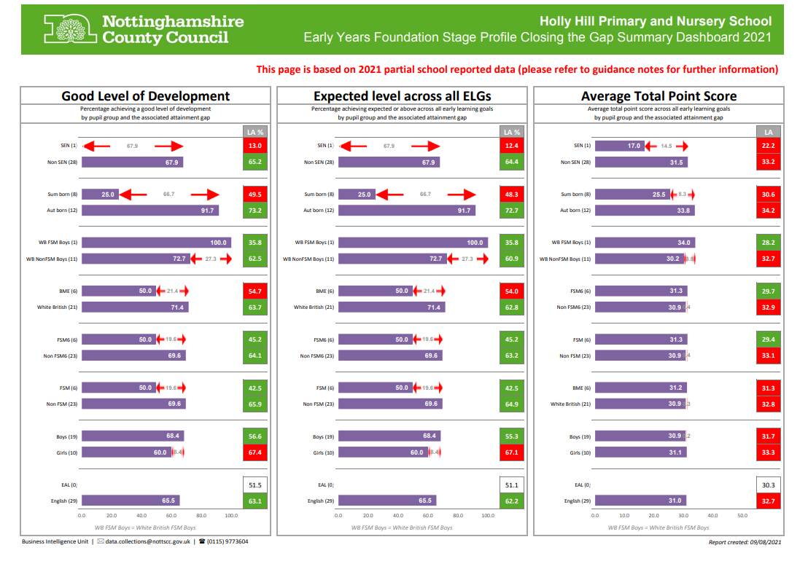
2020 – 21 PP CHILDREN MEETING ARE+ DATA (ONE YEAR PROGRESS)
 | READING |  | WRITING |  | MATHS
End of lockdown – introduction of NFERs | END OF LOCKDOWN 2021 (ARE+) | END OF SUMMER 2021 (ARE+) | END OF LOCKDOWN 2021 (ARE+) | END OF SUMMER 2021 (ARE+) | END OF LOCKDOWN 2021 (ARE+) | END OF SUMMER 2021 (ARE+)
YEAR 1 | 15% | 17% | 17% | 25% | 31% | 33%
YEAR 2 | 22% | 44% | 22% | 38% | 6% | 31%
YEAR 3 | 30% | 39% | 32% | 33% | 15% | 28%
YEAR 4 | 24% | 43% | 35% | 24% | 5% | 24%
YEAR 5 | 39% | 55% | 6% | 28% | 11% | 28%
YEAR 6 | 11% | 47% | 0% | 33% | 0% | 33%

PP GAP PRIOR TO COVID AND AFTER COVID
 | % GAP ARE IN R,W,M (SPRING 2020) | % GAP ARE IN R,W,M (SUMMER 2021)
YEAR 3 | 20% | 22%
YEAR 4 | 45% | 17%
YEAR 5 | 39% | 26%
YEAR 6 | 17% | 55% (addition of 7 PP children since Year 3)

