
Holly Hill Primary and Nursery School
Pupil premium strategy statement

This statement details our school’s use of pupil premium (and recovery premium for the 2022 to 2023 academic year) funding to help improve the attainment of our disadvantaged pupils. It outlines our pupil premium strategy, how we intend to spend the funding in this academic year and the effect that last year’s spending of pupil premium had within our school.

School overview
Detail | Data
School name | Holly Hill Primary and Nursery School
Number of pupils in school | 314
Proportion (%) of pupil premium eligible pupils | 36%
Academic year/years that our current pupil premium strategy plan covers (3-year plans are recommended) | September 2021 – July 2024
Date this statement was published | October 2022
Date on which it will be reviewed | July 2023
Statement authorised by | Mrs Leanne Steed
Pupil premium leads | Mrs Leanne Steed and Miss Lucy Fretwell
Governor / Trustee lead | Abbie Teale
Funding overview
Detail | Amount
Pupil premium funding allocation this academic year | £136,071
Recovery premium funding allocation this academic year | £40, 979
Pupil premium funding carried forward from previous years (enter £0 if not applicable) | £0
Total budget for this academic year  If your school is an academy in a trust that pools this funding, state the amount available to your school this academic year | £177, 050

Part A: Pupil premium strategy plan

Statement of intent
When making decisions about using Pupil Premium funding it is important to consider the context of the school, the subsequent challenges faced and research conducted by the EEF. In line with the EEF guidance, our strategy takes a three-tiered approach ensuring that we are meeting the needs of the ‘whole’ child. Our strategy has also been informed by the work of Marc Rowland in “Addressing Educational Disadvantage in Schools and Colleges”.
Marc Rowland states a number of barriers to learning for disadvantaged children and at Holly Hill we find these to be the most common:
- Limited vocabulary
- Under-developed oral language
- Poor self-regulation and self-perception
- Lack of access to high quality early years provision
At Holly Hill, we also find that, in some cases, our disadvantaged children have:
- Attendance and punctuality issues
- Complex family situations and multi-agency involvement
- Parents who lack confidence to engage with us
Our data demonstrates that children enter our school at a lower than average level. As a result, we prioritise keeping class sizes small in the Early Years and Infant years. The challenges throughout school are varied and there is no “one size fits all”. Our strategy allows for some flexibility in approach so that the needs of individual children and families can be met. Ensuring all children can learn, make progress and thrive in the school environment is our ultimate intent.

Challenges

This details the key challenges to achievement that we have identified among our disadvantaged pupils.
Challenge number | Detail of challenge
 | Limited vocabulary
 | Underdeveloped oral language
 | Poor self-regulation and self-perception
 | Lack of access to high quality early years provision
 | Attendance and punctuality issues
 | Complex family situations and multi-agency involvement
 | Parents who lack confidence to engage
 | Need for consistent Pupil Premium strategies in classrooms

Intended outcomes
This explains the outcomes we are aiming for by the end of our current strategy plan, and how we will measure whether they have been achieved.
Intended outcome | Success criteria
All PP children to feel happy, safe and engaged with their learning | Pupil voice surveys evidence that PP children are happy, safe and enjoying school
Progress in Reading | Achieve above national average progress scores in KS2 Reading (0)
Progress in Writing | Achieve above national average progress scores in KS2 Writing (0)
Progress in Mathematics | Achieve above national average progress scores in KS2 Maths (0)
Phonics | Achieve above national average expected standard in PSC
Attendance | Ensure attendance of disadvantaged pupils is above 95%
PP children enjoy and engage with a wide range of extra-curricular activities | PP children are tracked to ensure that engagement with wider activities is varied throughout their time in school.  Aim for all PP children to be offered or take part in:  - A trip  - A residential  - A sporting opportunity  - A musical opportunity  PP children are targeted to attend as appropriate
Staff use consistent, best practice strategies to support the progress of the PP children in their class. | Staff will have had opportunities to share best practice for supporting PP children’s attainment, engagement and wellbeing.

Activity in this academic year
This details how we intend to spend our pupil premium (and recovery premium funding) this academic year to address the challenges listed above.

Teaching (for example, CPD, recruitment and retention)
Budgeted cost: £73, 311
Activity | Evidence that supports this approach | Challenge number(s) addressed | In Year Review: Spring
CPD | The best available evidence indicates that great teaching is the most important lever schools have to improve pupil attainment. Ensuring every teacher is supported in delivering high-quality teaching is essential to achieving the best outcomes for all pupils, particularly the most disadvantaged among them. EEF | 1, 2, 3, 4, 8 | Ashley Booth Whole Class Reading  - Consistency across school  - New staff have now had the same training
Additional UKS2 teacher | Smaller classes only impact upon learning if the reduced numbers allow teachers to teach differently – for example, having higher quality interactions with pupils or minimising disruption.  The gains from smaller class sizes are likely to come from the increased flexibility for organising learners and the quality and quantity of feedback the pupils receive (see school feedback policy). EEF | 1, 2, 3, 4 | Data shows that,  In some year groups, PP children are out-performing their non-PP peers and in some year groups, the PP/non-PP gap is very small.  There is a gap between PP and non-PP in some year groups (in some subjects) and pupil progress plans are in place.
KS1/FS2 teacher | There is some evidence for additional benefits of smaller class sizes with younger children, so smaller class sizes may be a more effective approach during the early stages of primary school.  The gains from smaller class sizes are likely to come from the increased flexibility for organising learners and the quality and quantity of feedback the pupils receive (see school feedback policy). EEF | 1, 2, 3, 4

Targeted academic support (for example, tutoring, one-to-one support structured interventions)
Budgeted cost: £88, 480
Activity | Evidence that supports this approach | Challenge number(s) addressed | In Year Review: Spring
1:1 or small group tuition | Evidence indicates that one to one tuition can be effective, providing approximately five additional months’ progress on average.  Short, regular sessions (about 30 minutes, three to five times a week) over a set period of time (up to ten weeks) appear to result in optimum impact. | 1, 2, 3, 7 | - All Teaching Assistants responsible for delivering interventions now contribute to Provision Map to record interventions and review progress and impact of each intervention delivered.  - Interventions will be reviewed at the end of every half term.  - Children that don’t make acceptable progress will/have received an adapted intervention.  - PP children are targeted for interventions and are tracked on Provision Map to monitor their specific progress.
SALT | Without appropriate and timely intervention, children with Speech, Language and Communication Needs (SLCN) are at higher risk of negative outcomes, including on their educational achievement, employment prospects, behaviour and involvement in the justice system, as well as their social, emotional and mental health.  https://www.england.nhs.uk/ltphimenu/children-and-young-people/speech-language-and-communication-services/ | 1, 2, 4 | Pupils with active Speech and Language therapist involvement are supported with their individual targets set by the therapist within school by the Language Lead and when targets are being generalised they are also supported by class staff. Pupil specific resources are made and used and shared with parents as required. Speech and Language therapists also visit school to review targets or carry out assessments. Parents are also involved by attending sessions both at clinic or within school and regular informal discussions or support with Language Lead. Parents/ carers now have to contact the SALT team themselves when targets have been achieved or need adjusting – this is following liaison with the Language Lead. Following this appointment and re assessment pupils can be discharged from SALT or new targets set and supported within school. New referrals to SALT are also made by the Language Lead as required for pupils from F1-Yr6 for specific speech sound difficulties in conjunction with parents / carers. The Language Lead works with a range of SALT teams (Community, ASD, SLIT) and private speech therapists. All targets are shared with school staff and support available re general speech, language difficulties provided by Language Lead or SEND Team eg colourful semantics, strategies and signs / symbols.
FS2, KS1, Y3/4, Y5/6 TA interventions and Government partially funded Academic Mentor | Teaching assistants who provide one to one or small group targeted interventions shows a stronger positive benefit of between four and six additional months on average. EEF | 1, 2, 3, 4 | - All Teaching Assistants (including Academic Mentor) responsible for delivering interventions now contribute to Provision Map to record interventions and review progress and impact of each intervention delivered.  - Interventions will be reviewed at the end of every half term.  - Children that don’t make acceptable progress will/have received an adapted intervention.  - PP children are targeted for interventions and are tracked on Provision Map to monitor their specific progress
Times tables  Rockstars | It is important to make the purpose of homework clear to pupils (e.g. to increase a specific area of knowledge, or to develop fluency in a particular area). EEF | 3, 7 | · Pupil feedback positive  · Staff feedback positive  · Children enjoy learning times tables and competition element of the activity  · Improved multiplication/times tables skills  · Improved speed with times tables  · Times table data improving - review to be completed in April 2023  · Progress in class related to tables eg factors/fractions/geometry etc  · Year 4 data improving prior to Times Table Check
Mathletics (FS2 – KS2) |  | 3, 7 | · Improved motivation of pupils  · Extra work being completed at home for practise  · Children enjoy activity and therefore Maths  · Maths seen in a variety of contexts  · Fun and enjoyable activities allow children to learn while having fun – removes barriers  · Maths accessible to all pupils and can be given learning relevant to stage – inclusion of all in the match lesson and the children do not feel different or that others know what they are doing. Confidence increases
Reading eggs (FS2 – KS1) |  | 3, 7 | Available to all pupils F2- Yr 2 for both home and school use by individual log on details. Links on class web pages to website. Additional Ks2 SEND / Nest pupils also have individual accounts to support learning. App also on school iPads.

Wider strategies (for example, related to attendance, behaviour, wellbeing)
Budgeted cost: £40, 097
Activity | Evidence that supports this approach | Challenge number(s) addressed | In Year Review: Spring
Behaviour mentor | The average impact of behaviour interventions is four additional months’ progress over the course of a year. Evidence suggests that, on average, behaviour interventions can produce moderate improvements in academic performance along with a decrease in problematic behaviours. EEF | 1, 2, 3, 5, 6 | Pupils attending have expressed they enjoy the sessions, although a few pupils have asked if sessions could be more active. Relationship has developed with some pupils with complex needs. However, full impact has yet to be seen and children accessing still need support around the SEMH needs.
Magic Breakfast | “No child should be too hungry to learn” National School Breakfast Programme | 3, 5, 6 | - Pupil voice continues to prove that children benefit from free breakfast being provided. Children are ready to learn after their breakfast and are more engaged learners.
Family support worker | The average impact of the Parental engagement approaches is about an additional four months’ progress over the course of a year. There are also higher impacts for pupils with low prior attainment. By designing and delivering effective approaches to support parental engagement, schools and teachers may be able to mitigate some of these causes of educational disadvantage, supporting parents to assist their children’s learning or their self-regulation. EEF | 1, 2, 3, 4, 5, 6, 7 | Strong family links with our community to support attendance issues that arise.  Attendance of some families has significantly improved due to the monitoring and support services offered by the FSW.
ELSA sessions  See TA funding detailed in targeted academic support. | Evidence suggests that children from disadvantaged backgrounds have, on average, weaker SEL skills at all ages than their more affluent peers. These skills are likely to influence a range of outcomes for pupils: lower SEL skills are linked with poorer mental health and lower academic attainment. EEF  ‘Health and wellbeing contribute to the achievement and life chances of all pupils.’ - Marc Rowland | 1, 2, 3, 6 | ELSA sessions continue to provide support to those children targeted for support. ELSA lead identifies children for ongoing support or offer to children who would benefit from the service.
Each Amazing Breath | Take Five was initially designed to help students reduce stress and have greater capacity in school, with peers, and at home. That core remains, and has evolved to also assist students (and staff) with:  - Improves Readiness to Learn  - Aids classroom management  - Helps students focus more during lessons, and reduces disruptive classroom behaviour  - Cultivates children and young people to feel safer and more in control  - Cultivates emotional health and well-being  - Facilitates improved coping strategies and better choice making  - Supports children and young people to have the space to reflect on their own behaviour  - Provides practical de-escalation tools children and young people can self-apply  - Fosters gentle, kind, and daily self-care  - Cultivates self-leadership to move forward confidently and authentically  - Facilitates peer to peer support  - Fosters personal capacity to help others from a place of safety, empathy, and mutual respect  The average impact of metacognition and self-regulation strategies is an additional seven months’ progress over the course of a year – EEF. | 3
Uniform | Another challenge facing equity vs equality in education is poverty. 60% of the most disadvantaged students come from low-income homes or communities. Because their families or schools might have very limited budgets, it can be difficult to provide these students with equitable resources.  To summarize, these are some of the benefits of focusing on equity in education:  - Higher test scores  - Better health  - Stronger social atmosphere  - Longer life  - Economic growth  https://www.waterford.org/education/equity-vs-equality-in-education/ | 1, 2, 3, 6, 7 | - Trip funding has been used to offer children in receipt of the PP funding a discounted rate on recent residential trips, who otherwise would not have been able to attend.
Flexi-PP money |  | 1, 2, 3, 6, 7
Book bags |  | 1, 2, 3, 6, 7
Trips funding |  | 1, 2, 3, 6, 7
Tapestry  Scholarpack Comms  Little Chicks | 1. Parental engagement has a positive impact on average of 4 months’ additional progress. It is crucial to consider how to engage with all parents to avoid widening attainment gaps.  2. Consider how to tailor school communications to encourage positive dialogue about learning. There is some evidence that personalised messages linked to learning can promote positive interactions.  3. Parental engagement strategies are typically more effective with parents of very young children. It is important to consider how you will maintain parental engagement as children get older. For example, providing flexible communications (e.g. short sessions at flexible times) might create opportunities for parents of older pupils to engage with the school. EEF | 4, 6, 7 | Tapestry is used to record significant learning opportunities for children in EYFS and for communication and engagement with parents. The expectations to gather evidence has reduced in the new EYFS Framework, however we still find it to be a useful tool to record learning and encourage parents to support home learning opportunities.
Provision map | “Simple to use, Provision Map is a comprehensive tool which enables you to map and manage provision effectively and efficiently.”  Michael Surr, Education Development Officer, NASEN. | 1, 2, 3, 4, 5, 6, 7 | - PP Lead provided further training on the use of Provision Map, and this has been successful. Provision Map is now being used to record half-termly intervention timetables and PP children have been targeted and this is being recorded.  - Training has been given on how to review the impact of an intervention, and this will prove beneficial when considering the impact of the interventions being delivered.
Total budgeted cost: £201, 888

Part B: Review of outcomes in the previous academic year

Pupil premium strategy outcomes
Intended outcome | Success criteria | End of 21/22 Review of impact
All PP children to feel happy, safe and engaged with their learning | Pupil voice surveys evidence that PP children are happy, safe and enjoying school. | Pupil voice surveys will be carried out in the Autumn term to reflect on the impact and effectiveness of the 21/22 strategy.  Intended outcome will continue to be developed as part of the 22/23 strategy.  Pupil voice is on our 2022-23 School Development Plan, with a view to ensure that Pupil Premium children are represented in all areas.
Progress in Reading | Achieve above national average progress scores in KS2 Reading (0) | 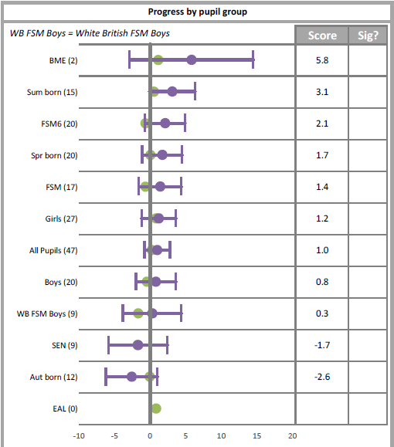  Target achieved – FSM6 progress score 2.1  School % of PP working at ARE or above by the end of KS2 – 55%  National % of all children working at ARE or above by the end of KS2 – 74%
Progress in Writing | Achieve above national average progress scores in KS2 Writing (0) | 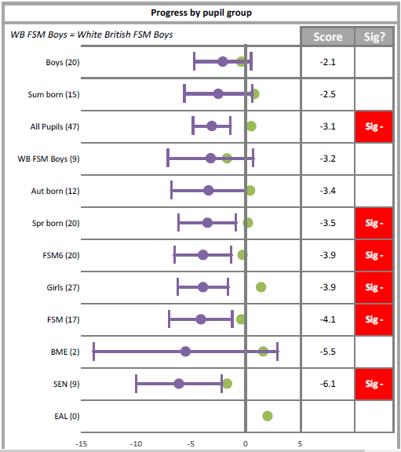  Target is developing. We know that at Holly Hill, COVID-19 school closures had a significant impact of writing attainment. Most children did not complete writing-related home learning tasks. Writing continues to be an area for development and therefore is targeted on the 2022-23 English Action Plan.  School % of PP working at ARE or above by the end of KS2 – 30%  National % of all children working at ARE or above by the end of KS2 – 69%
Progress in Mathematics | Achieve above national average progress scores in KS2 Maths (0) | 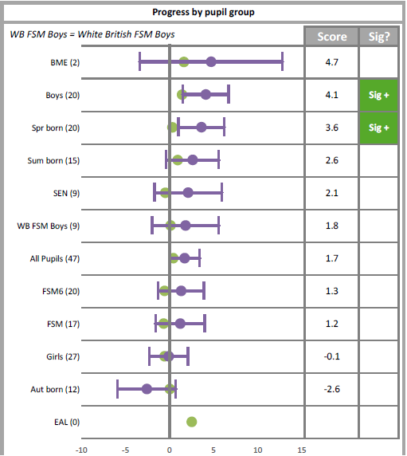  Target achieved – FSM6 progress score 1.3  School % of PP working at ARE or above by the end of KS2 – 45%  National % of all children working at ARE or above by the end of KS2 – 71%
Phonics | Achieve above national average expected standard in PSC | Holly Hill’s percentage of PP children passing the Phonics Screening Check at the end of KS1:  85% (+5.8% relative to the Local Authority)  Teaching Assistant interventions, small class sizes and small group tuition have all played a pivotal part in the achievement of this Phonics Screening Check result.  - Children have accessed high quality teaching in a small class size, which has allowed the teacher to work more closely with PP children and target them more effectively.  - Class teacher was able to identify children who were at risk of falling behind and same-day interventions delivered to ensure no children fell behind.  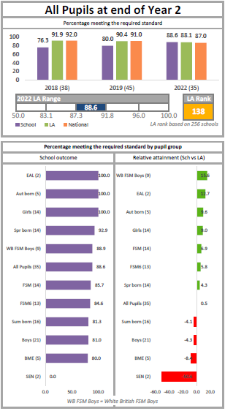
Attendance | Ensure attendance of disadvantaged pupils is above 95% | FSM attendance – 90.7% compared to 92.7% non-FSM  - Initial group of monitoring children identified for September 2021 (new system and policy introduced given increased capacity of FSW)  - 18 out of the 26 children identified for monitoring were PP – 14 had improved attendance with an average of a 6% increase
PP children enjoy and engage with a wide range of extra-curricular activities | PP children are tracked to ensure that engagement with wider activities is varied throughout their time in school  Aim for all PP children to be offered or take part in:  - A trip  - A residential  - A sporting opportunity  - A musical opportunity  PP children are targeted to attend as appropriate | Provision Map has been used effectively to monitor the engagement of PP children in a range of extra-curricular activities.  All PP children have been offered and taken part in a trip, a residential (in year groups which offered them). The cost of the trips were subsidised for PP children. All children have been offered the opportunity to take part in a sport (after-school club/lunch club).  - All PP children attended a trip in 21/22, meaning that they have all had an opportunity to take part in a curriculum-enhancing experience that bought their classroom learning to life.  - A number of children utilised the PP trip/residential cost subsidiary, which ultimately enabled them to attend a wider-curricular opportunity that they otherwise would not have been able to. In each case, it was clear that the result of this was raised confidence and self-esteem due to accessing life-enhancing opportunities and experiences with their peers.  - All PP children accessed a whole-class instrument lesson in 21/22 with many choosing to continue this skill outside of school – this passion was sparked as a result of their experiences in school. A new partnership with a piano teacher has been formed to allow another avenue of music tuition, along with small group guitar tuition, which PP children are targeted to attend.

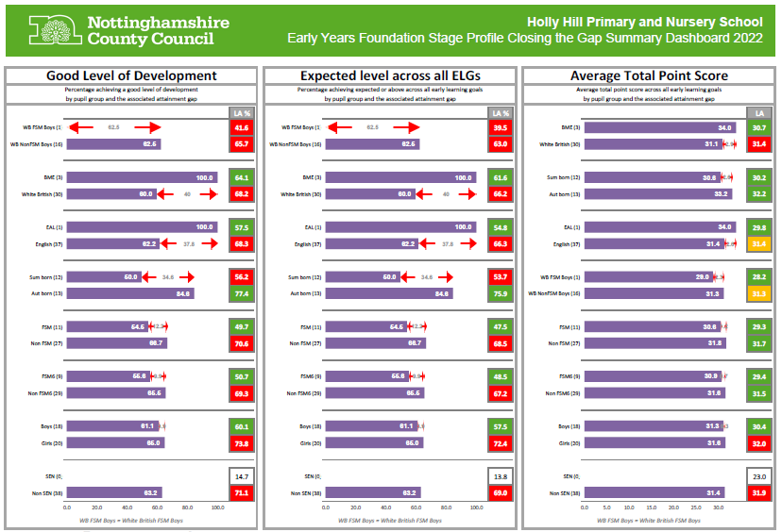
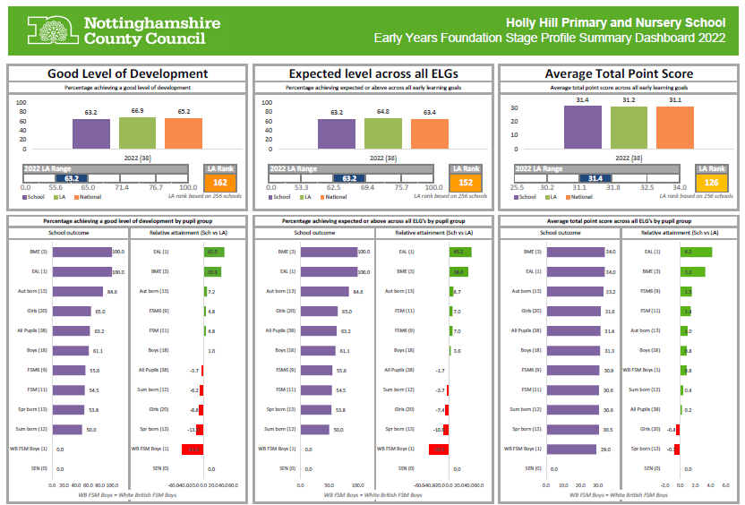
PP children in EYFS

Externally provided programmes
Please include the names of any non-DfE programmes that you purchased in the previous academic year. This will help the Department for Education identify which ones are popular in England.
Programme | Provider
Mentoring programme | Brighter Futures Through Sport
Fine Motor Skills intervention | Griffin OT
Developing Outdoor Learning | OPAL

