
Pupil premium strategy statement

This statement details our school’s use of pupil premium (and recovery premium for the 2023 to 2024 academic year) funding to help improve the attainment of our disadvantaged pupils.

It outlines our pupil premium strategy, how we intend to spend the funding in this academic year and the effect that last year’s spending of pupil premium had within our school.

School overview
Detail | Data
School name | Holly Hill Primary and Nursery School
Number of pupils in school | 305
Proportion (%) of pupil premium eligible pupils | 35%
Academic year/years that our current pupil premium strategy plan covers (3-year plans are recommended) | September 2021 – July 2024
Date this statement was published | October 2023
Date on which it will be reviewed | July 2024
Statement authorised by | Mrs Leanne Steed
Pupil premium leads | Mrs Leanne Steed and Miss Lucy Fretwell
Governor / Trustee lead | Abbie Teale
Funding overview
Detail | Amount
Pupil premium funding allocation this academic year | £142, 950
Recovery premium funding allocation this academic year | £15,224
Pupil premium funding carried forward from previous years (enter £0 if not applicable) | £0
Total budget for this academic year  If your school is an academy in a trust that pools this funding, state the amount available to your school this academic year | £158,174

Part A: Pupil premium strategy plan

Statement of intent
When making decisions about using Pupil Premium funding it is important to consider the context of the school, the subsequent challenges faced and research conducted by the EEF. In line with the EEF guidance, our strategy takes a three-tiered approach ensuring that we are meeting the needs of the ‘whole’ child. Our strategy has also been informed by the work of Marc Rowland in “Addressing Educational Disadvantage in Schools and Colleges”.
Marc Rowland states a number of barriers to learning for disadvantaged children and at Holly Hill, we find these to be the most common:
- Limited vocabulary
- Under-developed oral language
- Poor self-regulation and self-perception
- Lack of access to high quality early years provision
At Holly Hill, we also find that, in some cases, our disadvantaged children have:
- Attendance and punctuality issues
- Complex family situations and multi-agency involvement
- Parents who lack confidence to engage with us
Our data demonstrates that children enter our school at a lower than average level. As a result, we prioritise keeping class sizes small in the Early Years and Infant years. The challenges throughout school are varied and there is no “one size fits all”. Our strategy allows for some flexibility in approach so that the needs of individual children and families can be met. Ensuring all children can learn, make progress and thrive in the school environment is our ultimate intent.

Challenges

This details the key challenges to achievement that we have identified among our disadvantaged pupils.
Challenge number | Detail of challenge
1. | Initial assessments and observations show that many disadvantaged children joining school have under developed oral language skills, limited vocabulary and limited experience of educational settings  This slows progress in many areas of learning into KS1 and beyond.  This has a significant impact on their vocabulary, comprehension skills and ability to be creative writers, resulting in not achieving age related expectations.  Last year, the % of PP children achieving a Good level of development (GLD) by the end of the EYFS was 36.4% (31% behind National outcomes).  - Where children at the end of EYFS did not achieve GLD, it was because of lower achievement in writing.  - Where children at the end of KS2 did not achieve expected combined, it was because of lower achievement in writing.
2. | Poor self-regulation and self-perception  Some pupils need to develop their organisational skills, resilience and determination. Some children over-rely on adult support to feel confident to try challenging things.
3. | Attendance and punctuality issues  Disadvantaged pupils’ attendance was 90.9% This reduces school hours and can cause them to fall behind their peers.
4. | Complex family situations and multi-agency involvement  This can mean that some children do not always arrive at school ready to learn.
5. | Parents who lack confidence to engage  This can mean that engagement in day to day school life and wider-school life is not always high.

Intended outcomes
This explains the outcomes we are aiming for by the end of our current strategy plan, and how we will measure whether they have been achieved.
Intended outcome | Success criteria
All PP children to feel happy, safe and engaged with their learning | Pupil voice surveys evidence that PP children are happy, safe and enjoying school
Progress in Reading | Achieve above national average progress scores in KS2 Reading (0)
Progress in Writing | Achieve above national average progress scores in KS2 Writing (0)
Progress in Mathematics | Achieve above national average progress scores in KS2 Maths (0)
Progress in Phonics | Achieve above national average expected standard in PSC
Improving attendance | Ensure attendance of disadvantaged pupils is above 95%
PP children enjoy and engage with a wide range of extra-curricular activities | PP children are tracked to ensure that engagement with wider activities is varied throughout their time in school.  Aim for all PP children to be offered or take part in:  - A trip  - A residential  - A sporting opportunity  - A musical opportunity  PP children are targeted to attend as appropriate

Activity in this academic year
This details how we intend to spend our pupil premium (and recovery premium funding) this academic year to address the challenges listed above.

Teaching (for example, CPD, recruitment and retention)
Budgeted cost: £73, 311
Activity | Evidence that supports this approach | Challenge number(s) addressed
CPD | The best available evidence indicates that great teaching is the most important lever schools have to improve pupil attainment. Ensuring every teacher is supported in delivering high-quality teaching is essential to achieving the best outcomes for all pupils, particularly the most disadvantaged among them. EEF | 1, 2
Oral language strategies CPD and interventions | The average impact of Oral language interventions is approximately an additional six months’ progress over the course of a year. Some studies also often report improved classroom climate and fewer behavioural issues following work on oral language. EEF | 1, 2
KS1/FS2 teacher | There is some evidence for additional benefits of smaller class sizes with younger children, so smaller class sizes may be a more effective approach during the early stages of primary school.  The gains from smaller class sizes are likely to come from the increased flexibility for organising learners and the quality and quantity of feedback the pupils receive (see school feedback policy). EEF | 1, 2

Targeted academic support (for example, tutoring, one-to-one support structured interventions)
Budgeted cost: £88, 480
Activity | Evidence that supports this approach | Challenge number(s) addressed
1:1 or small group tuition | Evidence indicates that one to one tuition can be effective, providing approximately five additional months’ progress on average.  Short, regular sessions (about 30 minutes, three to five times a week) over a set period of time (up to ten weeks) appear to result in optimum impact. | 1, 2, 5
SALT | Without appropriate and timely intervention, children with Speech, Language and Communication Needs (SLCN) are at higher risk of negative outcomes, including on their educational achievement, employment prospects, behaviour and involvement in the justice system, as well as their social, emotional and mental health.  https://www.england.nhs.uk/ltphimenu/children-and-young-people/speech-language-and-communication-services/ | 1, 2
FS2, KS1, Y3/4, Y5/6 TA interventions and Government partially funded Academic Mentor | Teaching assistants who provide one to one or small group targeted interventions shows a stronger positive benefit of between four and six additional months on average. EEF | 1, 2
Times tables rockstars | It is important to make the purpose of homework clear to pupils (e.g. to increase a specific area of knowledge, or to develop fluency in a particular area). EEF | 2, 4
Mathletics (FS2 – KS2) |  | 2, 4
Reading eggs (FS2 – KS1) |  | 2, 4

Wider strategies (for example, related to attendance, behaviour, wellbeing)
Budgeted cost: £40, 097
Activity | Evidence that supports this approach | Challenge number(s) addressed
Behaviour mentor | The average impact of behaviour interventions is four additional months’ progress over the course of a year. Evidence suggests that, on average, behaviour interventions can produce moderate improvements in academic performance along with a decrease in problematic behaviours. EEF | 1, 2, 3, 4
Magic Breakfast | “No child should be too hungry to learn” National School Breakfast Programme | 2, 3, 4
Family Support Worker | The average impact of the Parental engagement approaches is about an additional four months’ progress over the course of a year. There are also higher impacts for pupils with low prior attainment. By designing and delivering effective approaches to support parental engagement, schools and teachers may be able to mitigate some of these causes of educational disadvantage, supporting parents to assist their children’s learning or their self-regulation. EEF | 1, 2, 3, 4, 5
ELSA sessions  See TA funding detailed in targeted academic support. | Evidence suggests that children from disadvantaged backgrounds have, on average, weaker SEL skills at all ages than their more affluent peers. These skills are likely to influence a range of outcomes for pupils: lower SEL skills are linked with poorer mental health and lower academic attainment. EEF  ‘Health and wellbeing contribute to the achievement and life chances of all pupils.’ - Marc Rowland | 1, 2, 3, 4
Uniform | Another challenge facing equity vs equality in education is poverty. 60% of the most disadvantaged students come from low-income homes or communities. Because their families or schools might have very limited budgets, it can be difficult to provide these students with equitable resources.  To summarize, these are some of the benefits of focusing on equity in education:  - Higher test scores  - Better health  - Stronger social atmosphere  - Longer life  - Economic growth  https://www.waterford.org/education/equity-vs-equality-in-education/ | 1, 2, 3, 4, 5
Flexi-PP money |  | 1, 2, 3, 4, 5
Book bags |  | 1, 2, 3, 4, 5
Trips funding |  | 1, 2, 3, 4, 5
Tapestry | 1. Parental engagement has a positive impact on average of 4 months’ additional progress. It is crucial to consider how to engage with all parents to avoid widening attainment gaps.  2. Consider how to tailor school communications to encourage positive dialogue about learning. There is some evidence that personalised messages linked to learning can promote positive interactions.  3. Parental engagement strategies are typically more effective with parents of very young children. It is important to consider how you will maintain parental engagement as children get older. For example, providing flexible communications (e.g. short sessions at flexible times) might create opportunities for parents of older pupils to engage with the school. EEF | 1, 2, 4, 5
Scholarpack Comms |  | 1, 2, 4, 5
Little Chicks |  | 1, 2, 4, 5
Provision map | “Simple to use, Provision Map is a comprehensive tool which enables you to map and manage provision effectively and efficiently.”  Michael Surr, Education Development Officer, NASEN. | 1, 2, 3, 4, 5
Total budgeted cost: £201, 888

Part B: Review of outcomes in the previous academic year

Pupil premium strategy outcomes
Intended outcome | Success criteria | Review of impact  End of 2022-2023
All PP children to feel happy, safe and engaged with their learning | Pupil voice surveys evidence that PP children are happy, safe and enjoying school. | In pupil voice interviews, children expressed the following.  Tbc week 02.10.23  Annual parent questionnaire reported that 100% of parents said that their child feels safe and happy at school and that they do well with their learning. 98% said that where bullying incidents happen, school deal with these cases quickly and effectively.
Progress in Reading | Achieve above national average progress scores in KS2 Reading (0) | Good progress has been made towards this desired outcome.  KS2 reading outcomes in 2022/2023 show that more than 63% of disadvantaged pupils met the expected standard.  - This is a progress score of 0.1  - This is +5.3% against the Local Authority outcomes  - This is +3.3% against National outcomes  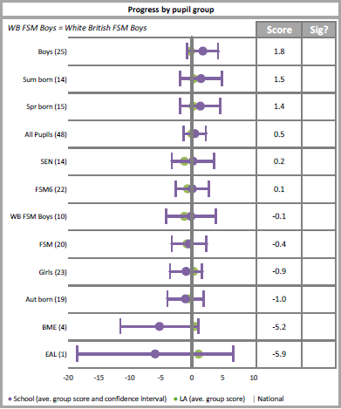  Intervention monitoring reports showed that…  Pupil voice showed that…  Observations showed that…  Book looks showed that…
Progress in Writing | Achieve above national average progress scores in KS2 Writing (0) | Some progress has been made towards achieving this desired outcome.  KS2 writing outcomes in 2022/2023 show that 50% of disadvantaged pupils met the expected standard (this has improved from last year’s 30%).  - This is a progress score of -1.0 (this has improved from last year’s -3.9)  - This is -7.1% against the Local Authority outcomes  - This is -8.3% against National outcomes  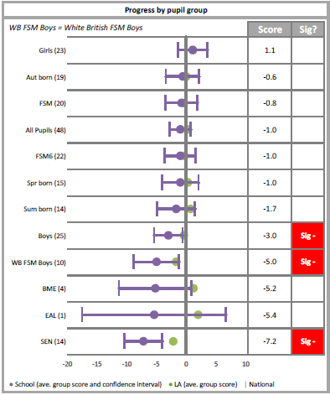  Intervention monitoring reports showed that…  Pupil voice showed that…  Observations showed that…  Book looks showed that…  Monitoring and evidence has shown that writing is a school-wide issue, for both PP and non-PP children.  Writing is on the 2023-2024 School Development Plan, with PP as an area of focus, to enable this desired outcome to be met.
Progress in Mathematics | Achieve above national average progress scores in KS2 Maths (0) | Very good progress has been made towards achieving this desired outcome.  KS2 mathematics outcomes in 2022/2023 show that more than 68% of disadvantaged pupils met the expected standard (this is an improvement against last year’s 45%).  - This is a progress score of 2.3 (This is an improvement against last year’s 1.3)  - This is +9.1% against the Local Authority outcomes  - This is +9.2% against National outcomes  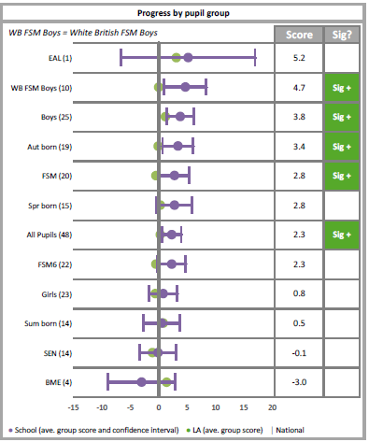  Intervention monitoring reports showed that…  Pupil voice showed that…  Observations showed that…  Book looks showed that…
Phonics | Achieve above national average expected standard in PSC | Some progress has been made towards achieving this desired outcome.  End of KS1 phonics outcomes in 2022/2023 show that more than 85% of disadvantaged pupils met the expected standard.  - This is +2.7% against the Local Authority outcomes  - This is -4.4% against National outcomes  The successful embedding of the Little Wandle phonics scheme, possible through TA support, small class sizes and small group tuition have all played a pivotal part in the achievement of this Phonics Screening Check result.  - Children have accessed high quality teaching in a small class size, which has allowed the teacher to work more closely with PP children and target them more effectively.  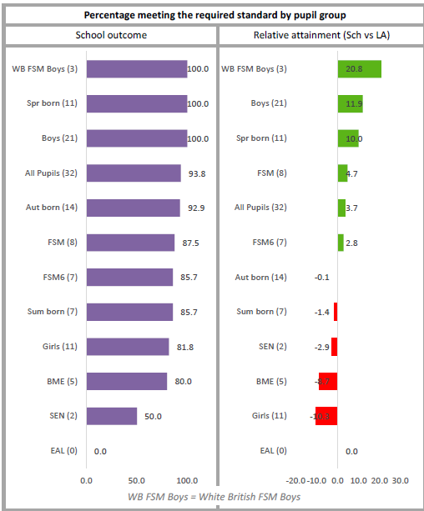  - Class teacher was able to identify children who were at risk of falling behind and same-day interventions delivered to ensure no children fell behind.
Attendance | Ensure attendance of disadvantaged pupils is above 95% | Some/limited progress has been made in achieving this desired outcome. Although overall attendance % had improved, the gap has widened between PP and non-PP due to an increase in non-PP attendance.  2021-2022 90.7% compared to 92.7% non-PP  2022-2023 90.9% compared to 94% non-PP
PP children enjoy and engage with a wide range of extra-curricular activities | PP children are tracked to ensure that engagement with wider activities is varied throughout their time in school  Aim for all PP children to be offered or take part in:  - A trip  - A residential  - A sporting opportunity  - A musical opportunity  PP children are targeted to attend as appropriate | Provision Map has been used effectively to monitor the engagement of PP children in a range of extra-curricular activities.  All PP children have been offered and taken part in a trip, a residential (in year groups which offered them). The cost of the trips were subsidised for PP children. All children have been offered the opportunity to take part in a sport (after-school club/lunch club).  All PP children attended a trip in 22/23, meaning that they have all had an opportunity to take part in a curriculum-enhancing experience that bought their classroom learning to life.  A number of children utilised the PP trip/residential cost subsidiary, which ultimately enabled them to attend a wider-curricular opportunity that they otherwise would not have been able to. In each case, it was clear that the result of this was raised confidence and self-esteem due to accessing life-enhancing opportunities and experiences with their peers.  All PP children accessed a whole-class instrument lesson in 22/23 with many choosing to continue this skill outside of school – this passion was sparked as a result of their experiences in school.

PP children in EYFS
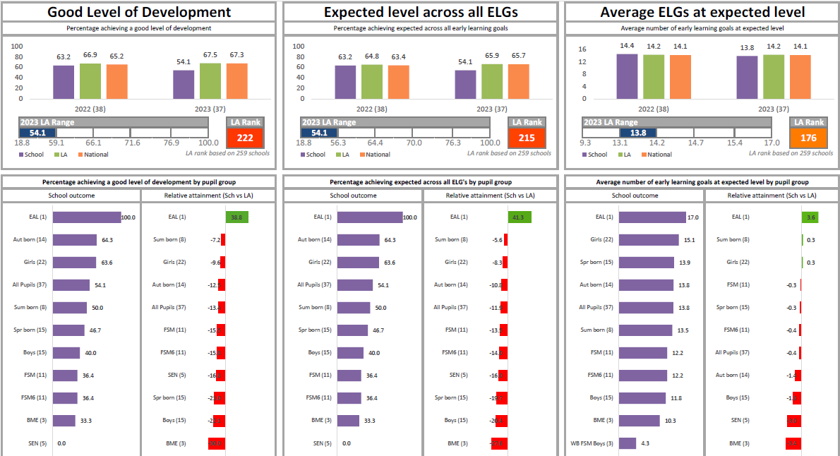

Externally provided programmes
Programme | Provider
Mentoring programme | Brighter Futures Through Sport
Fine Motor Skills intervention | Griffin OT
Developing Outdoor Learning | OPAL

