
Pupil premium strategy statement

This statement details our school’s use of pupil premium funding to help improve the attainment of our disadvantaged pupils.

It outlines our pupil premium strategy, how we intend to spend the funding in this academic year and the effect that last year’s spending of pupil premium had within our school.

School overview
Detail | Data
School name | Holly Hill Primary and Nursery School
Number of pupils in school | 305
Proportion (%) of pupil premium eligible pupils | 35%
Academic year/years that our current pupil premium strategy plan covers (3-year plans are recommended) | September 2021 – July 2024
Date this statement was published | October 2024
Date on which it will be reviewed | September 2027
Statement authorised by | Mrs Leanne Steed
Pupil premium leads | Miss Lucy Fretwell (PP lead)  Mrs Leanne Steed (Headteacher)
Governor / Trustee lead | Abbie Teale
Funding overview
Detail | Amount
Pupil premium funding allocation this academic year | £162,870
Pupil premium funding carried forward from previous years (enter £0 if not applicable) | £0
Total budget for this academic year  Including LAC PP, Post LAC PP | £162,870

Part A: Pupil premium strategy plan

Statement of intent
When making decisions about using Pupil Premium funding it is important to consider the context of the school, the subsequent challenges faced and research conducted by the EEF. In line with the EEF guidance, our strategy takes a three-tiered approach ensuring that we are meeting the needs of the ‘whole’ child. Our strategy has also been informed by the work of Marc Rowland in “Addressing Educational Disadvantage in Schools and Colleges”.
Marc Rowland states a number of barriers to learning for disadvantaged children and at Holly Hill, we find these to be the most common:
- Limited vocabulary
- Under-developed oral language
- Poor self-regulation and self-perception
- Lack of access to high quality early years provision
At Holly Hill, we also find that, in some cases, our disadvantaged children have:
- Attendance and punctuality issues
- Complex family situations and multi-agency involvement
- Parents who lack confidence to engage with us
Our data demonstrates that children enter our school at a lower than average level. As a result, we prioritise keeping class sizes small in the Early Years and Infant years. The challenges throughout school are varied and there is no “one size fits all”. Our strategy allows for some flexibility in approach so that the needs of individual children and families can be met. Ensuring all children can learn, make progress and thrive in the school environment is our ultimate intent.

Challenges

This details the key challenges to achievement that we have identified among our disadvantaged pupils.
Challenge number | Detail of challenge
1. | Initial assessments and observations show that many disadvantaged children joining school have under developed oral language skills, limited vocabulary and limited experience of educational settings  This slows progress in many areas of learning into KS1 and beyond.  This has a significant impact on their vocabulary, comprehension skills and ability to be creative writers, resulting in not achieving age related expectations.  Last year, the % of PP children achieving a Good level of development (GLD) by the end of the EYFS was 37.5% (14.6% behind National outcomes, compared to the year before which was 31% behind National outcomes).  - Where children at the end of EYFS did not achieve GLD, it was because of lower achievement in writing.  - Where children at the end of KS2 did not achieve expected combined, it was because of lower achievement in writing.
2. | Poor self-regulation and self-perception  Some pupils need to develop their organisational skills, resilience and determination. Some children over-rely on adult support to feel confident to try challenging things.
3. | Attendance and punctuality issues  Disadvantaged pupils’ attendance last year was 92.6% This reduces school hours and can cause them to fall behind their peers.
4. | Complex family situations and multi-agency involvement  This can mean that some children do not always arrive at school ready to learn.
5. | Parents who lack confidence to engage  This can mean that engagement in day to day school life and wider-school life is not always high.

Intended outcomes
This explains the outcomes we are aiming for by the end of our current strategy plan, and how we will measure whether they have been achieved.
Intended outcome | Success criteria
Improve attainment in Reading across the school | Achieve in line with Free School Meal children nationally.
Improve attainment in Writing across the school | Achieve in line with Free School Meal children nationally.
Improve attainment in Maths across the school | Achieve in line with Free School Meal children nationally.
Improve the number of children passing the Phonics Screening Check | Achieve in line with Free School Meal children nationally.
Improve attendance | Attendance of disadvantaged pupils is above 95%
Increase the number of disadvantaged children who are achieving a Good Level of Development | Achieve in line with Free School Meal children nationally.
To achieve and sustain improved emotional resilience and wellbeing | Pupil voice will show that children feel safe and happy in school.  Teacher voice will show that children feel motivated and confident to ‘always choose to be the best’ they can be in lessons, around school and through engagement in the wider curriculum.  Increase in parental engagement with events across school, which in turn positively impacts engagement, emotional resilience and wellbeing of disadvantaged pupils.

Activity in this academic year
This details how we intend to spend our pupil premium (and recovery premium funding) this academic year to address the challenges listed above.

Teaching (for example, CPD, recruitment and retention)

Activity | Evidence that supports this approach | Challenge number(s) addressed
CPD | The best available evidence indicates that great teaching is the most important lever schools have to improve pupil attainment. Ensuring every teacher is supported in delivering high-quality teaching is essential to achieving the best outcomes for all pupils, particularly the most disadvantaged among them. EEF | 1, 2
Oral language interventions | The average impact of Oral language interventions is approximately an additional six months’ progress over the course of a year. Some studies also often report improved classroom climate and fewer behavioural issues following work on oral language. EEF | 1, 2

Targeted academic support (for example, tutoring, one-to-one support structured interventions)

Activity | Evidence that supports this approach | Challenge number(s) addressed
1:1 or small group tuition | Evidence indicates that one to one tuition can be effective, providing approximately five additional months’ progress on average.  Short, regular sessions (about 30 minutes, three to five times a week) over a set period of time (up to ten weeks) appear to result in optimum impact. | 1, 2, 5
SALT | Without appropriate and timely intervention, children with Speech, Language and Communication Needs (SLCN) are at higher risk of negative outcomes, including on their educational achievement, employment prospects, behaviour and involvement in the justice system, as well as their social, emotional and mental health.  https://www.england.nhs.uk/ltphimenu/children-and-young-people/speech-language-and-communication-services/ | 1, 2
FS, KS1, Y3/4, Y5/6 TA interventions | Teaching assistants who provide one to one or small group targeted interventions shows a stronger positive benefit of between four and six additional months on average. EEF | 1, 2
Times Tables Rockstars | It is important to make the purpose of homework clear to pupils (e.g. to increase a specific area of knowledge, or to develop fluency in a particular area). EEF | 2, 4
Mathletics (FS2 – KS2) |  | 2, 4
Reading eggs (FS2 – KS1) |  | 2, 4

Wider strategies (for example, related to attendance, behaviour, wellbeing)

Activity | Evidence that supports this approach | Challenge number(s) addressed
Behaviour mentor | The average impact of behaviour interventions is four additional months’ progress over the course of a year. Evidence suggests that, on average, behaviour interventions can produce moderate improvements in academic performance along with a decrease in problematic behaviours. EEF | 1, 2, 3, 4
Breakfast Bagels | “No child should be too hungry to learn” National School Breakfast Programme | 2, 3, 4
Family Support Worker | The average impact of the Parental engagement approaches is about an additional four months’ progress over the course of a year. There are also higher impacts for pupils with low prior attainment. By designing and delivering effective approaches to support parental engagement, schools and teachers may be able to mitigate some of these causes of educational disadvantage, supporting parents to assist their children’s learning or their self-regulation. EEF | 1, 2, 3, 4, 5
ELSA  See TA funding detailed in targeted academic support | Evidence suggests that children from disadvantaged backgrounds have, on average, weaker SEL skills at all ages than their more affluent peers. These skills are likely to influence a range of outcomes for pupils: lower SEL skills are linked with poorer mental health and lower academic attainment. EEF  ‘Health and wellbeing contribute to the achievement and life chances of all pupils.’ - Marc Rowland | 1, 2, 3, 4
School-level Social and Emotional Learning Approaches | The average impact of successful SEL interventions is an additional four months’ progress over the course of a year. Alongside academic outcomes, SEL interventions have an identifiable and valuable impact on attitudes to learning and social relationships in school. | 1,2,3,4,5
Provision of equitable resources:  - Uniform  - Book bags  - Trip funding  - Flexible money to support | Another challenge facing equity vs equality in education is poverty. 60% of the most disadvantaged students come from low-income homes or communities. Because their families or schools might have very limited budgets, it can be difficult to provide these students with equitable resources.  To summarize, these are some of the benefits of focusing on equity in education:  - Higher test scores  - Better health  - Stronger social atmosphere  - Longer life  - Economic growth  https://www.waterford.org/education/equity-vs-equality-in-education/ | 1, 2, 3, 4, 5
Parental engagement strategies:  - Tapestry  - Scholarpack Comms | 1. Parental engagement has a positive impact on average of 4 months’ additional progress. It is crucial to consider how to engage with all parents to avoid widening attainment gaps.  2. Consider how to tailor school communications to encourage positive dialogue about learning. There is some evidence that personalised messages linked to learning can promote positive interactions.  3. Parental engagement strategies are typically more effective with parents of very young children. It is important to consider how you will maintain parental engagement as children get older. For example, providing flexible communications (e.g. short sessions at flexible times) might create opportunities for parents of older pupils to engage with the school. EEF | 1, 2, 4, 5
Provision map | “Simple to use, Provision Map is a comprehensive tool which enables you to map and manage provision effectively and efficiently.”  Michael Surr, Education Development Officer, NASEN. | 1, 2, 3, 4, 5
Part B: Review of outcomes in the previous academic year

Pupil premium strategy outcomes
This is the last year of our 3-year Pupil Premium plan. The review will comment on the progress the school has made towards the 7 intended outcomes.
Intended outcome | Success criteria | Review of impact  End of 2023-2024
All PP children to feel happy, safe and engaged with their learning | Pupil voice surveys evidence that PP children are happy, safe and enjoying school. | In pupil voice interviews, children expressed the following.  - 100% of children were happy at school either all of the time or most of the time.  - 90% of children were interested in their learning either all of the time or most of the time.  Provision of universal free breakfast continues to be pivotal in our mission to ensure no child is every too hungry to learn and every child starts their day ready to learn.
Progress in Reading | Achieve above national average progress scores in KS2 Reading (0)  Due to no progress scores, this criteria will change to a comparison against national outcomes | Some progress has been made towards this desired outcome.  KS2 reading outcomes in 2023/2024 show that 60.3% of disadvantaged pupils met the expected standard.  - There is no progress data due to COVID-19.  - This is +1.5% against the Local Authority outcomes  - This is -2.3% against National outcomes
Progress in Writing | Achieve above national average progress scores in KS2 Writing (0)  Due to no progress scores, this criteria will change to a comparison against national outcomes | Data would show that limited progress has been made towards achieving this desired outcome; however, a significant amount of work has been done this year to address progress being made in writing long-term, despite this not having translated into writing outcomes yet.  KS2 writing outcomes in 2023/2024 show that 34.8% of disadvantaged pupils met the expected standard.  - This is -20.8% against the Local Authority outcomes  - This is -24% against National outcomes  Monitoring and evidence has shown that writing is a school-wide issue, for both PP and non-PP children.  - ALL children meeting the expected standard in Writing is -10.5% against the Local Authority  - ALL children meeting the expected standard in Writing is -14% against National outcomes  Senior Leaders and PP lead delivered training with a focus on oracy and attitudes to writing this year; this will continue next academic year.  A pupil voice sample showed the following.  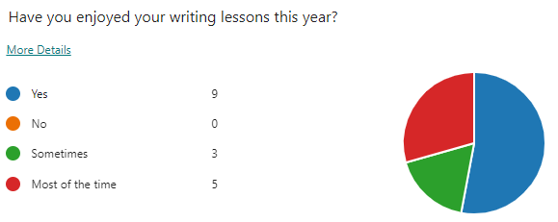  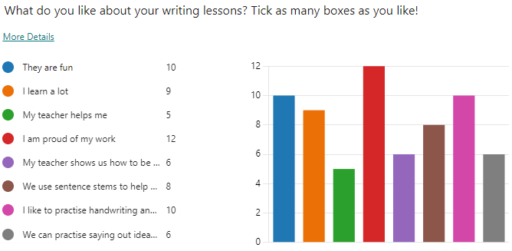  Observations showed that staff are implementing trainging given on oracy strategies (sentence stems, partner talk, oral rehearsal, seating strategies). More follow-up work will continue next academic year.  Book looks showed that more children were benefitting from oral rehearsal supported by sentence stems, and this translated into their writing and its improved sense and clarity.
Progress in Mathematics | Achieve above national average progress scores in KS2 Maths (0)  Due to no progress scores, this criteria will change to a comparison against national outcomes | Some progress has been made towards achieving this desired outcome.  KS2 mathematics outcomes in 2023/2024 show that 47.8% of disadvantaged pupils met the expected standard.  - This is -12.3% against the Local Authority outcomes  - This is -11.6% against National outcomes  The Year 6 cohort last year was 50% SEND, 20% being both PP and SEND, contributing to the comparatively low Maths data this year:  High quality teaching/Targeted academic support put in place to address the low data throughout the year:  - Every FSM6 child accessed a Maths intervention to target gaps last year  - Maths interventions and pre/post-teach were priorities for TA staffing in KS2  - Member of SLT utilised to split the Y5/6 class to target the Year 6’s, of which 50% were FSM6 (this left the Year 5’s with a Maths group of 12 children, 33% of which were FSM6)  - Training provided by the Maths lead with a specific focus on adapting the Power Maths scheme for every child
Phonics | Achieve above national average expected standard in PSC | Good progress has been made towards achieving this desired outcome.  End of Y1 phonics outcomes in 2023/2024 show that 46.7% of disadvantaged pupils met the expected standard.  - This is -19.9% against the Local Authority outcomes  - This is -21.7% against National outcomes  However, by the end of Year 2, 100% of disadvantaged pupils met the expected standard.  - This is +19.3% against the Local Authority outcomes  The successful embedding of the Little Wandle phonics scheme, including the absolutely pivotal rapid catch-up in Year 2 and beyond, made possible through TA support, small class sizes and small group tuition have all played a pivotal part in the achievement of this end of KS1 Phonics data outcome.  - Children have accessed high quality teaching in a small class size, which has allowed the teacher to work more closely with PP children and target them more effectively.  - Class teacher was able to identify children who were at risk of falling behind and same-day interventions delivered to ensure no children fell behind.
Attendance | Ensure attendance of disadvantaged pupils is above 95% | Good progress has been made in achieving this desired outcome. There has been significant work done to close the gap between PP and non-PP attendance.  2022-2023 90.9% compared to 94.3% non-PP (GAP -3.5)  2023-2024 92.6% compared to 93.4% non-PP (GAP -0.8)
PP children enjoy and engage with a wide range of extra-curricular activities | PP children are tracked to ensure that engagement with wider activities is varied throughout their time in school  Aim for all PP children to be offered or take part in:  A trip  A residential  A sporting opportunity  A musical opportunity  PP children are targeted to attend as appropriate | Provision Map has been used effectively to monitor the engagement of PP children in a range of extra-curricular activities.  All PP children have been offered the opportunity to take part in a trip and a residential (in year groups which offer them). The cost of the trips were subsidised for PP children. All children have been offered the opportunity to take part in a sport (after-school club/lunch club).  All PP children attended a trip in 23/24, meaning that they have all had an opportunity to take part in a curriculum-enhancing experience that bought their classroom learning to life.  A number of children utilised the PP trip/residential cost subsidiary, which ultimately enabled them to attend a wider-curricular opportunity that they otherwise would not have been able to. In each case, it was clear that the result of this was raised confidence and self-esteem due to accessing life-enhancing opportunities and experiences with their peers.  All PP children accessed a whole-class instrument lesson in 23/24 with many choosing to continue this skill outside of school – this passion was sparked as a result of their experiences in school.

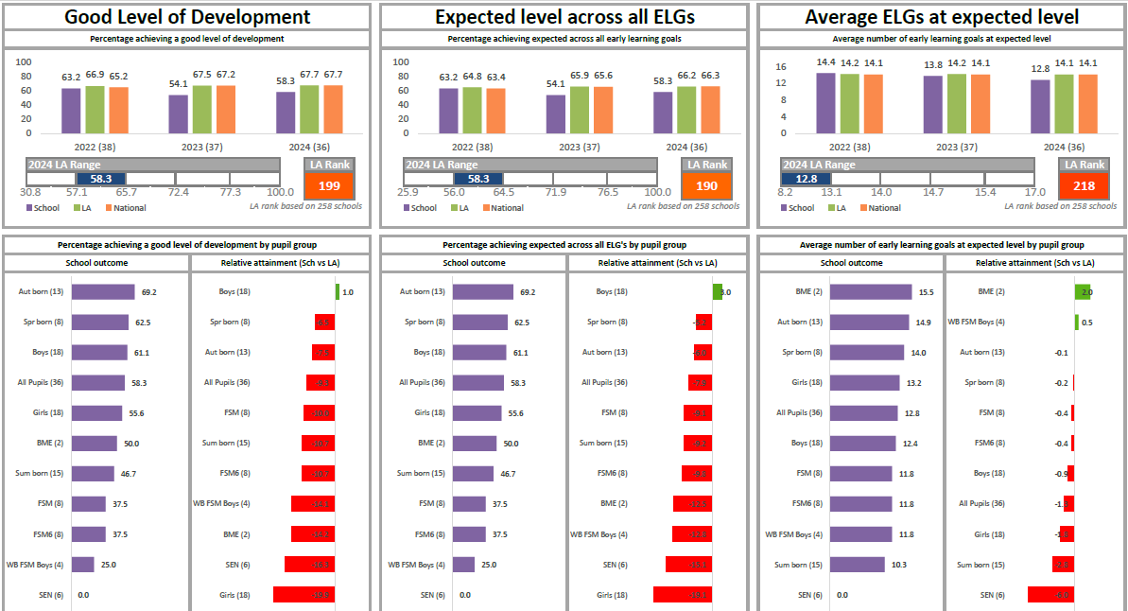
PP children in EYFS

Externally provided programmes
Programme | Provider
Mentoring programme | Brighter Futures Through Sport
Fine Motor Skills intervention | Griffin OT
SALT

