F2 Curriculum Organiser – Commotion in the Ocean – Summer 2 2025
Key Knowledge and Skills
Communication and Language
To know To know key vocabulary linked to the ocean.
To know I can recall my experience as a series of events.
I can give explanations for why things happen, making use of recently introduced vocabulary.
I can use language to describe what pirates are like.
Expressive Arts and Design
To know they can create with colour, texture and function.

To know how to print with a range of materials

I can safely use and explore a variety of materials, tools and techniques.
To know that materials can be joined in different ways.
I can explore ways of joining materials using different resources.
I can explain the process they have used.
I can explore, use and refine a variety of artistic effects to express their ideas and feelings.

Understanding the World
Know people and animals grow and change as time passes.
Know that comparisons can be made through observation.
Know that living and non-living things can be classified.
I can identify similarities and differences between living things, drawing on their experiences and what has been read in class.
I can explore the natural world around them, making observations and drawing pictures of animals and plants.
Know Know that information can be drawn from a simple map.

Know that we live in Selston which is in Nottingham, in England, in the UK.

Opportunities and Experiences
Half Termly Bake Off – 50p donations greatly appreciated
Pirate Day – 10th July
Sports Day – 19th June
EYFS Garden Party-25th June
Transition Days -30th June and 1st July

E

Our Key Texts
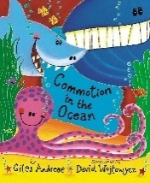
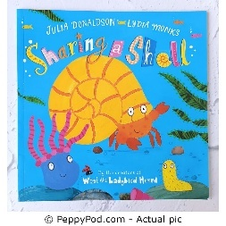
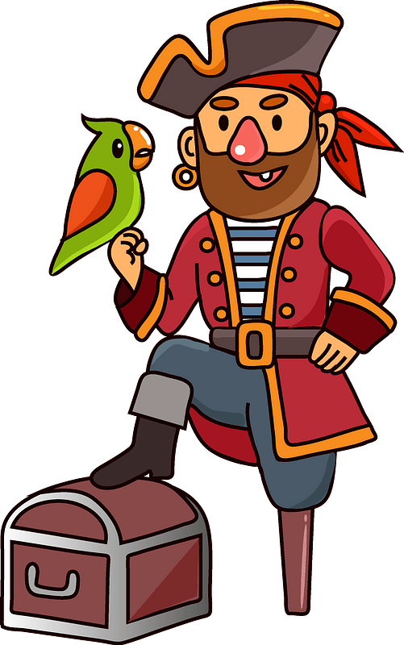

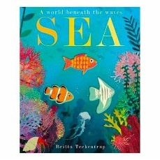
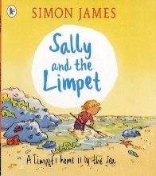
Maths
Number bonds to 10
Part Whole models
3D shapes
Weight, length, height
Odds, evens, doubling, sharing

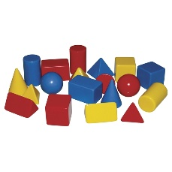
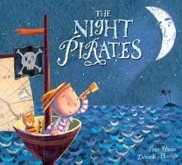
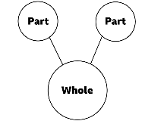

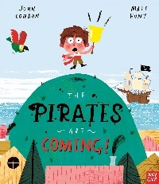
Vocabulary-Chatter Words o
Rockpool

Ocean
Habitat
Anemone
Care
Island
Care
Island
ckpool
Ocean
Habitat
Anemone
Care
Island

Rockpool
Ocean
Habitat
Anemone
Care
Island



