Holly Hill Primary and Nursery School Teaching and Learning Policy

TEACHING AND CURRICULUM INTENT
Every child has the right to the best possible education. We aim to ensure that all pupils, regardless of ability, SEND or circumstances, reach their full potential and gain the skills and knowledge necessary to lead successful lives, as outlined in our school vision:
‘A happy and nurturing environment, providing ambitious and meaningful learning experiences, truly making a difference by keeping all children at the heart of everything we do’
In order to ensure that the teaching at Holly Hill is able to fulfil this vision, we have identified ‘key aspects’ of our school in conjunction with staff and stakeholders.

Key Aspects:
The key aspects of our curriculum, to ensure we deliver our vision, are as follows:
- 2 focus foundation subjects per half term
- Subjects taught discretely, but under an over-arching theme
- A focus on emotional well-being and healthy relationships
- A balance of knowledge and skills
- Interwoven diversity
- Rich vocabulary, quality texts and stories across the curriculum.
- Outdoor learning
- Preparation for adult life and work
- Experiences and opportunities for all
These key aspects are represented across our whole curriculum and are taken into consideration by staff while planning, teaching and evaluating their teaching. Every subject leader will also take these key aspects into account when conducting a self-evaluation of their subject.
A detailed rationale for all of our key aspects can be found on our website under ‘Our Curriculum Rationale and Intent Statement’. https://www.hollyhillschool.co.uk/curriculum/

Organisation and Planning
At Holly Hill, our curriculum is based on the September 2014 National Curriculum for Key Stages 1 & 2 and the Early Years Framework in Foundation Stage. Our curriculum is delivered using a variety of approaches and resources depending on the nature of the subject being taught and the needs of the children (for more details please refer to the separate subject policies).
Our curriculum is a progression model where prior learning is built on from F1 to Year 6.
In EYFS we use the ‘I Cans’ based on the EYFS framework and Development Matters to deliver a progressive curriculum using directed learning opportunities and continuous/enhanced provision to support and deepen learning.
From Year 1 onwards, our classes are organised into mixed year group ‘phases’. Because of this, the long-term curriculum plans are in a 2-year rolling programme format. This ensures that by the time pupils leave each phase, they have covered the full National Curriculum content for these year groups. Exceptions to this are found in elements of Maths and English, where it is imperative that pupils learn new content that is specific to their year group.
When planning lessons, teaching staff ensure that the lesson content is relevant and provides appropriate levels of challenge by using the following:
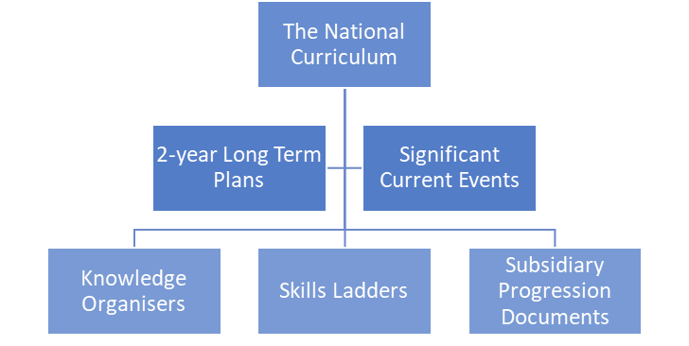

Knowledge-Rich Curriculum
In order to maintain a curriculum that is as broad and balanced as possible, each half term is taught under an umbrella theme title, with Science + 2 foundation subjects as a focus.
Keeping an umbrella theme allows for cross-curricular links to be made as part of the wider schema, as well as providing opportunities for the application of rich vocabulary across those subjects.
A focus on Science and just two other foundation subjects in a half term, gives pupils the time to go ‘in depth’ with those subjects. We believe that part of good preparation for pupil’s later life is having a clear distinction between the different subjects, giving them insight into their own strengths and aspirations. This also enables teacher’s time to plan sequences of learning, which are challenging and rooted in quality subject-specific knowledge.
At Holly Hill we believe that our curriculum enables children to know more and remember more by carefully selecting the key knowledge that pupils need to learn in a unit. We select key knowledge which is one or more of the following:
- Required understanding in order to develop a new skill
- Has particular cultural or subject-specific significance
- Has clear links within a schema of key concepts, building upon prior learning
- Is relevant and meaningful for pupils’ later learning and life
The key knowledge for each unit is collated on a knowledge organiser. These documents are an essential tool for lesson planning, as well as pupil learning and assessment. As such, our knowledge organisers should be used in the following ways:
- Form the basis of what is taught in lessons
- Referred back to throughout the teaching sequence
- Published on individual class web pages for Parents to access
- Stuck in pupil books for reference during lessons and lesson reviews
- Used as part of pupil assessment for foundation subjects
- Matched with the vocabulary and content of classroom displays

Key Concepts:
At Holly Hill we believe that an effective way for pupils to recall and retain knowledge is by using a schema model: understanding the relationships between different pieces of knowledge. While the key aspects of our curriculum reflect the intent behind it, within the teaching of our curriculum there are certain ‘key concepts’ that bind together the knowledge and skills that our pupils learn.
The key concepts of our curriculum can be seen in the diagram below.

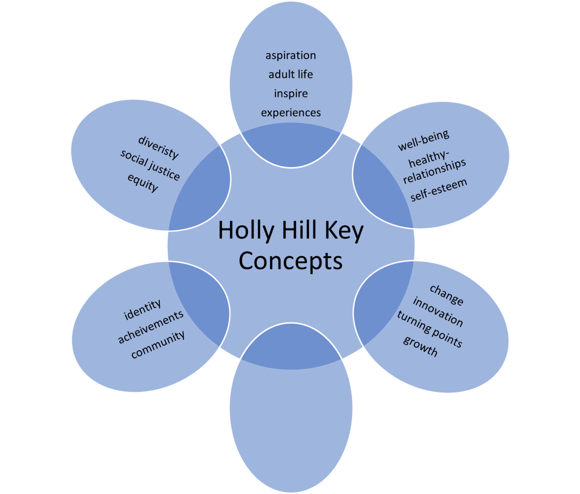

AMBITION

H
appiness

Great Explorers

Moving On Up

The Golden Age

Crime and Punishment

How To Save

The Human Race

Clockwork

Earth heroes

What’s Wonderful About
Stevie?

A
round the world

in 80 days

World War
One

Bizarre Bodies

Animal Adventures

What a performance!

Amazing
Me!

Toys

Enchanted
Worlds

China

Romans

e
engagement

enjoyment

Staff are aware of where their teaching fits into the key concepts in order guide their children in making connections with and unlocking their prior learning. Where appropriate for the age and ability of pupils, they will be able to identify these connections for themselves.’

IMPLEMENTING THE CURRICULUM

Planning Requirements
Long term plans:
These have been written by teachers, and quality assured by subject/school leaders. Long term plans are published on the website for parents to view. The long term plans are concrete documents, which ensure full coverage of the National Curriculum and can only be amended following a review and agreement by leaders.
Medium term plans:
At Holly Hill we place great importance on staff well-being and therefore strive to reduce unnecessary workload wherever possible. One of the ways in which this is done, is by using knowledge organisers in place of medium term planning documents. Each knowledge organiser outlines the key knowledge to be taught, along with vocabulary, core texts and wider opportunities and experiences. Teachers will refer to this document in order to know what teaching and learning needs to take place for that half term and inform their short term plans.
Short term/ daily plans:
Responsibilities for short term and daily lesson plans are shared between the teachers in each mixed-age phase. Planning should take the form of individual lesson presentations using Smart Notebook or PowerPoint software and does not need to be written into a separate lesson plan template.
Teachers should ensure that lesson plans and presentations contain the following:
- Learning objectives for every lesson
- ‘Knowledge Check Ups’ to review learning at the start or end of the lesson
- Links to necessary lesson resources
- Models or worked examples to set consistent expectations
- Key questions or discussion points
- Enough detail that they can be used by cover teachers in case of an emergency

Feedback and Intervention
We believe that quality feedback on pupils’ work is one part of an effective ‘Assessment for Learning’ cycle, alongside planning and teaching. The amount of teacher time spent on written feedback, should not be disproportionate to the time spent on the other aspects of this cycle. The focus of teacher’s feedback should always be that which is most beneficial for the child. We also believe that timely and personalised verbal feedback can be the most powerful in enabling pupils to make progress within the lesson, rather than a review marking of work already completed. Full details of how we use feedback to support effective teaching and learning can be found in the Holly Hill Feedback Policy.
Where pupils are at risk of falling behind, teaching staff should identify the child as requiring an early intervention to address any gaps in knowledge and overcome any barriers to further learning. All interventions are recorded and monitored through the use of Provision Map software. This software also provides staff with an extensive list of available intervention strategies, programmes and resources for use with pupils.
Where concerns regarding a child’s progress and attainment persists, staff should consult with the SENCO (L.Rotherham) and decide on the correct level of support needed using a ‘graduated response.’ For further details of the identification, support and monitoring of pupils with SEND, see the Holly Hill SEND Policy.

Teaching Sequence
For the majority of lessons at Holly Hill, an effective teaching sequence will follow the process below:
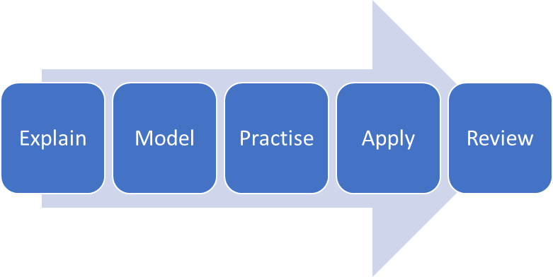
- Explain: The teacher will introduce new concepts, vocabulary and ideas that engage and challenge the thinking of their pupils.
- Model: Teachers demonstrate using strategies such as worked examples, ‘thinking out loud’ and real-world examples.
- Practise: Pupils are given opportunity to experiment and trial the strategies they have been shown.
- Apply: Pupils apply the learning into a different context, example or discussion.
- Review: Key knowledge is reviewed at regular intervals to create changes in long-term memory.
As previously mentioned, we place value on pupils having a clear understanding of different subjects and not seeing their learning as all being ‘work’ or ‘topic’. Because of this, each subject policy has additional guidance on an effective teaching sequence that is specific to that discipline.
Recording and presentation of work

EYFS
In Early Years Foundation Stage, pupils’ work is recorded using a variety of media. Staff ensure that all 17 areas of learning are reflected in the children’s learning journal. Learning Journey’s are used to record significant pieces of work to demonstrate progress throughout the EYFS. Written work is progressively built up throughout the children’s time in EYFS, leading to daily writing opportunities.

KS1
In Key Stage One, all pupils write in pencil. Pupils’ achieving high standards of handwriting are rewarded daily with praise for their presentation achievements. Lessons are recorded in a book which should have a date and learning objective; this should be printed using a Letter Join font. An example layout and success criteria can be found in the Holly Hill feedback policy. Evidence of pupils’ work can be found in the following places:
- English book
- Wow Write
- Maths book
- Science
- Creative Arts
- Humanities
- Jigsaw Journal

KS2
In Key Stage Two, all pupils will write in a blue ink pen by the end of Year 3.
Each lesson recorded in a book should have a date and learning objective. This can be written by the child or printed using a Letter Join font. An example layout and success criteria can be found in the Holly Hill feedback policy.
Evidence of pupils’ work can be found in the following places:
- English book (Red 8mm lined)
- Maths book (Orange 1cm square)
- Science (Blue 8mm lined)
- Creative Arts: Music, D.T., Computing, (Purple 8mm lined)
- Humanities: History, Geography (Green 8mm lined)
- Religious Education (Yellow 8mm lined)
- Jigsaw Journal (light purple 8mm lined)
- French folder (Clear ziplock)
- Sketch book (Black, unlined) Further presentation consistencies:
- Handwriting is taught using the Letter Join scheme (see English policy)
- Resources created by staff should also model the Letter Join font
- Date and Learning Objectives should be underlined in pencil
- Mistakes should be crossed out using pencil and a ruler
- All drawings, including technical diagrams should be completed in pencil - Pupils should use pencil crayons for any colouring in books

Timetables
The basis of a daily timetable at Holl Hill can be seen below.
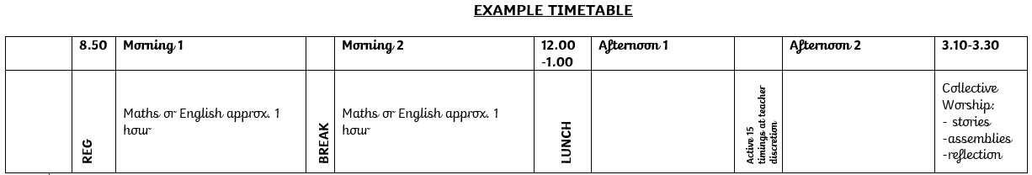
Within this timetable structure, there are certain daily and weekly timetable commitments that teachers should adhere to:
- Approx 1 hour of Maths daily
- Approx 1 hour of English daily
- Daily Phonics in FS and KS1
- Daily Spelling and Grammar in KS2
- Daily 10-15min Arithmetic and fluency practise
- Whole Class guided reading and individual reading (See English policy)
- Monday afternoon JIGSAW session.
- Approx 2 hours a week Science
- Approx 2 hours a week P.E. (including Active 15)
There will be occasional times when variations in the timetable will be either unavoidable or beneficial to the learning of the pupils. However, we believe that routine and predictability are vital elements for pupils sense of security and well-being and as such, any changes to the timetable for a longer period should be discussed with the Headteacher.

Learning Environment
At Holly Hill, we believe that the learning environment should be purposeful, and above all, be for the benefit of the pupils. Staff should be mindful of the cognitive load the that an overstimulating environment can place on pupils and endeavour to create classrooms that are calm and inviting. One way to achieve this, it would be recommended that displays are limited to the display boards provided within the classrooms.

As a minimum, each classroom should have the following:
- An English working wall
- A Maths working wall
- Evidence of pupil’s best work to be celebrated
- A visual timetable
- Resources that are clearly labelled for pupils to access independently

ASSESSMENT
EYFS
- On entry to FS2, all children complete a government baseline assessment.
- Children’s formative assessments take place continuously using ‘I can’ statements and Tapestry for recording and evidencing.
- Summative assessments take place at the end of every term.
- Statutory assessments for FS2 children take place at the end of the Summer term and are reported to the DfE.
Key Stages 1 and 2
- Formative assessments for core subjects take place continuously and are recorded on ‘year group objective’ sheets. These sheets are colour coded and shared with parents termly.
- Summative assessments take place termly using the following methods:
- Year 1 – Teacher Assessment
- Year 2 – Combination of SATs and teacher assessment for reading, writing and maths
- Years 3, 4 and 5 – NFER for reading and maths, teacher assessment for writing
- Year 6 – SATs and teacher assessment for writing

Statutory Assessments
- Assessment in phonics for Year 1 children take place in June and are reported to the DfE.
- Statutory assessments in Reading, Writing and Maths for Year 2 children take place in June and are reported to the DfE.
- Statutory assessment in Times Tables for Year 4 children take place in June and are reported to the DfE.
- Statutory assessments in Reading, Writing and Maths for Year 6 children take place in June and are reported to the DfE.

HOMEWORK
At Holly Hill we recognise the valuable part that homework can play in a child’s education. EEF also states that “homework has an impact by enabling pupils to undertake learning to practice and consolidate skills”. We also recognise that children have many other rich and varied learning experiences that they enjoy during their evenings, weekends and holidays. We appreciate and value that they may attend clubs and have wider interests outside of school, and also that they need time to socialise with friends and family, play, relax, and have fun. With this in mind, and as we all want our children to be balanced, happy human beings, we are keen to get the level and amount of homework that we send home right for a child’s age. We believe that homework only works if we have parents and children’s support and enthusiasm
To reflect this finding, homework at Holly Hill focuses on three key aspects of the curriculum:
- reading
- spellings
- times tables

Reading
The DfE Reading Framework states that “Reading is fundamental to education”, and that “Pupils who find it difficult to learn to read are likely to struggle across the curriculum”. We also believe that reading unlocks the rest of the curriculum and for this reason, prioritise regular reading practice at home in our homework policy.
Our expectation is that children read 5 times per week as a minimum. We invest in high quality reading diaries so that parents and children can record their reading and can be proud of their achievements.
This will be reading to an adult in the younger years to practise phonics application and our phonics scheme ‘Little Wandle’ clearly states the books that our children learning phonics should access and take home. As our children become more fluent in reading, they will begin to read for pleasure and this reading may become more independent.

Spellings
Providing spellings supports our intent to introduce and expose children to a varied and rich vocabulary. Being able to spell these words enables children to begin using them in their independent writing. Consultation with parents showed that practising spellings was an aspect of homework that parents felt was a manageable task that they felt confident to support with.

Times tables
Times tables is prioritised in our homework policy as they are the foundation and building block for so many mathematical concepts. Quick retrieval of times tables facts enables more efficient calculations in other areas of maths. This quick recall and fluency is developed through regular practise which parents can provide easily in the home environment.

ROLES AND RESPONSIBILITIES
The governing body is responsible for:
- Ensuring reports are provided by the headteacher and subject leaders and that action is taken where areas are identified as requiring improvement.
- Having a good understanding of pupil progress data in order to ask challenging questions.
- Visiting the school to increase knowledge of classroom activity and conducting the following activities:
  - Observing lessons
  - Viewing recordings of lessons as appropriate
  - Viewing samples of pupils’ work
  - Talking to pupils about their experiences
  - Talking to teachers about their experiences
  - Reporting their findings to the entire governing board
The SLT is responsible for:
- Taking a general overview of the atmosphere in the school on a day-to-day basis by visiting classes and talking to staff and pupils.
- Liaising with parents to ensure needs are being met.
- Working in classrooms, including teaching, regularly.
- Carrying out focussed monitoring activities e.g. lesson visits and book looks.
- Reviewing and commenting on planning, knowledge organisers and coverage maps
- Discussing all summative data with staff.
- Discussing pupil progress with class teachers termly.
- Completing a self-evaluation of the school’s quality of teaching.
- Reporting on the quality of teaching and learning in the governors’ report.
- Acting as role models for teaching staff, ensuring the ‘key aspects’ of our curriculum are upheld.
- Ensuring the School Development Plan is ambitious and has a positive impact on teaching and learning.
Subject Leaders are responsible for:
- Developing and reviewing curriculum policies and schemes of work in collaboration with colleagues.
- Taking accountability for the progress of pupils in their given subject.
- Reporting on the effectiveness of the curriculum to the SLT and the governing body.
- Providing professional training in their given subject to the governing body as required.
- Carrying out all other responsibilities, including curriculum monitoring as outlined in the Subject Leader Handbook.
Teaching staff are responsible for:
- Monitoring and evaluating their teaching.
- Planning lessons that take into account the ‘key aspects’ of our curriculum.
- Delivering a curriculum that is broad and balanced.
- Inspiring and encouraging pupils to become lifelong learners.
- Ensuring that the knowledge and skills pupils are taught are challenging and appropriate for the age and abilities of the pupils they teach.
- Seeking professional dialogue and feedback from colleagues or the SLT.
- Reviewing and evaluating their planning (including the content of Knowledge Organisers) regularly.
- Collaborating with colleagues to moderate pupil achievement.
- Assessing the learning and progress of their pupils.
- Reporting pupil progress to parents, at Parents evenings and in termly reports.
- Participating in analysis of summative data, timetabling interventions and pupil progress reviews.
- Adapting their teaching to meet the needs of all pupils within their class (See SEND policy).
Pupils are responsible for following the Holly Hill Way: • Respecting our school.
- Respecting each other
- Respecting themselves.
- Always trying their best.
Parents are responsible for: .
- Ensuring their child has suitable uniform or outerwear for the season. In EYFS where uniform is not mandatory, parents must ensure their child has clothes suitable for outdoor play.
- Ensuring their child arrives at school on time and with good attendance.
- Supporting their child with Early Reading
- Supporting their child with homework tasks as appropriate for their age and ability (e.g. Upper Key Stage 2 children will be able to complete most tasks independently).
- Encouraging their child to value education and see its benefits for their future life and wellbeing.
- Discussing their child’s progress at parent’s meetings and reviews.
- Keeping a positive home-school relationship.

Written and approved: September 2025

To be reviewed: September 2026

