F1 Curriculum Organiser – Commotion in the Ocean – Summer 2 2025
Opportunities and Experiences
Half Termly Bake Off – 50p donations greatly appreciated
Pirate Day – 10th July
Sports Day – 19th June
EYFS Graden Party-25th June
Transition Days -30th June and 1st July

E
Key Knowledge and Skills
Communication and Language
Know that information can be gathered by asking ‘why’ questions.
Know that stories can be retold using a story map.
I can ask and respond to why questions.
I can retell a longer story.
Expressive Arts and Design
Know the melodic shape (moving melody, such as up and down, down and up) of familiar songs.

Know that art exists all around us.
Know that you can make art with a range of different materials.

I can sing the same pitch of a tone sung by another person (‘pitch match’).

I can perform a simple rhythm.
I can repeat (short rhythmic and melodic) patterns.
I can they identify reasons why I like some music more than others.
I can join different materials and explore different textures.
Understanding the World
Know new vocabulary when talking about sea life creatures.
Know that living creatures can have similarities and differences.
Know that there is land and sea.
I can talk about the things they have observed such as plants, animals, natural or found objects.
I can ask questions about their familiar world, such as the place they live or the natural world.
I can talk about different features on a simple treasure map.
I can talk about where I live and use use key vocabulary when looking at a simple map.

Our Key Texts
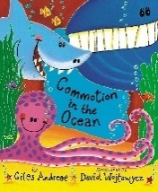
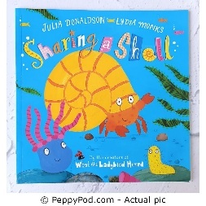
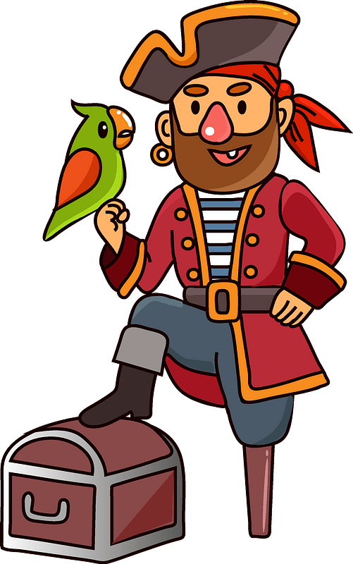

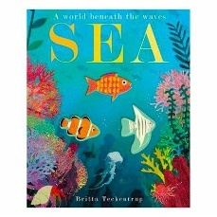
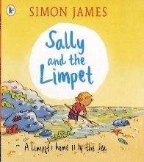
Maths
Recap numbers 1-5
Positional Language
2D shapes
Patterns
Sorting

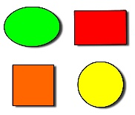
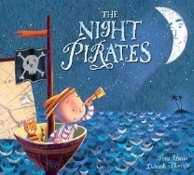


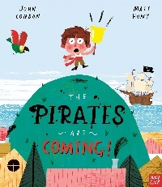
Vocabulary-Chatter Words o
Rockpool

Ocean
Habitat
Anemone
Care
Island
Care
Island
ckpool
Ocean
Habitat
Anemone
Care
Island

Rockpool
Ocean
Habitat
Anemone
Care
Island



