

Whole School Child Protection Policy
Holly Hill Primary and Nursery School
September 2025

Head Teacher | Leanne Steed
Senior Leader(s) available for contact  in the absence of DSLs | Tia Watson
Senior Designated Safeguarding Lead | Leanne Steed
Deputy Designated Safeguarding Lead | Jayne Leal
Additional Safeguarding Leads | Tia Watson and Lindsey Rotherham
Designated Teacher for Children in Care | Leanne Steed
Safeguarding Governor | Robin Edwards
LA Safeguarding Children in Education Officer | Zain Iqbal - zain.iqbal@nottscc.gov.uk
Local Authority Designated Officer | LADO@nottscc.gov.uk - 0115 804 1272
Policy approved by the Governing Body | 15.10.2025
Date for Review | September 2026


Table of Contents
- Policy Introduction and Ethos
Purpose and scope of policy, school ethos, Whole school approach, Annual review, and public availability
- Contextual Safeguarding at Holly Hill Primary and Nursery school
Local safeguarding concerns, curriculum and school responses, school commitment
- Statutory Duties and Legal Framework
KCSIE 2005, Working Together 2023, Education Act 2002, Children Act 1989, Children and Social Work Act 2017, Counter-Terrorism 2015 (Prevent Duty), SEND code of practice, Teacher’s Standards
- Aims and Responsibilities
Roles of governors, headteacher, DSLs and Staff, Multi-agency working expectations, whole-school safeguarding culture
- Reporting concerns
Procedure for staff to report concerns, immediate referral guidance (MASH/Police), recording and escalation protocols, confidentiality, and consent principles
- Supporting Pupils
Early help and pastoral support, vulnerable groups (SEND, mental health, young carers, etc.), promoting resilience and self-esteem, staff awareness of trauma informed practice, use of restrictive practices
- Safeguarding in the Curriculum
RSHE, PSHE and wider curriculum integration, topics (online safety, exploitation, domestic abuse, FGM, radicalisation), empowering pupils to seek help and understand risk
- Online Safety
Filtering and monitoring systems, risks from AI, mobile tech and social media, staff responsibilities and curriculum coverage, reference to DfE digital standards
- Working with Parents/Carers
Consent and information sharing, communication about safeguarding responsibilities, support for families and transparency
- Children in Care and Previously in Care
Role of designation teacher, PEP reviews and Virtual School liaison, Private fostering awareness, Kinship Care and reporting duties
- Particularly Vulnerable Groups
Identification and support strategies, reasonable adjustments for protected characteristics, specific risks (FGM, forced marriage, exploitation)
- Prevention in the Curriculum
Embedding safeguarding across subjects, promoting protective behaviours and resilience, age-appropriate teaching on risk, empowering pupils to seek help, staff responsibilities in delivering preventative education
- Child on Child abuse and Sexual Harassment
Definitions and types of abuse, procedures for prevention, reporting and response, support for victims and perpetrators, NSPCC, Lucy Faithful Foundation, and other resources
- Allegation Against Staff
Procedures for managing allegations and low-level concerns, role of LADO and case manager, whistleblowing, and safeguarding culture

- Professional Development and Training
Induction and refresher training timelines, DSL and governor training expectations, whole-school safeguarding updates, training register and evaluation,
- Identification for visitors
Expectations for visiting professionals, ID and DBS verification, Nottinghamshire DBS letter process
- Appendices
Safeguarding concerns flowchart, Body Map guidance and proforma

Section A - Policy Introduction & Ethos
The purpose of this policy is to detail how HOLLY HILL PRIMARY AND NURSERY SCHOOL ensures that all children and young people enrolled in the school are protected and safeguarded from harm, reflecting current legislation, known best practices, and compliance with relevant government guidance.
This policy applies to all staff, governors, volunteers, and visitors, and outlines the school’s commitment to safeguarding and promoting the welfare of children as a core part of its ethos and values. Safeguarding is everyone’s responsibility, and this policy sets out the expectations for a whole-school approach to child protection.
This policy is informed by the statutory guidance Keeping Children Safe in Education (KCSIE) 2025 and Working Together to Safeguard Children 2023, which together set out the responsibilities of schools and other agencies in identifying, responding to, and preventing harm to children.
School Ethos
At HOLLY HILL PRIMARY AND NURSERY SCHOOL, we are committed to creating a safe, inclusive, and nurturing environment where every child feels valued, respected, and supported. We recognise that children’s welfare is paramount and that safeguarding is integral to all aspects of school life, including teaching and learning, pastoral care, and extracurricular activities. We aim to foster a culture of openness, trust, and transparency, where safeguarding concerns are taken seriously and responded to appropriately.
At Holly Hill we care for and respect:
- ourselves
- each other, and
- our school.
- We choose to be the best we can be.

Whole School Approach
Safeguarding and child protection are embedded across the school’s policies, procedures, and practices. All staff receive regular training and updates to ensure they understand their roles and responsibilities. The school works in partnership with children, parents/carers, and external agencies to promote a culture of vigilance and proactive safeguarding. Throughout this policy, the term ‘whole-school approach’ is used to refer to a unified safeguarding strategy across the entire education setting, including colleges.
The following policies contribute to the school’s whole-school approach to safeguarding:
- Staff Code of Conduct
- Child Behaviour Policy
- Anti-Bullying Policy
- Child-on-Child Abuse Policy
- Online Safety Policy
- Safer Recruitment Policy
- Whistleblowing Policy
- Attendance Policy
- Allegations Against Staff Policy
- RSHE (Relationships, Sex and Health Education) Policy
- SEND Policy
- Data Protection and Information Sharing Policy
- Educational Visits Policy
Each of these policies is informed by relevant sections of Keeping Children Safe in Education 2025 and reflects statutory guidance, best practice and the school’s safeguarding ethos.
Annual Review and Public Availability
This policy is reviewed, or sooner if required due to changes in legislation or guidance. The review is led by THE HEADTEACHER and approved by the governing body. The policy is made publicly available via the school’s website and can be requested in alternative formats if needed.
Section B - Contextual Safeguarding at Holly Hill Primary and Nursery School
Contextual safeguarding recognises that the risks children face are often beyond the control of their families and can occur in a variety of settings such as peer groups, schools, colleges and neighbourhoods. Our school is dedicated to understanding and addressing these wider environmental factors that may pose a threat to the safety and well-being of our students.
At HOLLY HILL PRIMARY AND NURSERY SCHOOL, we are aware of our main contextual safeguarding issues and use our curriculum to ensure all children are educated about them. These may include, but are not limited to, child criminal exploitation (CCE), child sexual exploitation (CSE), online harm, child-on-child abuse, radicalisation, and local patterns of domestic abuse or substance misuse. We work closely with our local safeguarding partners to monitor emerging risks and adapt our provision accordingly.
Our Commitment
At HOLLY HILL PRIMARY AND NURSERY SCHOOL, we are committed to proactively identifying and responding to the contextual safeguarding risks that affect our pupils both within and beyond the school environment. We recognise that safeguarding does not stop at the school gates and that children may be exposed to harm in their peer groups, online spaces, neighbourhoods, and wider communities.
To uphold this commitment, we will:
- Collaborate with students, families, and the wider community to understand the lived experiences of our pupils and to co-develop effective safeguarding responses.
- Provide ongoing training for all staff to recognise the signs of contextual harm, including exploitation, child-on-child abuse, and online risks, and to respond confidently and appropriately.
- Embed contextual safeguarding into our curriculum, ensuring pupils are equipped with the knowledge and skills to recognise risk, seek help, and make safe choices.
- Implement robust policies and procedures that reflect the unique safeguarding needs of our school community and are informed by local intelligence and national guidance.
- Engage with external agencies and safeguarding partners, including police, health, and social care, to share information, coordinate support, and contribute to multi-agency safeguarding efforts.
- Monitor and review safeguarding data and trends to ensure our approach remains responsive, evidence-informed, and tailored to emerging risks.
This commitment underpins our whole-school approach to safeguarding and reflects our belief that every child deserves to feel safe, supported, and empowered—wherever they are.
We encourage all members of our school community to contribute to our safeguarding efforts by staying informed, being vigilant, and working together to create a safe environment for everyone. If there are any concerns or suggestions, please do not hesitate to contact our safeguarding team
Section C - Statutory Duties and Legal Framework
Our safeguarding arrangements are shaped by both national legislation and statutory guidance, as well as local safeguarding expectations in Nottinghamshire. Together, these establish the legal duties and operational standards our school must meet to keep children safe.
1. National Legislative Duties
We carry out all functions with a view to safeguarding and promoting the welfare of children in line with:
- Education Act 2002
  - Section 175 - duty on local authorities, governing bodies of maintained schools, and FE colleges.
  - Section 157 - equivalent duty on proprietors of independent schools, academies, and free schools.
- Education (Independent School Standards) Regulations 2014
- Non-Maintained Special Schools (England) Regulations 2015
- Children Act 1989 & Children Act 2004 - duties to safeguard and promote welfare, including participation in local multi-agency safeguarding arrangements.
- Children and Social Work Act 2017 (Section 16H) - duty to provide information to safeguarding partners when requested.
- Education and Training (Welfare of Children) Act 2021
- Counter-Terrorism and Security Act 2015 (Section 26) - Prevent Duty.
- Teachers’ Standards (2021) - professional responsibility to safeguard pupils.
- Childcare Act 2006 & Childcare (Disqualification) Regulations 2018
- Serious Crime Act 2015 - mandatory duty for staff to report known cases of Female Genital Mutilation (FGM) in under-18s disclosed to them during their work.
2. Statutory Guidance
We have regard to:
- Keeping Children Safe in Education (KCSIE) 2025
- Working Together to Safeguard Children (2023)
- Working Together to improve school attendance (2024)
- Information Sharing Advice for Practitioners (DfE)
- Relevant national guidance on safer recruitment, online safety, and specific safeguarding issues.
These documents set out requirements including:
- A whole-school approach to safeguarding.
- Clear referral and reporting procedures.
- The appointment of a suitably trained Designated Safeguarding Lead (DSL) with appropriate resources and time.
- Safer recruitment practices and maintenance of a Single Central Record.
- Ongoing staff training and annual safeguarding updates.
- Systems for children to express concerns and be listened to.
- Procedures for managing allegations and low-level concerns.
- Online safety measures, including filtering and monitoring in line with the DfE Filtering and Monitoring Standards (2023).
- Compliance with legal notification duties (e.g. private fostering, pupil deletions from roll).
3. Local Safeguarding Expectations (Nottinghamshire)
At HOLLY HILL PRIMARY AND NURSERY SCHOOL, we are committed to meeting the expectations set out by the Nottinghamshire Safeguarding Children Partnership (NSCP). These include:
- Following NSCP multi-agency procedures and ensuring they are reflected in our school policies.
- Engaging fully in local safeguarding arrangements, including early help pathways, child protection conferences, and multi-agency risk assessments.
- Completing the annual Section 175/157 safeguarding audit and acting on any identified areas for improvement.
- Participating in serious case reviews, child safeguarding practice reviews, and learning reviews where appropriate.
- Liaising with the Local Authority Designated Officer (LADO) within one working day of any allegation against a person working with children, including volunteers and third-party providers.
- Maintaining comprehensive safeguarding records to inform review of concerns and ensure effective information sharing with safeguarding partners.
- Ensuring all staff are aware of local referral routes, including to the Multi-Agency Safeguarding Hub (MASH).
- Promoting a culture of listening to children, with clear systems for pupils to raise concerns and be taken seriously.
4. Core Duties in Practice
To fulfil our statutory and local safeguarding obligations, we will:
- Engage with local safeguarding partners and act on requests for information.
- Appoint and support a Designated Safeguarding Lead (and deputies, where applicable) with the authority, training, and time to carry out the role.
- Maintain accountability for safeguarding across leadership and governance.
- Operate safer recruitment, including DBS/barred list checks, prohibition checks, right-to-work checks, and online searches for shortlisted candidates.
- Keep an up-to-date Single Central Record covering all required staff, volunteers, and governance.
- Check suitability for early/later years provision in line with the Childcare Disqualification Regulations.
- Refer to the DBS where an individual is removed from regulated activity due to safeguarding concerns.
- Consider referral to the Teaching Regulation Agency in cases of serious misconduct.
- Meet the Prevent Duty, including risk assessment, training, and referrals.
- Report known cases of FGM in under-18s directly to the police (teachers only).
- Notify the local authority about private fostering arrangements and deletions from roll.
- Provide induction and annual safeguarding updates to all staff, ensuring familiarity with Part 1 of KCSIE and relevant annexes.
- Implement and review online safety measures including filtering, monitoring, and cyber security standards.
Section D - Aims and Responsibilities
At HOLLY HILL PRIMARY AND NURSERY SCHOOL, safeguarding is a shared responsibility that demands clear leadership, accountability, and a whole-school commitment to protecting children. We strive to create a safe, inclusive, and nurturing environment where pupils feel secure, valued, and heard. All staff are expected to understand their safeguarding responsibilities and respond promptly to any concerns. Safeguarding is embedded throughout school life—from the curriculum and pastoral care to staff conduct—ensuring it remains a central focus. We work in close partnership with families and external agencies to safeguard children from harm, and our approach is firmly rooted in the principles outlined in Working Together to Safeguard Children 2023 and Keeping Children Safe in Education 2025.
1. Whole-School Safeguarding Culture
We are committed to maintaining a whole-school approach to safeguarding that reflects vigilance, openness, and accountability. This commitment is reflected in the systems we have in place to ensure pupils can express concerns and be taken seriously, and in the safe culture we foster for whistleblowing and raising low-level concerns in line with statutory guidance. Staff are supported to feel confident in reporting concerns and challenging unsafe practices. Safeguarding is fully integrated into our policies, curriculum, and daily routines, ensuring it is part of the fabric of school life. Our approach is inclusive, addressing the needs of all pupils, including those with SEND and additional vulnerabilities. We also recognise that safeguarding extends beyond the school gates, encompassing online safety, peer relationships, and wider community contexts.
2. Roles and Responsibilities
Governing Body
The governing body ensures strategic oversight of safeguarding by:
- Appointing a trained link governor for safeguarding and receiving regular reports from the DSL.
- Ensuring all governors have read Part 2 of KCSIE 2025 (and at least one governor reads the full guidance).
- Ensuring safeguarding policies and procedures are in place, reviewed annually, and aligned with Nottinghamshire Safeguarding Children Partnership (NSCP) thresholds and protocols.
- Monitoring the Single Central Record to ensure compliance with all statutory vetting checks, including DBS and Section 128 checks.
- Overseeing safer recruitment practices and ensuring a safeguarding culture throughout the organisation.
- Appointing a Designated Safeguarding Lead from the senior leadership team and ensuring effective cover arrangements.
- Ensuring governors themselves are subject to appropriate checks and safeguarding training.
- Engaging in the annual Section 175/157 safeguarding audit and strategic reviews of safeguarding practice.
- Ensuring safeguarding is a standing item at governing body meetings and providing strategic challenge.
- Ensuring the school’s online safety arrangements, including filtering and monitoring, comply with the DfE Filtering and Monitoring Standards (2023).
Headteacher
The headteacher provides operational leadership of safeguarding by:
- Ensuring all staff, volunteers, and contractors receive safeguarding induction before commencing work.
- Allocating sufficient time, training, and resources to enable the DSL to fulfil their role.
- Promoting a culture where staff feel confident to raise concerns about pupils or practice.
- Liaising with the Local Authority Designated Officer (LADO) in cases of allegations against staff, including supply staff and volunteers.
- Ensuring safeguarding concerns such as poor attendance, children missing education, forced marriage, or domestic abuse are identified and acted upon.
- Overseeing regular review of the child protection policy to ensure compliance with KCSIE, Working Together, and local procedures.
- Ensuring staff are aware of Operation Encompass and domestic abuse notifications.
- Ensuring online safety education is embedded across the curriculum in line with statutory guidance.
- Ensure attendance concerns are treated as safeguarding issues, particularly where persistent absence may indicate welfare concerns. Implement the statutory expectations of Working Together to Improve School Attendance (2024), including early intervention and multi-agency collaboration.
Designated Safeguarding Lead (DSL)
The DSL is the lead professional for safeguarding and child protection and will:
- Have a clearly defined role and be provided with sufficient time, supervision, and support to carry it out.
- Complete updated safeguarding training at least every two years.
- Promote a culture of listening to children and taking account of their wishes and feelings.
- Make referrals to children’s social care, police, or the Channel programme where required.
- Liaise with safeguarding partners and attend multi-agency meetings and case conferences.
- Maintain secure, accurate, and confidential safeguarding records.
- Ensure all staff know how to report concerns and are familiar with safeguarding procedures.
- Lead on online safety, including the school’s filtering and monitoring systems using.
- Ensure safeguarding records are transferred securely when pupils move school and that support is continuous during transitions.
- Liaise with the senior mental health lead and external support agencies as appropriate.
- Be available during school hours and ensure Deputy DSLs can provide cover if absent.
- Meet regularly with Deputy DSLs to review caseloads and procedures.
All Staff
All staff, including volunteers and visiting professionals, must:
- Read and understand Part 1 of KCSIE 2025 (or Annex A, where appropriate) and the school’s child protection policy, and any other policies the school deems appropriate.
- Recognise signs of abuse, neglect, exploitation, and contextual harm.
- Report concerns immediately using the school’s safeguarding procedures.
- Record concerns accurately and provide any additional relevant information.
- Share information with the DSL and, if necessary, make direct referrals to children’s social care.
- Follow the school’s low-level concerns procedures if worried about an adult’s behaviour.
- Undertake safeguarding training at induction and at regular intervals thereafter.
- Maintain an attitude of “it could happen here” in relation to safeguarding.
- Supervise pupils appropriately when using online platforms and report any breaches in filtering or monitoring.
- Monitor attendance patterns and report persistent absence or children missing education.
- Be aware of specific safeguarding risks including FGM (known cases), forced marriage, honour-based abuse, exploitation, extremism, and serious violence.
- Support statutory assessments and work with social workers when required.
- Raise concerns about safeguarding practice (whistleblowing) when needed.
3. Multi-Agency Working
We actively participate in Nottinghamshire’s multi-agency safeguarding arrangements by:
- Sharing information lawfully and effectively with safeguarding partners, in line with the Information Sharing Advice for Practitioners (DfE).
- Participating in early help assessments, child protection plans, and strategy meetings.
- Understanding and applying local thresholds and protocols for assessment and referral.
- Responding promptly to requests for information from safeguarding partners.
- Allowing access to children’s social care for assessments under Section 17 (child in need) or Section 47 (child protection) of the Children Act 1989.
- Following the NSCP escalation procedures if disagreements arise about safeguarding decisions.
- Engaging in child safeguarding practice reviews, serious case reviews, and local learning events.
- Contributing to local safeguarding developments, including through the Nottinghamshire Education Subgroup.
4. Staff Induction and Training
All staff, governors, and volunteers must receive safeguarding induction appropriate to their role before commencing work. This includes:
- Copies of key policies.
- Identification of the DSL, deputies, and safeguarding governor.
- Familiarisation with reporting procedures and safeguarding systems.
- Confirmation of having read Part 1 (or Annex A) of KCSIE 2025.
Safeguarding training is refreshed regularly and includes updates on emerging risks, online safety, and local procedures. Governors receive training to provide strategic challenge and oversight. DSLs receive enhanced training including data protection and cyber security.
E - Reporting Concerns
At HOLLY HILL PRIMARY AND NURSERY SCHOOL, safeguarding is everyone’s responsibility. All staff, volunteers, and visitors must report any concerns about a child’s welfare, safety, or behaviour immediately. We follow clear procedures for reporting, recording, and escalating concerns in line with statutory guidance and local protocols.
1. Immediate Response to a Disclosure
If a child, parent, or carer shares a concern or discloses abuse:
- Listen calmly and attentively, allowing them to speak freely.
- Use open-ended questions (e.g., “Can you tell me what happened?”).
- Avoid leading or investigative questions.
- Reassure them that they are being taken seriously and will be supported.
- Do not promise confidentiality — explain that you must share the information to keep them safe.
- Avoid physical comfort gestures unless clearly appropriate.
- Do not ask the child to write a statement or sign your notes.
- Record the child’s exact words and any wishes or feelings expressed on CPOMS.
- Report verbally to the DSL when time is of the essence as well as recording on CPOMS.
- Where possible, manage disclosures with two staff present, ideally including the DSL or Deputy DSL.
2. Reporting Procedures
Staff must:
- Report concerns to the DSL or Deputy DSL as soon as possible, and by the end of the day at the latest.
- If the DSL is unavailable, report to the most senior person on site and ensure the DSL is informed later.
- In emergencies, call 999 or make a direct referral to Nottinghamshire MASH — anyone can make a referral.
- Do not delay reporting due to uncertainty — if unsure, speak to the DSL.
- Do not view, copy, or share images in cases involving nudes/semi-nudes.
- Share information only on a need-to-know basis.
- Report concerns about staff (including supply staff and volunteers) to the Headteacher, or to the Chair of Governors if the concern is about the Headteacher.
Examples of concerns include:
- Signs of abuse, neglect, exploitation, or radicalisation
- Child-on-child abuse, sexual violence, or harassment
- Domestic abuse, forced marriage, FGM, or honour-based abuse
- Online abuse or inappropriate adult communication
- Private fostering arrangements
- Changes in behaviour, attendance, or presentation
- A person who may pose a risk to children living in the same household
3. Recording and Escalation Protocols
All concerns, decisions, and actions must be recorded:
- Record immediately, and by the end of the same working day on the school’s secure safeguarding system, CPOMs.
- Include date, time, context, and direct quotes or observations.
- Record facts, not assumptions, and include your full name and role.
- Note non-verbal behaviour and physical indicators (e.g., “bruise on right arm above elbow”).
- Tag child protection files separately from the main pupil file.
- Transfer safeguarding records securely when a pupil moves school (within 5 working days) and obtain confirmation of receipt.
- Retain safeguarding records securely until the pupil reaches age 25.
The DSL:
- Monitors records for patterns and ensures appropriate escalation.
- Presses for reconsideration or escalates using NSCP procedures if concerns persist or outcomes are unclear.
4. Confidentiality and Consent
- Information is shared in line with the Information Sharing Advice for Practitioners (DfE), the Data Protection Act 2018, and UK GDPR.
- Consent is not required to share information if a child or adult is at risk of significant or serious harm.
- Parents/carers are usually informed, unless doing so would increase risk.
- All non-routine information sharing is logged appropriately.
- If in doubt, staff should consult the DSL or Deputy DSL.
5. DSL Actions Following a Concern
The DSL or Deputy DSL will:
- Assess urgency and immediate safety needs.
- Review the child’s presentation and known history.
- Inform relevant staff on a need-to-know basis.
- Use appropriate assessment tools (e.g., body maps, contextual safeguarding tools).
- Refer to MASH, Prevent, or Police where necessary.
- Consider early help or internal pastoral support.
- Notify the local authority of private fostering arrangements.
- Follow up referrals within 48 hours and maintain contact with social workers.
- Attend and contribute to strategy meetings, child protection conferences, and core groups.
- Share reports with parents/carers, and where appropriate, the child.
- Document all actions, decisions, and rationales in the safeguarding record.
- Use escalation procedures if concerns are not addressed or outcomes are unclear.
FGM Mandatory Reporting:
In known cases of Female Genital Mutilation (FGM), teachers must report directly to the police via 101 by the end of the next working day, in addition to informing the DSL.
6. Support for Staff and Pupils
We recognise that reporting safeguarding concerns can be distressing. Support is available through:
Support for Staff:
- Named link staff for safeguarding cases who act as a point of contact and support.
- Access to helplines, counselling, and peer support, including referral to external services where appropriate.
- Time-out or supervision opportunities for staff affected by disclosures or safeguarding processes.
- Confidentiality and respectful handling of sensitive information to protect staff wellbeing.
- Whistleblowing and complaints procedures to raise concerns about unsafe practice or safeguarding failures.
- Staff wellbeing and supervision sessions, where available, to reflect on safeguarding practice and emotional impact.
Support for Pupils:
- Pastoral support from trusted adults.
- Safe spaces within school where pupils can go if they feel overwhelmed or need time out.
- Regular check-ins for pupils involved in safeguarding concerns, including those subject to child protection or early help plans.
- Empowerment through education, including RSHE and PSHE lessons that build resilience, self-esteem, and understanding of safeguarding risks.
Staff should speak to the DSL or Headteacher if they feel a pupil requires additional support following a safeguarding concern.
F - Supporting Pupils
At HOLLY HILL PRIMARY AND NURSERY SCHOOL, we are committed to ensuring that all pupils feel safe, supported, and able to thrive. Safeguarding is not only about protecting children from deliberate harm but also about creating a nurturing environment in which they are valued, respected, and encouraged to achieve their full potential.
We recognise that some children may require additional support to stay safe, and we are dedicated to identifying and addressing these needs at the earliest opportunity. Our approach is informed by Keeping Children Safe in Education (KCSIE) 2025, Working Together to Safeguard Children 2023, and the Nottinghamshire Safeguarding Children Partnership (NSCP) procedures.
1. Whole-School Commitment to Support
- We aim to create a caring, positive, safe, and stimulating environment which promotes the social, physical, emotional, and moral development of all pupils.
- We ensure pupils know they can talk to trusted adults and that their voices will be heard and acted upon.
- Safeguarding and pupil wellbeing are embedded throughout our curriculum, pastoral support, and wider school activities.
2. Early Help and Pastoral Support
- We are committed to the principles of early identification and intervention, in line with the Nottinghamshire Pathway to Provision.
- Staff are trained to recognise when children may benefit from early help and to raise these concerns with the DSL.
- The DSL will consider early help assessments and referrals to external services, working closely with families to provide coordinated support.
- We make use of local initiatives such as Operation Encompass, ensuring staff are informed of incidents of domestic abuse and can provide timely support in school.
3. Supporting Vulnerable Groups
We recognise that some pupils are more vulnerable to safeguarding concerns. This includes, but is not limited to:
- Children with special educational needs and disabilities (SEND)
- Children with social, emotional, or mental health needs
- Children in care and previously in care
- Young carers
- Children missing education or persistently absent
- Children affected by domestic abuse, substance misuse, or parental mental health difficulties
- Children at risk of criminal or sexual exploitation (CCE/CSE), radicalisation, or serious youth violence
- Children from minoritised groups who may face additional barriers or discrimination
We will make reasonable adjustments and provide targeted interventions to meet these pupils’ needs. Support may include in-school provision, referrals to early help, or multi-agency working through the NSCP framework.
4. Mental Health and Wellbeing
- All staff are trained to be alert to the links between safeguarding and mental health.
- Where a child is experiencing mental health difficulties, we will work with parents, the school’s Senior Mental Health Lead, health professionals, and external services such as CAMHS or MHST.
- We promote mental health through a whole-school approach, including wellbeing initiatives, safe spaces in school, and embedding resilience and coping strategies within the curriculum.
5. Use of Restrictive Practices
Restrictive practices are only used in exceptional circumstances to prevent harm and must be:
- Proportionate, reasonable, and necessary
- In line with the school’s Behaviour Policy
- Carried out by staff trained in approved techniques
- Documented thoroughly, including the rationale, actions taken, and outcomes
- Reported to parents/carers and, where appropriate, safeguarding partners
Restrictive practices must never be used as punishment or to enforce compliance. We prioritise de-escalation, pupil dignity, and emotional regulation. Any use of physical intervention is reviewed by the DSL and senior leadership to ensure safeguarding standards are upheld.
6. Trauma-Informed and Inclusive Practice
- We adopt a trauma-informed approach, recognising the impact of adverse childhood experiences (ACEs) on behaviour, relationships, and learning.
- Staff are supported to respond with sensitivity and consistency, fostering trusting relationships and safe routines.
- We are committed to equality and inclusion, actively challenging discrimination and ensuring equity of access to support for all pupils.
7. Alternative Provision and Education Outside of School
Where a pupil is placed in alternative provision or educated off-site, we:
- Retain overall safeguarding responsibility and maintain oversight of the pupil’s welfare and progress.
- Share relevant safeguarding information with the provider in advance of placement.
- Seek and expect written assurance that the provider has effective safeguarding policies and procedures in place.
- Monitor attendance, progress, and wellbeing through regular contact with both the provider and the pupil.
8. Ongoing Monitoring and Transitions
- Safeguarding records are monitored to identify emerging patterns of concern.
- Individual support plans are regularly reviewed with pupils, parents/carers, and professionals.
- When pupils move schools, safeguarding records are transferred securely and within five working days, in line with NSCP expectations.
9. Empowering Pupils
We are committed to equipping pupils with the knowledge and confidence to safeguard themselves by:
- Delivering a RSHE and PSHE programme (JIGSAW) that covers online safety, healthy relationships, exploitation, and resilience.
- Ensuring pupils know about support services such as Childline, NSPCC, and local safeguarding agencies.
- Embedding opportunities for pupil voice, such as school councils, wellbeing champions, or feedback forums, to shape our safeguarding culture.
Section G - Safeguarding in the Curriculum
At HOLLY HILL PRIMARY AND NURSERY SCHOOL, we believe safeguarding is most effective when it is embedded across the whole curriculum and school life. Our aim is to equip pupils with the knowledge, skills, and confidence to recognise risk, seek help, and make safe, informed choices in all aspects of their lives.
1. Whole-School Approach to Preventative Education
- Safeguarding education is delivered through a planned, progressive, and age-appropriate programme that reflects our school’s values and ethos.
- Learning is timetabled and reinforced across the wider curriculum and through the wider school culture.
- Delivery includes:
  - RSHE (Relationships, Sex and Health Education)
  - PSHE (Personal, Social, Health and Economic Education)
  - Computing and Online Safety
  - Assemblies, themed days/weeks, and external speakers
  - Cross-curricular links (e.g., English, Drama, Citizenship, PE)
- Our curriculum promotes a culture of zero tolerance towards abuse, discrimination, harassment, and violence of any kind.
2. Key Topics Covered
We ensure pupils are educated on a broad range of safeguarding issues, using evidence-based resources and adapting content to reflect local safeguarding priorities.
Topics include (but are not limited to):
- Bullying (including cyberbullying and prejudice-based bullying)
- Online safety, digital resilience, and responsible use of technology
- Child-on-child abuse, sexual harassment, and harmful sexual behaviour
- Domestic abuse and healthy relationships
- Consent, bodily autonomy, and respect for boundaries
- Exploitation (Child Sexual Exploitation, Child Criminal Exploitation, county lines)
- Radicalisation and extremism
- Honour-based abuse, including FGM and forced marriage
- Mental health, resilience, and emotional wellbeing
- Substance misuse and risky behaviours
- Road, fire, and water safety
- Knife crime and serious youth violence
3. Empowering Pupils
We aim to create an environment where pupils:
- Feel safe to ask questions, challenge unsafe behaviours, and express concerns without fear of stigma.
- Understand their rights, responsibilities, and the importance of respecting others.
- Know how to access help, both in school and externally (e.g., Childline, NSPCC, Kooth).
- Recognise signs of abuse, exploitation, and coercion.
- Develop resilience, empathy, critical thinking, and self-esteem.
Pupil voice is central to our approach. We actively involve pupils in shaping, evaluating, and improving our safeguarding curriculum through various feedback mechanisms.
4. Staff Responsibilities
All staff are expected to:
- Reinforce safeguarding messages consistently across subjects and interactions.
- Be alert to safeguarding concerns or disclosures arising during lessons.
- Use age-appropriate, inclusive, and accessible language and resources.
- Adapt delivery to meet the needs of pupils with SEND and additional vulnerabilities.
- Share any concerns promptly with the Designated Safeguarding Lead (DSL).
Staff receive regular training and updates to ensure they are confident in delivering sensitive content and responding appropriately.
5. Curriculum Review and Evaluation
Our safeguarding curriculum is reviewed annually and informed by:
- Pupil feedback and engagement.
- Local and national safeguarding trends and emerging risks.
- Updates to statutory guidance (e.g., Keeping Children Safe in Education 2025, Relationships, Sex and Health Education statutory guidance).
- Input from the NSCP, MASH, Operation Encompass, and other safeguarding partners.
We are committed to continuous improvement, ensuring our safeguarding curriculum remains relevant, inclusive, and impactful, preparing pupils for life in modern Britain.
Section H - Online Safety
At HOLLY HILL PRIMARY AND NURSERY SCHOOL, we recognise that safeguarding children includes protecting them from risks associated with digital technologies. Online safety is a core part of our safeguarding strategy and is embedded across our curriculum, policies, and school culture.
We are committed to ensuring that pupils, staff, and visitors use technology safely and responsibly, and that our systems are robust enough to prevent access to harmful content while enabling effective learning.
1. Whole-School Approach to Online Safety
Online safety is addressed through:
- A dedicated Online Safety Policy aligned with DfE guidance and the Filtering and Monitoring Standards (2023)
- Integration into RSHE, PSHE, Computing, and wider curriculum
- Regular staff training and updates on emerging risks
- Engagement with parents/carers to promote safe use of technology at home
- Clear procedures for reporting online concerns, including cyberbullying, grooming, and harmful content
2. Filtering and Monitoring Systems
We use appropriate filtering and monitoring systems to:
- Block access to harmful or inappropriate content
- Monitor user activity for signs of risk or misuse
- Alert designated staff to potential safeguarding concerns
These systems are reviewed at least annually and are proportionate to the age, needs, and vulnerabilities of our pupils. We follow the DfE’s Digital and Technology Standards and ensure:
- Roles and responsibilities for managing filtering and monitoring are clearly defined
- Systems do not unreasonably impact teaching and learning
- Staff are trained to understand and respond to alerts appropriately
3. Risks Addressed
We educate and safeguard pupils against a range of online risks, including:
- Cyberbullying and online harassment
- Online grooming, exploitation, and radicalisation
- Exposure to pornography, violent content, or hate speech
- Sharing of nudes/semi-nudes and youth-produced sexual imagery
- Online challenges, hoaxes, and misinformation
- Use of generative AI, deepfakes, and manipulated media
- Access via mobile networks (e.g., 4G/5G) bypassing filters
Staff are trained to recognise signs of online harm and respond in line with safeguarding procedures.
4. Curriculum Integration
Pupils are taught to:
- Recognise online risks and unsafe behaviours
- Understand privacy, consent, and digital footprints
- Report concerns and seek help
- Use technology responsibly and respectfully
- Navigate misinformation, disinformation, and conspiracy theories
- Understand the risks and dangers associated with generative AI
We use age-appropriate resources and adapt content to reflect local safeguarding concerns and pupil needs.
5. Staff Responsibilities
All staff must:
- Supervise pupil use of technology appropriately
- Report breaches in filtering or monitoring systems
- Reinforce online safety messages across the curriculum
- Understand their role in safeguarding pupils online, including during remote learning
6. Remote Learning and Home Use
Where pupils access learning remotely, we ensure:
- Platforms used are secure and age-appropriate
- Pupils and parents receive guidance on safe use
- Staff maintain safeguarding oversight and report concerns
We work with families to promote safe online habits and provide support where risks are identified.
Section I – Working with Parents/Carers
At HOLLY HILL PRIMARY AND NURSERY SCHOOL, we recognise that safeguarding is most effective when schools work in partnership with parents and carers. We are committed to building strong, transparent relationships with families, based on mutual trust, respect, and shared responsibility for keeping children safe.
1. Communication and Transparency
We ensure that parents/carers:
- Are informed about the school’s safeguarding responsibilities and procedures
- Understand how concerns are managed and when referrals may be made
- Know who to contact if they have safeguarding concerns
- Can access the school’s Child Protection Policy and related safeguarding documents via the school website or on request
We aim to communicate in a way that is clear, accessible, and sensitive to individual needs, including providing information in alternative formats or languages where required.
2. Consent and Information Sharing
We follow the principles of the Data Protection Act 2018, UK GDPR, and Information Sharing Advice for Practitioners (DfE). While we seek parental consent for information sharing where appropriate, we will share information without consent if:
- A child is at risk of significant harm
- Seeking consent may increase the risk to the child
- There is a statutory duty to share information
Staff are trained to understand the boundaries of confidentiality and the importance of timely, lawful information sharing.
3. Supporting Families
We recognise that families may face challenges that impact their ability to safeguard their children. We offer support through:
- Early Help referrals and signposting to local services
- Pastoral support and family liaison staff
- Access to parenting programmes and workshops
- Referrals to external agencies (e.g., mental health, housing, domestic abuse support)
We work collaboratively with families to identify needs, agree support plans, and monitor progress.
4. Involving Parents in Safeguarding Education
We encourage parents/carers to engage with safeguarding education by:
- Sharing online safety guidance and resources
- Providing updates on safeguarding topics via newsletters, workshops, and school events
- Promoting awareness of risks such as exploitation, radicalisation, and harmful online content
- Encouraging open conversations at home about safety and wellbeing
We aim to empower families to reinforce safeguarding messages and support their children’s development.
5. Respecting the Child’s Voice
Where appropriate, we consider the child’s views when deciding whether to inform parents/carers about a safeguarding concern. This is particularly relevant where:
- The child is mature enough to make informed decisions
- Informing parents may increase risk or distress
- The child has expressed a clear preference
Decisions are made in consultation with the DSL and, where necessary, safeguarding partners.
Section J - Children in Care and Previously in Care
At HOLLY HILL PRIMARY AND NURSERY SCHOOL, we recognise that Children in Care (CiC) and those previously in care may face additional barriers to learning, wellbeing, and safety. We are committed to promoting their educational achievement, safeguarding their welfare, and ensuring they feel valued and supported throughout their time in our school.
1. Designated Teacher Responsibilities
We appoint a Designated Teacher for Children in Care, who is responsible for:
- Acting as a key point of contact for the Virtual School
- Attending and contributing to Personal Education Plan (PEP) reviews
- Ensuring that CiC pupils receive appropriate support, interventions, and access to enrichment opportunities
- Monitoring progress, attendance, and wellbeing
- Liaising with carers, social workers, and other professionals
The Designated Teacher works closely with the Designated Safeguarding Lead (DSL) to ensure a coordinated approach to safeguarding and education.
2. Children Previously in Care
We recognise that children who were previously looked after may continue to experience vulnerability. These pupils are supported through:
- Pastoral care and targeted interventions
- Access to mental health and wellbeing support
- Inclusion in safeguarding monitoring and review processes
- Continued liaison with the Virtual School where appropriate
Staff are made aware of the potential challenges faced by previously looked-after children and are trained to respond with sensitivity and understanding.
3. Private Fostering Arrangements
A private fostering arrangement occurs when a child under 16 (or under 18 if disabled) is cared for by someone who is not a parent or close relative for 28 days or more. We have a statutory duty to report any known or suspected private fostering arrangements to the local authority.
Staff must:
- Notify the DSL if they become aware of a private fostering arrangement
- Support the DSL in liaising with the family and confirming whether the local authority has been informed
- Ensure that safeguarding procedures are followed and that the child’s welfare is prioritised
We take steps during admission to verify the relationship between the child and the adults registering them.
4. Kinship Care Arrangements
Kinship care refers to children being raised by relatives or close family friends. These arrangements may be informal or formalised through legal orders. Schools must:
- Identify and support children in kinship care, including those not known to the local authority.
- Be aware of the local authority’s published Kinship Care offer and signpost carers to relevant support.
- Liaise with the Virtual School Head to promote educational outcomes for children in kinship care.
- Ensure staff understand the potential vulnerabilities and safeguarding needs of children in kinship arrangements.
4. Multi-Agency Working
We work closely with Virtual Schools, Children’s Social Care, Health and mental health services, Carers and families to ensure that CiC and previously looked-after children receive the support they need to thrive. We contribute to multi-agency plans and ensure that safeguarding concerns are addressed promptly and effectively.
Section K - Particularly Vulnerable Groups
At HOLLY HILL PRIMARY AND NURSERY SCHOOL, we recognise that some children and young people may be particularly vulnerable to abuse, neglect, exploitation, or harm due to their individual circumstances, characteristics, or lived experiences. We are committed to identifying these pupils early, providing tailored support, and ensuring that safeguarding arrangements reflect their specific needs.
1. Identification and Monitoring
We actively monitor and support pupils who may be vulnerable due to factors including (but not limited to):
- Special Educational Needs and Disabilities (SEND)
- Mental health needs
- Young carers
- Children in care or previously in care
- Children with a social worker or history of social care involvement
- Children affected by domestic abuse, parental substance misuse, or mental health
- Children at risk of exploitation (CSE, CCE, county lines)
- Children at risk of radicalisation or extremism
- Children from minority ethnic backgrounds or with protected characteristics
- Children who are LGBTQ+ or exploring their identity
- Children who are privately fostered
- Children missing education or frequently absent
- Children at risk of serious violence or involved in gang activity
Staff are trained to recognise signs of vulnerability and report concerns promptly to the DSL. We use safeguarding records, attendance data, behaviour logs, and pupil voice to identify patterns and respond proactively.
2. Reasonable Adjustments and Positive Action
We make reasonable adjustments to ensure that pupils with protected characteristics or additional needs are safeguarded effectively. This includes:
- Differentiated safeguarding education
- Accessible reporting systems
- Tailored pastoral support
- Positive action to address disadvantage or discrimination
- Inclusive curriculum content and representation
We promote a culture of respect, equity, and inclusion, and challenge all forms of prejudice-based bullying or harassment.
3. SEND and Communication Needs
Children with SEND may face barriers to recognising or reporting abuse. We ensure:
- Staff are trained to understand SEND-specific safeguarding risks
- Communication methods are adapted to meet individual needs
- Additional pastoral support is available
- External agencies (e.g. Learning Support, EHCP teams) are involved where appropriate
We recognise that challenging behaviour may be a sign of distress or unmet need and respond accordingly.
4. Specific Safeguarding Risks
We are alert to specific safeguarding risks that may disproportionately affect vulnerable groups, including:
- Female Genital Mutilation (FGM): Staff are aware of the mandatory reporting duty and indicators of risk.
- Forced Marriage and Honour-Based Abuse: We educate pupils and staff on recognising coercion and cultural pressures.
- Child Sexual Exploitation (CSE) and Child Criminal Exploitation (CCE): We work with external agencies to identify and support children at risk.
- Radicalisation and Extremism: We fulfil our Prevent Duty obligations through training, curriculum, and referral pathways.
- Serious Youth Violence and Knife Crime: We engage with community partners and police to address local concerns.
- Sexual Abuse and Grooming: Staff are trained to identify signs of manipulation, distress, and inappropriate relationships, and respond swiftly and sensitively.
5. Multi-Agency Collaboration
We work closely with safeguarding partners to support vulnerable pupils, including:
- Children’s Social Care
- Health and mental health services
- Youth justice and early help teams
- Domestic abuse and exploitation services
- Prevent and Channel teams
We contribute to multi-agency plans and ensure that pupils receive coordinated, timely support.
Section L - Prevention in the Curriculum
At HOLLY HILL PRIMARY AND NURSERY SCHOOL, we recognise that safeguarding is most effective when it is proactive, preventative, and embedded across the curriculum. We are committed to preparing pupils for life in modern Britain by equipping them with the knowledge, skills, and confidence to identify risk, make safe choices, and seek help when needed.
1. Preventative Education Strategy
We adopt a whole-school approach to preventative safeguarding education, which includes:
- A planned programme of RSHE and PSHE that is age-appropriate, inclusive, and accessible to all pupils
- Integration of safeguarding themes across subjects such as Computing, Citizenship, English, and Drama
- Regular assemblies, workshops, and themed events focused on safety, wellbeing, and resilience
- Use of evidence-based resources and input from external agencies (e.g. NSPCC, Police, Prevent Team)
Our curriculum reflects the statutory expectations outlined in KCSIE 2025, including the promotion of a culture of zero tolerance for abuse, harassment, and discrimination.
2. Key Topics Covered
Pupils are taught to:
- Recognise and manage risks in different contexts (online, peer relationships, public spaces)
- Understand consent, boundaries, and bodily autonomy
- Identify and respond to bullying, including cyberbullying and prejudice-based bullying
- Navigate online safety, including risks from AI, misinformation, and using critical thinking skills
- Understand the law around sharing nudes/semi-nudes and youth-produced sexual imagery
- Recognise signs of grooming, exploitation, and radicalisation
- Develop healthy relationships and challenge harmful behaviours
- Understand the impact of domestic abuse and how to seek help
- Resist peer pressure and make informed decisions
- Know how and where to report concerns
3. Curriculum Adaptation and Inclusion
We ensure that safeguarding education is:
- Differentiated to meet the needs of pupils with SEND and other vulnerabilities
- Responsive to local safeguarding concerns and emerging risks
- Inclusive of pupils with protected characteristics, with reasonable adjustments made where needed
- Reviewed annually to ensure relevance, impact, and alignment with statutory guidance
Pupils are actively involved in shaping the curriculum through feedback, pupil voice activities, and consultation.
4. Staff Responsibilities
All staff are expected to:
- Reinforce safeguarding messages across the curriculum
- Create safe spaces for discussion and disclosure
- Be alert to safeguarding indicators during lessons
- Liaise with the DSL if concerns arise during curriculum delivery
- Ensure that content is delivered sensitively and appropriately
Staff receive regular training to support effective delivery of preventative education.
Section M - Child-on-Child Abuse and Harmful Sexual Behaviour
At HOLLY HILL PRIMARY AND NURSERY SCHOOL, we recognise that children can be both victims and perpetrators of abuse. We are committed to preventing, identifying, and responding to all forms of child-on-child abuse, including harmful sexual behaviour (HSB), in line with statutory guidance and local safeguarding procedures.
We adopt a zero-tolerance approach to abuse and harassment between children and ensure that all incidents are taken seriously, investigated appropriately, and responded to with care and professionalism.
1. Definitions and Scope
Child-on-child abuse may include:
- Physical abuse (e.g. hitting, kicking, biting)
- Bullying (including cyberbullying and prejudice-based bullying)
- Sexual violence (e.g. rape, assault by penetration)
- Sexual harassment (e.g. sexual comments, jokes, online harassment)
- Sharing of nudes/semi-nudes (youth-produced sexual imagery)
- Upskirting (a criminal offence under the Voyeurism Act 2019)
- Initiation/hazing-type violence and rituals
- Controlling or coercive behaviour in peer relationships
- Emotional and psychological abuse (e.g. manipulation, intimidation, gaslighting)
Harmful sexual behaviour may be developmentally inappropriate, be coercive, abusive, or exploitative. It can occur online or offline and may be perpetrated by individuals or groups, directed at peers, younger children or even adults.
2. Prevention and Education
We take a proactive approach to preventing child-on-child abuse through:
- A robust RSHE and PSHE curriculum that teaches consent, boundaries, respect, and healthy relationships
- Online safety education, including risks from mobile networks and AI-generated content
- Assemblies, workshops, and pupil-led initiatives
- Staff training on recognising and responding to HSB and child-on-child abuse
- Clear behaviour policies and safeguarding procedures
We promote a culture where pupils feel safe to report concerns and understand that abuse is never acceptable.
3. Reporting and Responding to Incidents
All staff must report concerns about child-on-child abuse to the DSL immediately. The DSL will:
- Assess the nature and severity of the incident
- Consider the wishes and needs of the victim
- Take appropriate safeguarding action, including referral to MASH or the police if necessary
- Inform and involve parents/carers unless doing so would increase risk
- Record all actions, decisions, and outcomes in the safeguarding system
Victims are supported to feel safe, heard, and respected. Perpetrators are also supported, with consideration given to underlying needs or trauma.
4. Supporting Pupils
Support for victims may include:
- Pastoral care and safe spaces
- Access to counselling or therapeutic services
- Regular check-ins and trusted adult relationships
- Safety planning and adjustments to routines
Support for perpetrators may include:
- Behaviour interventions and restorative approaches
- Referral to external services (e.g. CAMHS, youth offending)
- Education around consent, boundaries, and respectful behaviour
We recognise that both victims and perpetrators may require safeguarding support and that early intervention is key to preventing escalation.
5. Multi-Agency Working and Resources
We work closely with safeguarding partners to address child-on-child abuse, including:
- Nottinghamshire MASH
- Police and youth justice services
- NSPCC and Stop It Now
- Lucy Faithfull Foundation
- Nottinghamshire Local Authority and other relevant safeguarding partners
We use tools such as the HSB Toolkit, Neglect Toolkit, and Contextual Safeguarding Self-Assessment to inform our practice.
Section N - Allegation Against Staff
At HOLLY HILL PRIMARY AND NURSERY SCHOOL, we take all allegations and concerns about staff conduct seriously. We are committed to maintaining a safeguarding culture where concerns are identified early, reported appropriately, and managed in line with statutory guidance and local procedures.
This section applies to all staff, including supply staff, volunteers, contractors, and visitors working with children.
1. Managing Allegations
We follow the procedures outlined in Part Four of Keeping Children Safe in Education (KCSIE) 2025 and the Nottinghamshire Safeguarding Children Partnership (NSCP) protocols.
An allegation may relate to a person who works with children and has:
- Behaved in a way that has harmed a child or may have harmed a child
- Possibly committed a criminal offence against or related to a child
- Behaved towards a child in a way that indicates they may pose a risk of harm
- Behaved in a way that indicates they may not be suitable to work with children
All allegations must be reported immediately to the Headteacher.
If the allegation concerns the Headteacher, it must be reported to the Chair of Governors who will act as the Case Manager. The chair must ensure the Local Authority Designated Officer (LADO) is informed within one working day and follow all statutory procedures to safeguard pupils and ensure a fair, impartial investigation.
2. Role of the Case Manager and LADO
The Case Manager (usually the Headteacher or Chair of Governors) is responsible for:
- Liaising with the LADO
- Ensuring the allegation is investigated promptly and fairly
- Coordinating with police and children’s social care where necessary
- Ensuring the safety and welfare of the child
- Supporting the member of staff subject to the allegation
The LADO provides oversight, advice, and guidance throughout the process and ensures consistency and timeliness.
3. Low-Level Concerns
A low-level concern is any concern that does not meet the harm threshold but may indicate that an adult is acting in a way that is inconsistent with the setting’s Code of Conduct.
Examples include:
- Being overly familiar with pupils
- Using inappropriate language
- Failing to maintain professional boundaries
All low-level concerns must be reported to the Headteacher and recorded securely. Patterns of behaviour are monitored, and concerns are escalated if necessary.
We promote a culture where staff feel confident to report concerns without fear of reprisal.
4. Whistleblowing
We encourage staff to raise concerns about poor or unsafe practice through our Whistleblowing Policy. This includes concerns about:
- Safeguarding failures
- Unsafe behaviour by colleagues
- Inadequate safeguarding procedures
Staff can report concerns internally or contact the NSPCC Whistleblowing Helpline:
Tel: 0800 028 0285 or email: help@nspcc.org.uk
Whistleblowers are protected under the Public Interest Disclosure Act and will not suffer detriment for raising genuine concerns.
5. Safeguarding Culture
We are committed to fostering a safeguarding culture that includes:
- Clear expectations for staff behaviour (Code of Conduct)
- Regular safeguarding training and updates
- Open dialogue and reflective practice
- Support for staff involved in safeguarding processes
- Transparent and fair management of allegations
Safeguarding is everyone’s responsibility, and we expect all staff to uphold the highest standards of professional conduct.
Section O – Professional Development and Training
At HOLLY HILL PRIMARY AND NURSERY SCHOOL, we recognise that safeguarding is most effective when all staff are confident, knowledgeable, and up to date with current guidance and best practice. We are committed to ensuring that all staff, governors, and volunteers receive appropriate safeguarding training and ongoing professional development.
1. Induction Training
All new staff, supply staff, volunteers, and governors receive safeguarding induction before commencing work. This includes:
- The setting’s Child Protection Policy
- The Staff Behaviour Policy / Code of Conduct
- The Behaviour Policy
- Identification of the Designated Safeguarding Lead (DSL) and deputies
- Procedures for reporting concerns and disclosures
- Confirmation of having read Part 1 (or Annex A) of Keeping Children Safe in Education (KCSIE) 2025
Induction is tailored to the individual’s role and responsibilities.
2. Ongoing Safeguarding Training
All staff receive safeguarding and child protection training that is:
- Refreshed at least annually
- Updated in response to emerging risks, changes in legislation, or local procedures
- Delivered through a combination of whole setting INSET, online modules, staff briefings, and external courses
Training includes topics such as:
- Online safety and filtering/monitoring standards
- Child-on-child abuse and harmful sexual behaviour
- Domestic abuse and Operation Encompass
- Exploitation (CSE, CCE, county lines)
- Mental health and trauma-informed practice
- Prevent and radicalisation
- FGM and honour-based abuse
- Whistleblowing and low-level concerns
3. DSL and Governor Training
The Designated Safeguarding Lead (DSL) and deputies:
- Complete enhanced safeguarding training every two years
- Attend termly DSL network meetings and local safeguarding briefings
- Receive training on data protection, online safety, and multi-agency working
- Are supported to maintain oversight of safeguarding trends and case management
Governors:
- Receive safeguarding training at induction
- Are updated annually on safeguarding responsibilities and strategic oversight
- The Safeguarding Link Governor attends additional training at least every three years
4. Training Register and Evaluation
We maintain a training register that records:
- Dates and types of training completed
- Staff attendance and completion status
- Evaluation of training impact and feedback
This register informs the annual safeguarding report to governors and helps identify gaps or future training needs.
5. Culture of Learning and Reflection
We promote a safeguarding culture that encourages:
- Continuous professional development
- Reflective practice and peer learning
- Openness to new guidance and local learning reviews
- Engagement with safeguarding partners and external expertise
Staff are encouraged to contribute to the development of safeguarding practice and share insights from training.
Section P - Identification for Visitors
At HOLLY HILL PRIMARY AND NURSERY SCHOOL, we are committed to ensuring that all visitors to our site are appropriately identified, vetted, and supervised in line with safeguarding expectations. We recognise that visiting professionals, contractors, and volunteers may have access to children and must therefore meet the same safeguarding standards as school staff.
1. Expectations for Visitors
All visitors must:
- Report to the main reception on arrival
- Present official photographic ID and, where applicable, evidence of DBS clearance
- Sign in using the setting’s visitor management system
- Wear a setting-issued visitor badge at all times while on site
- Be accompanied or supervised unless prior safeguarding clearance has been confirmed
Visitors without appropriate ID or clearance may be refused entry or restricted to non-child-facing areas.
2. DBS Verification and Nottinghamshire DBS Letter Process
Where visitors are from external organisations (e.g. NHS, social care, educational services), we follow the Nottinghamshire DBS Letter Process, which provides written confirmation from the employing organisation that:
- The visitor has undergone appropriate DBS checks
- Safeguarding procedures have been followed
- The visitor is suitable to work with children
This letter is updated annually and retained by the school for reference. Visitors from Nottinghamshire County Council or other approved agencies are expected to carry their organisation ID and be listed on the DBS verification letter.
3. Visiting Professionals and Contractors
Professionals working directly with pupils (e.g. therapists, social workers, peripatetic teachers) must:
- Be expected and pre-booked by the setting
- Have safeguarding clearance confirmed prior to arrival
- Be briefed on the school’s safeguarding procedures, including how to report concerns
Contractors working during school hours must:
- Be risk-assessed for safeguarding impact
- Be supervised if not DBS-cleared
- Avoid unsupervised contact with pupils
4. Volunteers and Regular Visitors
Volunteers who work regularly with children are subject to:
- Enhanced DBS checks
- Safeguarding induction and training
- Ongoing supervision and review
Occasional volunteers may be supervised and risk-assessed depending on the nature of their role.
5. Safeguarding Responsibilities
All visitors are expected to:
- Follow the school’s safeguarding procedures
- Report any concerns immediately to the Designated Safeguarding Lead (DSL)
- Maintain professional boundaries and confidentiality
Safeguarding information is displayed prominently in reception and staff areas, including contact details for the DSL and deputies.

Consult with child and family if necessary
- Agree support and refer to guidance “Pathway to Provision”
Allegations/Concerns regarding adults? (paid or volunteer)
- Call LADO: 0115 804 1272
- Call NSPCC Whistle Blowing: 0800 028 0285
Record all decisions and actions, working to agreed outcomes and within timescales.
Escalate any emerging threats/concerns by adopting NSCP procedures
Still concerned in school time?
- Make MASH referral:
0300 500 80 90
- If safe, call Early Help:
0115 804 1248
- Have all child/families personal details to hand
Out of hours concern?
- Out of hours emergency duty team: 0300 456 45 46

Safeguarding concern resolved/no longer held
- Decide on actioned needed to support child
- Implement any actions and support plans
- Record decisions and ensure follow ups take place
Discussing concerns with DSL
- DSL to consider further actions and make necessary decisions
- If unsure call MASH Consultation Line for advice: 0115 977 427 (details not to be shared, this is an advice line)
- Concerns, discussion, decisions and reasons for decision should be recorded in writing
- “Confidential concerns” or “Child protection file” should be opened and filed in line with school procedures
- At all stages, the child’s circumstance should be kept under review. Re-refer to relevant referral point if circumstances do not improve.
A child makes a disclosure
- Listen calmly and attentively, allow them to speak freely and reassure them that they have made the right choice
- Use open-ended questions (“Can you tell me what happened?”) and avoid leading or investigative questions
- Reassure them that they are being taken seriously and will be supported
- Do not promise confidentiality — explain that you must share the information to keep them safe
- Avoid physical comfort gestures unless clearly appropriate.
- Do not ask the child to write a statement or sign your notes
- Record the child’s exact words and any wishes or feelings expressed on paper
- Report verbally to the DSL or SLT in DSL’s absence and write up the conversation as soon as possible
- Where possible, manage disclosures with two staff present, ideally including the DSL or Deputy DSL
DO NOT DELAY. Take any immediate actions necessary if a child is in immediate danger and call the police on 101

Concerned for a child’s welfare in and outside of school?
Be alert to signs of abuse, low attendance, unusual behaviour and/or changes to presentation

Name of School - Child Protection & Safeguarding Flowchart

Guidance for Using Body Maps to Record Observations of Physical Injury
Where appropriate, medical assistance should be sought without delay.
Body maps are a tool to help staff accurately document and illustrate visible signs of harm or physical injury. They should be used in conjunction with the school's safeguarding recording procedures.
- Always use a black ink pen (not pencil), and do not use correction fluid or erasers.
- Do not remove clothing to examine injuries unless the area is already exposed due to treatment or the child’s clothing naturally allows visibility.
- Staff must not take photographs of any injuries or marks on a child’s body under any circumstances. Doing so may result in the staff member being subject to managing allegations procedures. Use the body map provided to record observations in line with this guidance.
- All concerns must be reported and recorded immediately to the appropriate safeguarding services, such as the Multi-Agency Safeguarding Hub (MASH) or the child’s allocated social worker if the case is already open to children’s social care.
When recording an injury, aim to include the following details for each mark observed (e.g. bruises, cuts, swelling, burns, scalds, lacerations):
- Exact location on the body (e.g. upper outer arm, left cheek)
- Size of the injury (in centimetres or inches)
- Shape of the injury (e.g. round, linear, irregular)
- Colour of the injury (note if multiple colours are present)
- Whether the skin is broken
- Presence of swelling, either at the site or elsewhere
- Any scabbing, blistering, or bleeding
- Whether the injury appears clean or contaminated (e.g. grit, fluff)
- Any restriction in mobility due to the injury
- Whether the site feels warm to the touch
- Whether the child appears feverish or in pain
- Any changes in the child’s posture or body movement
The date and time of the observation must be clearly recorded, along with the name and role of the person completing the record. Additional comments may be added where relevant.
If First Aid is administered, this should be recorded appropriately.
A completed body map should be stored securely within the child’s child protection file.
Names for child: |  | Details of physical injury:
Date of Birth: |  | Details of physical injury:
Name of worker: |  | Details of physical injury:
Signature of worker: |  | Details of physical injury:
Name of school: |  | Details of physical injury:
Date and time of observation: |  | Details of physical injury:
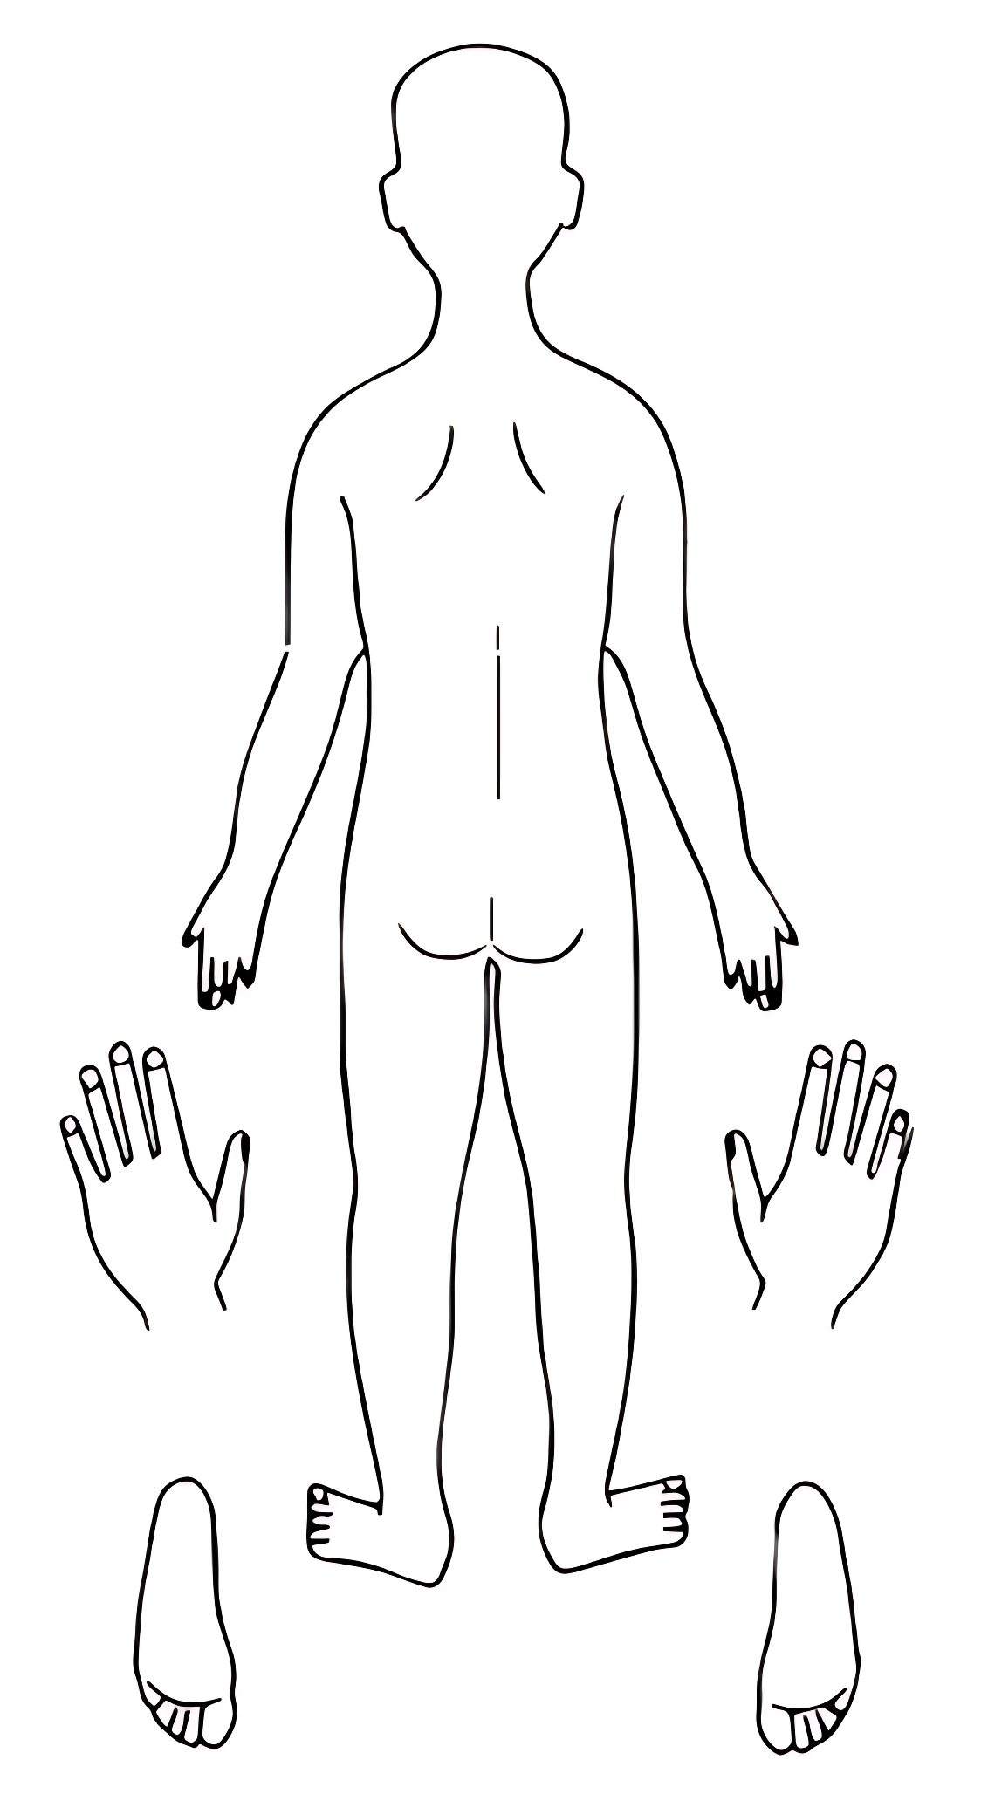
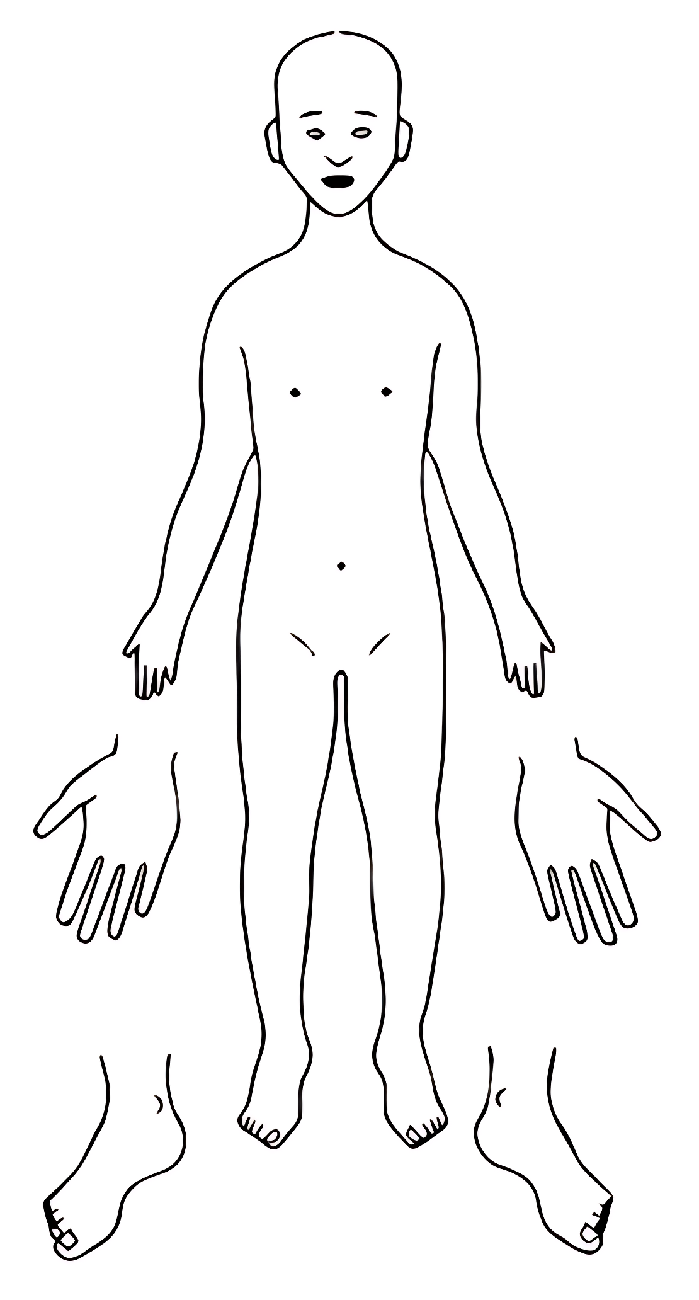
BACK
FRONT

LEFT
RIGHT
Names for child: |  | Details of physical injury:
Date of Birth: |  | Details of physical injury:
Name of worker: |  | Details of physical injury:
Signature of worker: |  | Details of physical injury:
Name of school: |  | Details of physical injury:
Date and time of observation: |  | Details of physical injury:
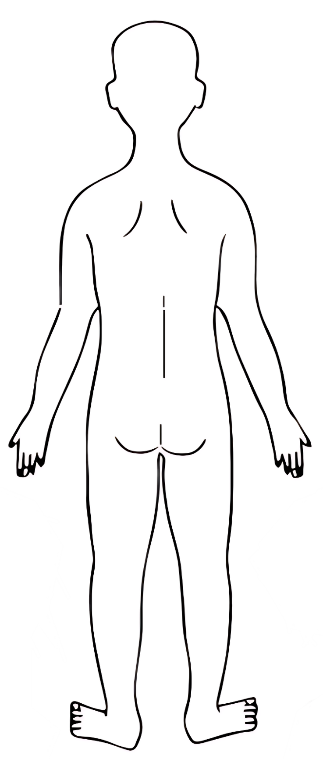
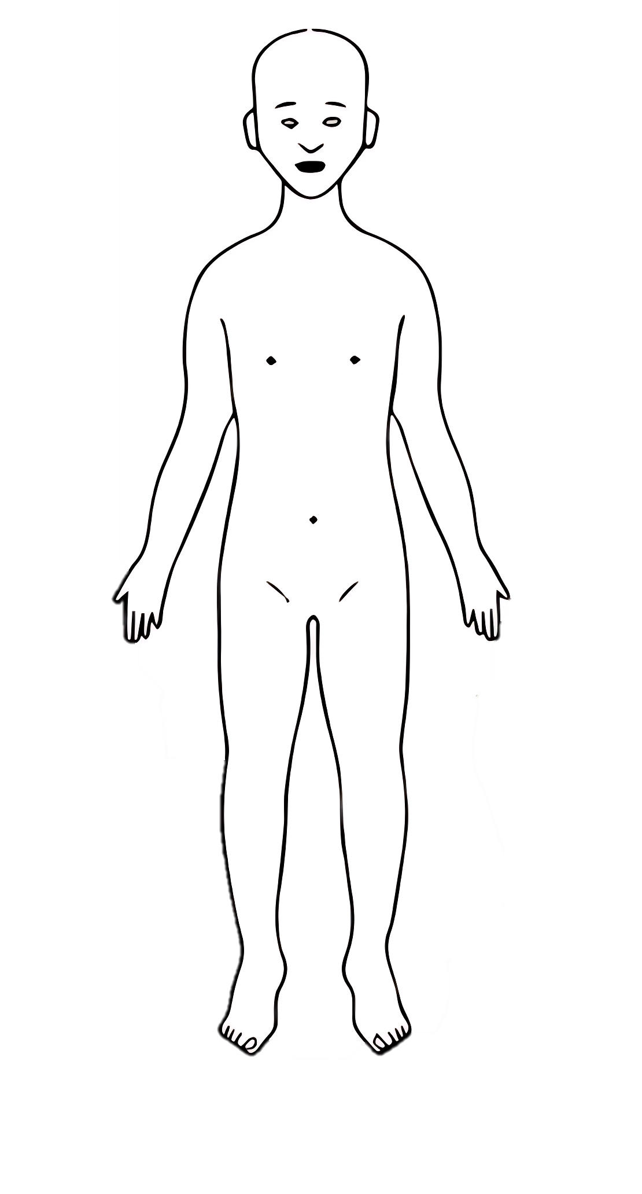
BACK
FRONT

Names for child: |  | Details of physical injury:
Date of Birth: |  | Details of physical injury:
Name of worker: |  | Details of physical injury:
Signature of worker: |  | Details of physical injury:
Name of school: |  | Details of physical injury:
Date and time of observation: |  | Details of physical injury:
RIGHT
LEFT

Names for child: |  | Details of physical injury:
Date of Birth: |  | Details of physical injury:
Name of worker: |  | Details of physical injury:
Signature of worker: |  | Details of physical injury:
Name of school: |  | Details of physical injury:
Date and time of observation: |  | Details of physical injury:
BACK OF HANDS
LEFT
RIGHT
PALMS
RIGHT
LEFT
Names for child: |  | Details of physical injury:
Date of Birth: |  | Details of physical injury:
Name of worker: |  | Details of physical injury:
Signature of worker: |  | Details of physical injury:
Name of school: |  | Details of physical injury:
Date and time of observation: |  | Details of physical injury:
RIGHT
LEFT
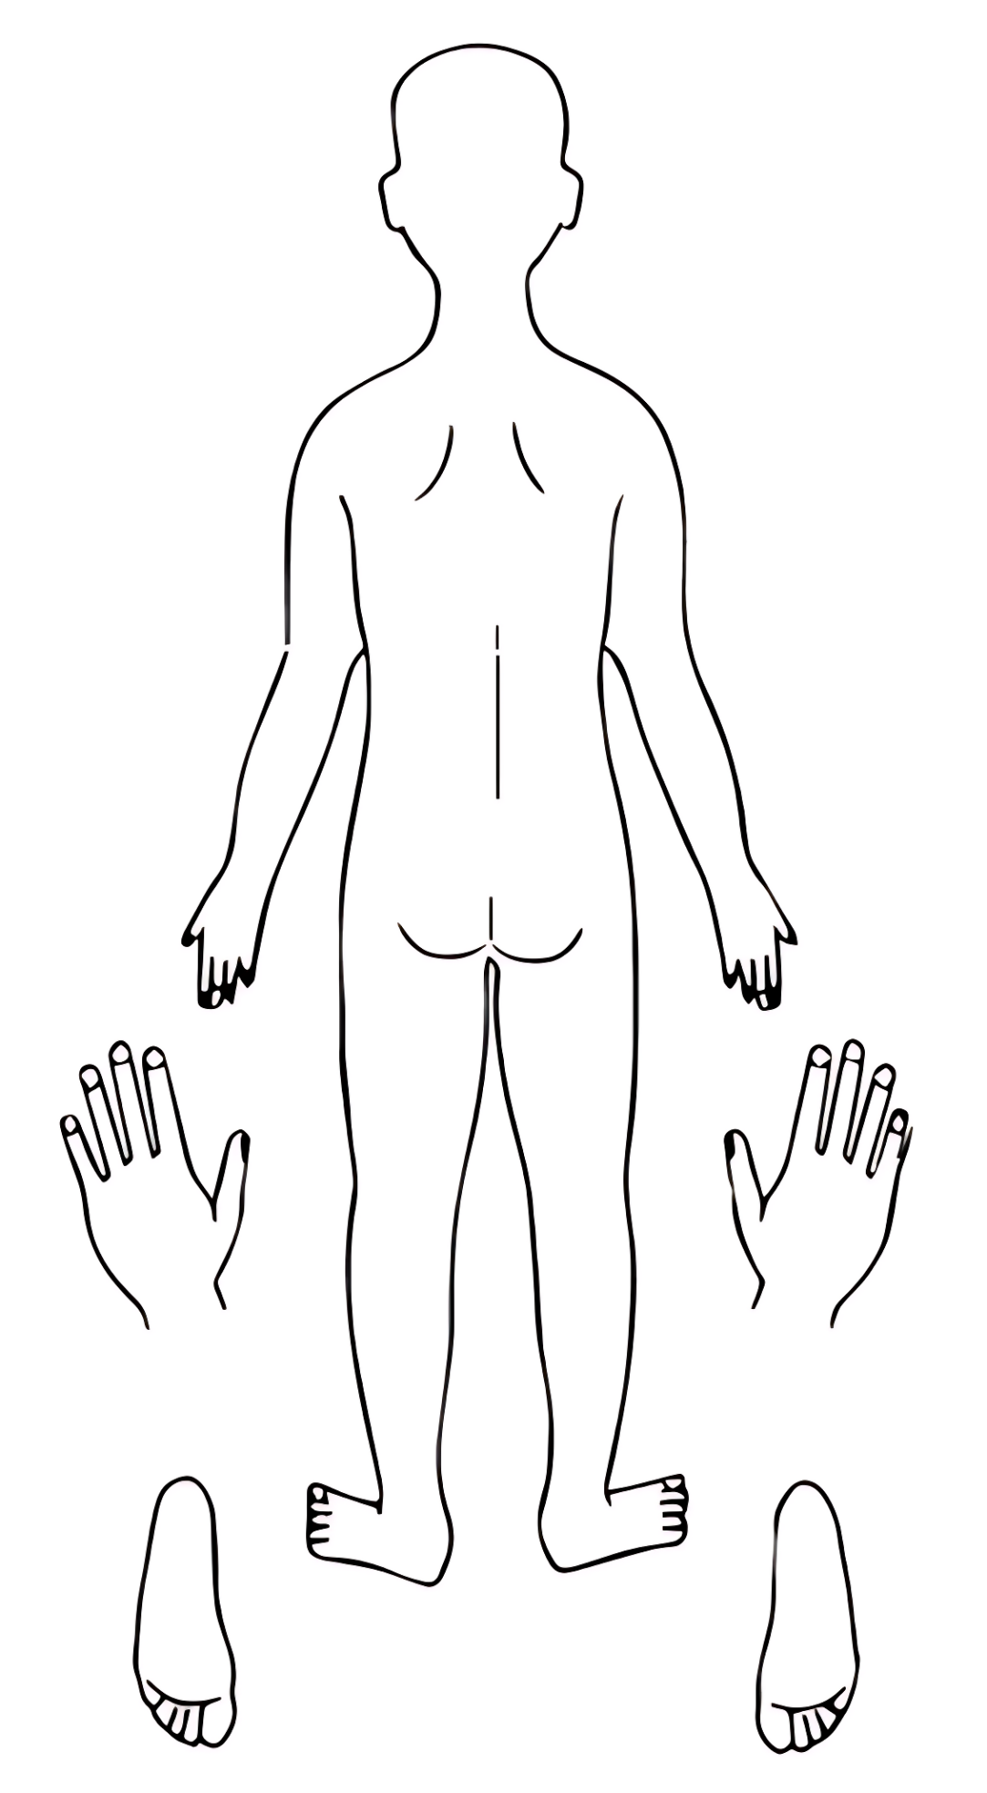
BOTTOM OF FEET
TOP OF FEET
LEFT
RIGHT

