Holly Hill and Nursery Primary School
Modern Foreign Languages Policy

1. Subject Intent

General Statement
At Holly Hill we believe that a quality MFL curriculum should broaden the horizons of pupils, opening their minds to other cultures and encouraging a mutual respect for people from different backgrounds. We believe that by learning an additional language, it deepens pupil’s understanding of grammatical structures and etymology of their own language, while also providing the foundations for learning further languages in later life.
The MFL curriculum at Holly Hill enables children to practise speaking and listening skills that will benefit them across the curriculum. Pupils will have the opportunity to learn vocabulary and phrases that are meaningful for real life (e.g. ordering at a café) and that will give them a valuable foundation for the KS3 languages curriculum.

Through our MFL curriculum we make links to our whole school curriculum intent statement. The aspects which are particularly significant to MFL are:

- Balance of knowledge and skills
- Diversity
- Rich vocabulary and quality texts
- Preparation for adult life and work

Specific Aims
The National Curriculum outlines the following aims for MFL:
- understand and respond to spoken and written language from a variety of authentic sources
- speak with increasing confidence, fluency and spontaneity, finding ways of communicating what they want to say, including through discussion and asking questions, and continually improving the accuracy of their pronunciation and intonation
- can write at varying length, for different purposes and audiences, using the variety of grammatical structures that they have learnt
- discover and develop an appreciation of a range of writing in the language studied
At Holly Hill the MFL curriculum is designed so that we meet the National Curriculum aims through a progression of skills and knowledge taught in the sequence below:

Cycle A
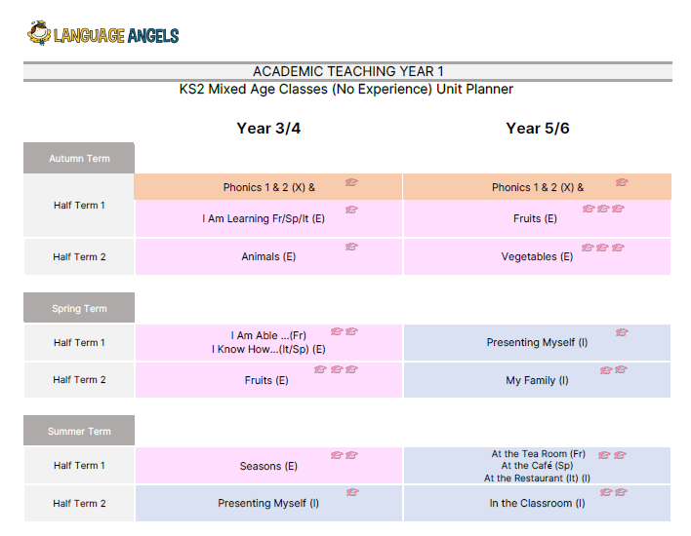
Cycle B

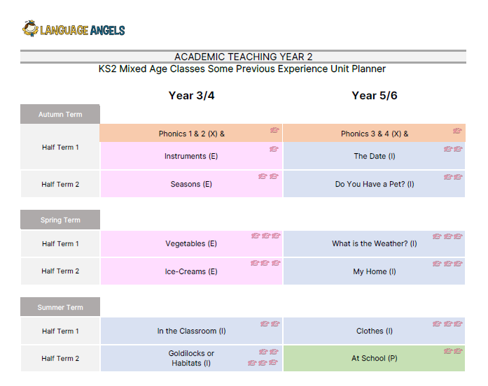
Rationale

At Holly Hill, we recognise a need for high quality resources and accurate grammatical teaching, that often requires specialist knowledge. In order to consistently provide this for our pupils, we have made the decision to follow the Language Angels Scheme of work.
Each Year in KS2 begins with a unit focussing on phonics and grammar. This revisits and reinforces the key concepts which will form the foundation of reading, writing and speaking in French.
Pupils in LKS2 are then taught units from the ‘Early Curriculum’, with pupils in UKS2 being taught from the ‘Intermediate Curriculum’. Pupils will be taught knowledge specific to that unit with skills progressing between the Early and Intermediate curriculum. (See skills progression map appendix 1)

2. Implementation

Teaching and Learning
Because at Holly Hill Primary and Nursery we understand that learning takes place when there is a change to long-term memory, we ensure staff and pupils are regularly using and referring to the knowledge organiser for any particular unit. In MFL key knowledge refers to specific phonics and grammatical features that will be used in the unit. A vocabulary mat is also given to the pupils at the start of each unit outlining the key words and phrases they will be learning. These resources should be referred to regularly during lessons and can be used as revision aids during starters/plenaries.

The Language Angels scheme of work is specifically designed to be comprehensive enough that it can be taught by non-specialist teachers. All lessons include full resources including pronunciation sound clips, which can be delivered by class teachers or cover assistants.
To enable regular practise of key vocabulary, lessons should take place weekly. Each lesson lasts between 30-45 minutes. The lesson slides can be used as a quick re-cap of the knowledge and skills previously taught or as part of an input for a longer lesson. At least half of Lessons can be extended depending on the amount of practise.

Children will build on previous knowledge gradually as their foreign language lessons continue to recycle, revise and consolidate previously learnt language whilst building on all four language skills: listening, speaking, reading and writing. Knowledge and awareness of required and appropriate grammar concepts will be taught throughout all units at all levels of challenge. Teachers are provided with a Progression Map and Grammar Grid (downloadable from the “Curriculum Guidance” area of the Language Angels website) to ensure all children are progressing their foreign language learning skills and are taught the appropriate grammar at the right time in their foreign language learning journey. Grammar rules and patterns will be taught by level of challenge:

- We start with nouns and articles and 1st person singular of high frequency verbs in Early Learning units.
- We move on to the use of the possessive, the concept of adjectives, use of the negative form, conjunctions/connectives and introduce the concept of whole regular verb conjugation in Intermediate units.
- We end with opinions and introduce the concept of whole high frequency irregular verb conjugation in Progressive units.
Grammar is integrated and taught discreetly throughout all appropriate units. Teachers can also use the specific Grammar Explained units to ensure pupils are exposed to all of the appropriate grammar so they are able to create their own accurate and personalised responses to complex authentic foreign language questions by the end of the primary phase.
The Progression Map shows precisely how pupil foreign language learning across the key skills of speaking, listening, reading, writing and grammar progresses within each Language Angels ‘Teaching Type’ and also how the level of learning and progression of each pupil is increased as pupils move across each subsequently more challenging Language Angels ‘Teaching Type’.
We have outlined on the Long Term Plans what each class in each year group will be taught and when it will be taught. Each class in each year group will have an overview of units to be taught during the academic year to ensure substantial progress and learning is achieved. Each teaching unit is divided into 6 fully planned lessons.
- Each unit and lesson will have clearly defined objectives and aims.
- Each lesson will incorporate interactive whiteboard materials to include ample speaking and listening tasks within a lesson.
- Lessons will incorporate challenge sections and desk-based activities that will be offered will three levels of stretch and differentiation. These may be sent home as homework if not completed in class.
- Reading and writing activities will be offered in all units. Some extended reading and writing activities are provided so that native speakers can also be catered for.
- Every unit will include a grammar concept which will increase in complexity as pupils move from Early Language units, through Intermediate units and into Progressive units.
- Extending writing activities are provided to ensure that pupils are recalling previously learnt language and, by reusing it, will be able to recall it and use it with greater ease and accuracy. These tasks will help to link units together and show that pupils are retaining and recalling the language taught with increased fluency and ease.
Units are progressive within themselves as subsequent lessons within a unit build on the language and knowledge taught in previous lessons. As pupils progress though the lessons in a unit they will build their knowledge and develop the complexity of the language they use. We think of the progression within the 6 lessons in a unit as ‘language Lego’. We provide blocks of language knowledge and, over the course of a 6-week unit, encourage pupils to build more complex and sophisticated language structures with their blocks of language knowledge.
SEND
Sensory, Physical and Medical
In MFL, particular barriers could be posed to pupils with hearing difficulties. To support children with Sensory, Physical and Medical needs in MFL strategies could include, seating pupils with hearing difficulties near the front, or giving them an ipad to be able to listen to pronunciations through head phones/ a number of times. All sound clips will also be accompanied by written and visual cues on the IWB.

Cognition and Learning
In MFL barriers could include processing issues,or learning needs such as dyslexia. To support children with Cognition and Learning needs in MFL strategies could include, giving pupils access to vocabulary maps (which are available to all pupils). Vocabulary maps could be used to pre-teach key words, or adapted to include visual representations/ signs and symbols. Where possible, teaching strategies could include the use of physical actions to give vocabulary or instructional cues, as well as regular use of choral repetition and chanting. Pupils significantly behind in English/ Reading will need similar supports in MFL to those they receive in English lessons. (See English Policy).

Social, Emotional and Mental Health
In MFL barriers could include being overwhelmed with a by overloading of information, which can be supported with the use of sensory breaks and shorter adapted tasks. Some children with Social, Emotional and Mental Health needs may find working in groups/ having conversations with other pupils difficult. In these cases it would be beneficial for teachers to choose a partner that the child feels comfortable working with. Other issues could arise if pupils prior experiences are assumed e.g. when talking about people they live with, the planning may need to be adapted to include vocabulary related to half-siblings or grandparents etc.

Communication and Interaction
In MFL barriers for pupils with communication and interaction needs could include Speech and Language difficulties, taking part in drama/role play, or speaking aloud in front of their peers. To support children with Communication and Interaction needs in subject area strategies could include, being placed with a trusted partner, pre-teaching of vocabulary, visual representations, or the opportunity to re-listen to the pronunciations. Staff will need to be aware of pupils with particular speech difficulties, as while MFL lessons can give lots of valuable opportunity for verbal practise of sounds, staff will need to be sensitive to whether pupils are comfortable speaking in front of large groups, or whether they may need additional practise and modelling of certain sounds.

3. Impact

Assessment
In MFL, we ensure progression through the use of knowledge organisers that are available for each unit as part of the Language Angels scheme.

In MFL, we assess the children formatively using key knowledge reviews and quizzes at the start and end of each lesson. Large parts of each lesson will include choral response and practise, which will enable the teacher to be constantly listening out for misconceptions in pronunciation or grammar. Each lesson should begin with a review of the learning and vocabulary from the previous session. The most effective way to do this is with practical, oral and conversational practise.

In MFL, we assess the children at the end of each unit. Assessments are available as part of the Language Angels scheme and are provided with the unit resources. Each assessment is split into 4 key areas: Speaking, Listening, Writing and Reading. When carrying out the assessments, staff may need to adapt the assessment to suit the needs of the individuals or group. For example, all or part of the assessment may be carried out individually, or as a group led task. Teacher’s should use a ‘best fit’ judgement based on the child’s understanding of the content of the unit and not hold back a judgement due to one particular weakness. E.g. a child who demonstrates understanding of ‘The Café’ through speaking, listening and reading, should not be held back because of a barrier with written recording.

Staff will use their assessment judgements to complete an evaluation of the learning in that unit, which is submitted to the subject leader. Where gaps or issues have been identified these will be acted upon through adaptation of later units to include recap of the prior learning with regular revisitation.

Monitoring and Evaluation

- Evidence of work can be found in a child’s MFL folder which they keep for two years across the key phase. Many lessons will not produce written records of the learning and audio or video recordings may be occasionally used to document practical work.
- Subject leaders will use a combination of evidence from the folders, learning walks, environment checks and end of unit data to monitor the standards in their subject and inform the action plans for curriculum development.
- Subject leaders will use the unit evaluations to inform their action plans and determine whether any further CPD is required.

What does the impact of MFL look like at Holly Hill?

By the end of KS2 pupils will be able to...
- understand and respond to spoken and written language from a variety of authentic sources. This will include well known stories (e.g. fairy stories), songs and ‘real life’ scenarios.
- speak with increasing confidence, fluency and spontaneity across a range of contexts that are meaningful for pupil’s KS3 curriculum and experiences abroad.
- can write at varying length, for different purposes and audiences, using the variety of grammatical structures that they have learnt.
- discover and develop an appreciation of a range of writing in the language studied.

Reviewed: September 2023

Date to be reviewed: September 2024

Appendix 1


