 | Holly Hill Agreed Mantras | 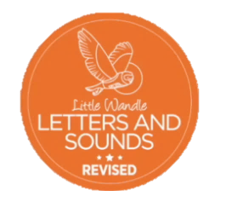

Mantra |  | Explanation
Digraph – two letters one sound (use one finger from each hand and put together as a visual) |  | Two letters making one sound e.g. ai.
Trigraph – three letters one sound (use fingers) |  | Three letters making one sound e.g. igh.
Copy me |  | To prompt the children to repeat after you.
Altogether |  | Everybody say something out loud together.
In phonics (not during reading practice)
Shuffle Time |  | Shuffle the cards (GPCs, tricky words, words) this is done during a phonics lesson not during reading practice.
When reading
Spot the diagraph/trigraph |  | Identify any sounds which are represented by more than one letter in the word before reading the word. E.g. ‘ai’ in train
Sound talk |  | Sound out the word before attempting to blend. E.g. t-r-ai-n
Whisper blend |  | Child whispers the letters to help them blend when reading as a stage between overtly blending out loud and blending in their head.
Blend in your head |  | Child is encouraged to blend in their head rather than out loud.
Chunk it up |  | Split longer words into parts to make them easier to read. E.g. train/ing ladd/er e/vent/ful This may be done by covering part of the word with your hand or the child may use their finger when in a book.
When spelling
Segmenting fingers | Ask children to hold up their hand ready to count the sounds – use the hand they DO NOT write with.
How many sounds? | Break the word down into sounds and put a finger up for each sound to count them. This helps children to not miss any graphemes when writing (although they may not always choose the correct grapheme it should be phonetically plausible – e.g. selecting ‘ay’ instead of ‘ai’). E.g. train – t-r-ai-n (4 fingers would be up)
One, two, three, show me! | Teacher says this to indicate to children they need to show their boards with their work on to the teacher.

