Working Scientifically
 |  | EYFS | Year 1 | Year 2 | Year 3 | Year 4 | Year 5 | Year 6
Exploring | Questioning | Explore ‘what if’ questions through play.  Begin to ask ‘how’ and ‘why’ questions about their familiar world. | Ask ‘why’ questions.  Confidently ask questions about the world around us. | Ask ‘why’ and ‘what if’ questions.  Begin to understand that questions can be answered in different ways. | Use knowledge and understanding to ask ‘why’ and ‘what if’ questions.  Ask relevant questions and plan for different types of enquiry to answer them. | Use knowledge and understanding to ask varied questions questions on a range of topics. Build on from Yr3 planning enquiries to solve questions. | Use knowledge and understanding to ask questions about observations made.  Ask further questions following discussion. | Use knowledge and understanding to challenge scientific ideas and concepts.  Ask further questions following discussion and following results to investigations.
Exploring | Explaining | Recall some simple scientific facts.  Pronounce simple scientific vocabulary.  Describe what is happening using pictures or actions. | Recall simple scientific facts.  Remember and use relevant scientific vocabulary.  Describe what is happening using vocabulary | Recall relevant scientific facts.  Construct an oral sentence using scientific vocabulary.  Describe and recall what has been observed. | Use science ideas and facts to describe and explain.  Use simple scientific vocabulary in a written sentence.  Describe simple scientific models / diagrams. | Show developing knowledge and understanding of scientific ideas and concepts.  Use scientific vocabulary during oral and written explanations.  Explain scientific models / diagrams. | Show clear knowledge and understanding of scientific ideas and concepts.  Accurately use a range of scientific vocabulary during oral and written explanations.  Use knowledge and understanding to describe and explain scientific models / diagrams. | Show secure knowledge and understanding of scientific ideas and concepts.  Use a range of complex scientific vocabulary in a written report.  Use scientific models / diagrams to explain new events (linking prior knowledge).
Exploring | Diagrams | Match a picture to the correct label. | Use a word bank to match a label to the correct part of an image | Label a simple diagram using scientific vocabulary. | Label and annotate a diagram with scientific information. | Draw, label and annotate a drawn diagram with given scientific information. | Draw a detailed scientific diagram, label and annotate with selected scientific information.  Diagrams used to explain and demonstrate learning. | Draw a detailed scientific diagram, label, annotate and explain drawn diagrams using scientific information.  Diagrams used to explain and demonstrate learning.
Exploring | Secondary sources/  Research | Use pictures to help with learning new things. | Use pictures and begin to use non-fiction books with support. | To begin to use secondary sources to find answers to questions.  To find information from books and computers. | Begin to realise how secondary sources could help to answer questions that cannot be answered through investigation. | Understand how secondary sources could help to answer questions that cannot be answered through investigation.  Link relevant scientific facts together in an answer. | From undertaking their own research  select and prioritise scientific facts to create an account or an argument.  Present own research in different ways – text, diagrams, tables, graphs. | Use own research to answer questions and  present a clear and logical argument using scientific facts to back up ideas and findings.  Select appropriate facts from a range of sources.
Classification | Identifying | Be able to name every day items that surround them. | Accurately name a range of things related to science. | Identify simple scientific things, ideas and processes. | Name a range of scientific things, ideas and processes. | Identify and describe changes in scientific processes. | Use knowledge and understanding to help identify unknown scientific things, ideas and processes. | Use knowledge, understanding and secondary resources to identify unknown scientific things, ideas and processes.
Classification | Classifying | Group by  familiar features e.g. Shape, size, colour  Use given instructions to sort. | Begin to observe, identify, compare and describe.  Group by similarity or difference.  Sort using simple yes/no statements. | Use multiple groups when sorting.  Begin to identify similarities and differences.  Follow and complete simple classification keys with obvious differences.  Begin to talk about criteria for grouping, sorting and classifying. | Create criteria for sorting.  Talk about criteria for grouping, sorting and classifying.  Construct a simple classification key using given information. | Create and explain criteria for sorting.  Construct a simple classification key. | Create criteria for sorting, which includes a sub-group.  Construct a complex classification key and other information records to identify, classify and describe. | Create criteria for sorting, which includes multiple sub-groups.
 |  |  |  |  |  |  |  | Construct and explain a complex classification key and other information records to identify, classify and describe.
Classification | Comparing | Describe given things – what do they look like? | Identify obvious differences. | Identify similarities and differences. | Create own groups for sorting objects e.g. ‘Rocks’ | Create a set of criteria for sorting objects and be able to talk in detail about choices made. | Create a set of criteria for sorting objects and be able to talk in detail about choices made.  Through closer observations begin to sub-group objects | As Year 5.  To be able to group and re-group using sets of criteria.
 |  | EYFS | Year 1 | Year 2 | Year 3 | Year 4 | Year 5 | Year 6
Experimenting and Investigating | Predicting | Suggest what might happen when faced with an everyday scenario | Suggest what might happen in an investigation. | Suggest what might happen in an investigation using causal conjunction ‘because’. | Predict cause and effect using the causal conjunction ‘because’ and use wider evidence and own experiences to justify predictions. | Use knowledge and understanding to justify a prediction. | Predict a trend, using a relationship prediction. | Use knowledge and understanding to generate a testable hypothesis following prediction.
Experimenting and Investigating | Observing | Look closely at the world around them.  Comment on what they can see. | Begin to make careful observations and draw what is seen.  Notice and observe changes over time (seasonal change)  Comment on what can be seen during an investigation. | Closely observe using simple equipment (magnifying glasses)  Identify changes during an investigation.  Through observations begin to make comparisons. | Begin to make systematic and careful observations.  Develop using equipment to observe (magnifiers)  Explain changes during an investigation. | Use knowledge and understanding to explain changes observed during an investigation. | Use knowledge and understanding to identify trends during an investigation. | Identify trends during an investigation and make justified predictions for the rest of or for subsequent investigation.
Experimenting and Investigating | Equipment | Use a range of everyday items to investigate.  Work safely when given instructions. | Use scientific equipment, including measuring cylinders, rulers, equipment for observing.  Notice risk and some common dangers. | Use a range of scientific equipment, including measuring cylinders, rulers, magnifiers, magnifying glasses  Notice risk and identify common dangers. | Select suitable equipment for a given task, including pipettes, rulers/measuring tapes and torches.  Predict obvious risks and act on safety suggestions. | Select and independently use a range of scientific equipment for a given task, including electrical equipment, force meters, and thermometers.  Plan to minimize risk and work safely. | Select the most appropriate equipment for an independently designed task, including force meters and thermometers.  Plan to minimize risk and describe safe use of equipment. | Justify reasons for selecting specific equipment and identify possible alternatives.  Use a wide range of scientific equipment.  Predict risks and explain how to plan and control risks.
Experimenting and Investigating | Designing | Suggest ideas to investigate.  Say how something might be investigated.  Follow a short demo and spoken instructions. | Suggest an idea to investigate and ask questions.  With help identify variables in an investigation.  Follow a short demonstration, spoken and picture instructions. | From observations suggest an idea for investigation.  Identify simple variables – possibly still with support.  Demonstrate how we something might be investigated.  Identify which variable are being tested.  Follow short spoken and written instructions in order. | Demonstrate and explain how something might be investigated.  Identify a range of variables which could be tested.  Follow instructions and write a simple method. | Plan a fair test by selecting variables to change and measure.  Identify a range of variables which could be tested and explain appropriate tests.  Design and write a simple ordered method. | Plan a fair test and ensure controlled variables are kept the same.  Identify a range of variables which could be tested and devise appropriate tests.  Design and write a reliable ordered method. | Plan a reliable and fair test.  Explain which variables will be kept the same and devise tests which ensure these variables are controlled.  Be able to collect repeat readings if necessary.  Design and write a reliable and precise method.
Data | Collecting/  Measuring | Use non-standard units of measure and compare 2 things e.g.: heavier / lighter. | Use non-standard units of measure and compare multiple things e.g.: lightest, light, heavier, heaviest.  (comparative language) | Measure using standard units:  Length: cm / m  Mass: g / kg  Capacity: ml / l | Measure and compare using standard units:  Length: mm / cm / m  Time: seconds / minutes / hours / days  Capacity: ml / l | Measure and compare using standard units:  Length: mm / cm / m  Mass: g / kg  Capacity: ml / l  Temperature: °C  Time: seconds / minutes | Measure, convert and compare using standard units:  Length: mm / cm / m  Mass: g / kg  Capacity: ml / l  Time: seconds / minutes  Force: N | Calculate an average from repeated measurements.
Data | Tables | Know a table is used to organise information.  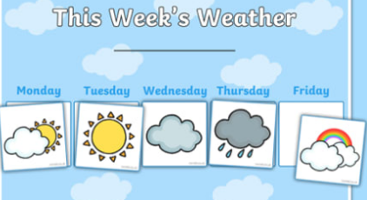 | Use a simple, given table to record basic information.  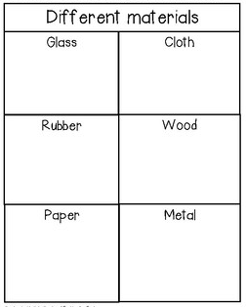 | Use a more detailed given table to tally and record totals and/or observations.  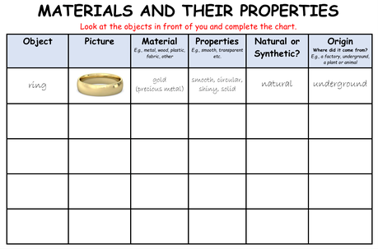 | Know how to draw and record a table of results independently.  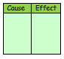 | Construct a simple table, with headings, to show information from observations or findings to investigations.  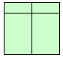 | Construct a more complex table, with multiple headings to show learning in Science, information from observations or findings to investigations.  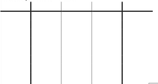 | As Year 5 plus…  Construct a complex table of results to show repeated data.  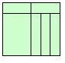
Data | Graphs | Use prepared pictograms to record observations.  Add pictures to a given pictogram and count pictures.  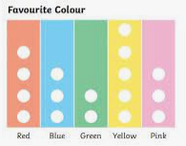 | Construct a simple pictogram within a frame  Add pictures to own pictogram.  Be able to write a total to represent pictures  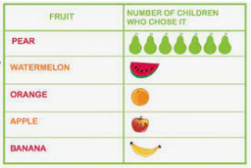 | Construct simple block charts.  Use a scale on a block chart to add the correct blocks.  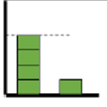 | Use own or given axes to construct a bar chart.  Draw bars on a given bar chart.  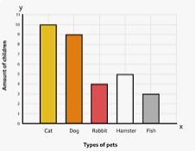 | Accurately and independently construct a bar chart.  Plot coordinates in the first quadrant.  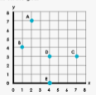 | Use axes to construct a line graph.  Join plotted coordinates with straight lines to create line graphs.  Compare 2 graphs.  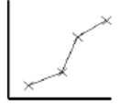 | Accurately and independently construct and scale a line graph.  Plot mean values and draw a trend line for linear data.  Compare scientific data on more than one graph.  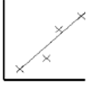
 |  | EYFS | Year 1 | Year 2 | Year 3 | Year 4 | Year 5 | Year 6
Making Conclusions | Patterns  and Relationships | Recognise simple patterns e.g.: size.  Use ‘more’ or ‘less’ to compare observations. | Recognise, create and describe simple patterns.  Use ‘more’ or less’ to compare numbers. | Describe simple patterns in data and charts.  Identify differences in sets of data. | Describe patterns in data, charts, and graphs.  Identify and explain differences in sets of data. | Describe patterns, trends and relationships in data, charts and graphs.  Identify and explain differences in sets of repeated data. | Describe and compare patterns, trends and relationships in data, charts and graphs.  Identify and explain differences in sets of repeated data and identify anomalies. | Describe and compare changing patterns, trends and relationships in data, charts and graphs.  Identify and explain, using margin of error, differences in sets of repeated data and identify anomalies.
Making Conclusions | Concluding | Talk about what they have found out in their play environment and through hands on activities. | Begin to explain what has happened in an investigation and what they have found out. Begin to use a wider vocabulary. | Say what has happened in an investigation.  Use results and findings to talk about what they have found out.  Begin to explore different ways to do things with help.  Suggest what changes could be made in an investigation. | Describe the results linking cause and effect.  Draw conclusions and use this to make predictions for further testing.  Begin to use scientific evidence to answer simple questions.  Begin to identify how to make my work better.  Identify weaknesses in the methods used.  Use scientific evidence to answer questions.  Begin to look for changes, patterns, similarities, differences and draw simple conclusions. | Use evidence to answer questions in order to support findings.  Use results to draw simple conclusions, make predictions, suggest improvements and raise further questions.  With help look for changes, patterns, similarities/differences in data in order to answer questions and draw conclusions.  With support identify new questions arising from data and make new predictions.  Think of new ways to improve what has been already done.  Begin to see patterns in results.  Answer questions from findings.  Identify weaknesses in the methods and suggest improvements. | Begin to identify scientific evidence.  Use evidence to draw conclusions based on their data and observations. Use the evidence to justify ideas, using scientific knowledge and understanding to explain findings.  Report and present findings and conclusions from enquiries. Demonstrate ‘degree of trust’ in results in oral and written forms.  Use data in conclusions and use science to explain.  Identify how limitations in the methods might affect the results and suggest improvements. | As previous years  Use primary and secondary data and ideas when concluding.  Identity limitations in the methods and use the results data to justify improvements.

