Holly Hill Primary and Nursery School
Science Policy

1. Subject Intent

General Statement
At Holly Hill we believe that a quality Science curriculum should encourage children to be inquisitive not only throughout their time at school but also into later life. The Science curriculum encompasses the acquisition and development of knowledge, concepts, skills and positive attitudes. From our Foundation Stage the Science curriculum will foster a curiosity about our world and the things around us. We will promote respect for all living things.
Throughout school, the children will develop the key knowledge that has been identified within each unit across appropriate year groups. We will ensure that ‘Working Scientifically Skills’ (please see appendix 1 - Science Learning and Assessment guidance booklet) are practised, built upon and developed at each stage so that they can apply their knowledge of Science in a progressive way when using equipment, conducting experiments and confidently explaining concepts.
We aim to develop children’s scientific vocabulary and empower the children to ask scientific questions. Throughout their time at Holly Hill we will offer memorable experiences in all age phases to broaden children’s life experiences of the world and develop scientific ideas and concepts further, for example-visits to farms and zoos in Foundation and KS1 to residentials where KS2 study micro habitats and investigating microorganisms and pond life.
We will also use our own extensive grounds to encourage scientific enquiry and maximise opportunities for learning.

Through our Science curriculum we make links to our whole school curriculum intent statement. The aspects which are particularly significant to Science are:

- Balance of knowledge and skills
- Emotional well-being and healthy relationships
- Diversity
- Rich vocabulary
- Experiences and opportunities
- Preparation for adult life and work
- Outdoor learning

Specific Aims

The national curriculum for Science aims to ensure that all pupils:

- develop scientific knowledge and conceptual understanding through the specific disciplines of biology, chemistry and physics.
- develop understanding of the nature, processes and methods of science through different types of science enquiries that help them to answer scientific questions about the world around them.
- are equipped with the scientific knowledge required to understand the uses and implications of science, today and for the future.

At Holly Hill the Science curriculum is designed so that we meet the National Curriculum aims through a progression of skills and knowledge taught in the sequence below:

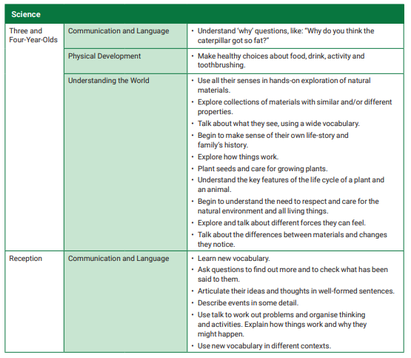
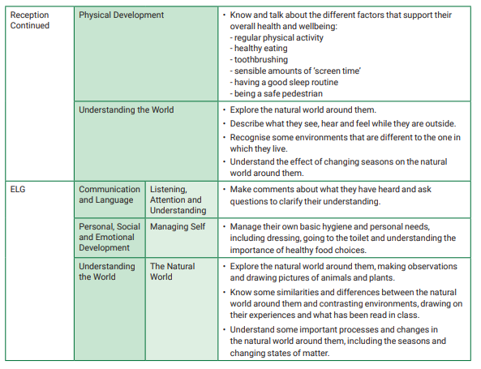
Key Stage 1

 | Autumn 1 | Autumn 2 | Spring 1 | Spring 2 | Summer 1 | Summer 2
Cycle A | Enchanted Worlds  Everyday Materials |  |  | What a  Performance  Living Things and their Habitats | Seaside  Animals Inc. Humans | Seaside  Living Things and their Habitat
Cycle B | Amazing Me  Animals inc. Humans | Toy Story  Uses of Everyday Materials | Who lives in a place like this?  Living Things and their Habitats | Mother Nature  Plants |  | London Rocks  Everyday Materials
Investigation and Exploration throughout each cycle

Lower Key Stage 2

 | Autumn 1 | Autumn 2 | Spring 1 | Spring 2 | Summer 1 | Summer 2
Cycle A | Egyptians  States of Matter | Festival of Light  Electricity | Stevie Wonder  Sound |  |  | Olympics  Animals inc. humas
Cycle B | Superheroes  Forces and Magnets | WW1  Light | Animal Adventures  Animals inc. Humans | Around the World  Plants | Dungeons and Dragons  Plants | Romans  Rocks
Investigation and Exploration

Upper Key Stage 2

 | Autumn 1 | Autumn 2 | Spring 1 | Spring 2 | Summer 1 | Summer 2
Cycle A | Great Explorers  Properties and Changes of Materials | Crime and Punishment  Evolution and Inheritance | How to save the Human Race  Earth and Space | Fight for the Crown  Forces |  | Moving on up  Plants
Cycle B | Clockwork  Light | Fantastic Beasts  Living Things and their Habitats | The Golden Age  Animals inc. Humans | World war II  Electricity |  | Shakespeare  An Introduction to Chemistry
Investigation and Exploration

Rationale
At Holly Hill, Science is taught as a discrete subject weekly. The strands of knowledge and understanding, and investigation and exploration are taught following year group objectives, skills ladders and knowledge organisers ensuring progression and continuity of learning in each phase. This progression enables the children to build upon previously acquired knowledge and understanding from the previous year group. Units are started in a particular year group and will be revisited in later ones, for example – the children develop their knowledge and understanding of materials in Year 2, Year 4 and Year 5 after their initial exploration in Y1. Objectives and activities will not be repeated but will build on what has been taught already. This strategy will enable the achievement of a greater depth and understanding of scientific concepts at each stage.

The progression of investigation and exploration skills have been set out for each year group in the format of our investigation boards. Each year group’s specific investigation board will focus on developing skills before progression to the next year. For example Year 1 begin their exploration journey developing their skills of observation. Years 3 and 4 will be taught about controlling variables and Year 6 will focus on analysing data, observing patterns and developing further ideas for prediction as well as continuing to use all previously focussed skills. The build up and continual practise of skills in this way will enable the children to become confident ‘scientists’ by the time they reach upper Key Stage 2.

Where possible, to make the science more purposeful and to enhance other curriculum areas, units are taught where they makes links with our broader curriculum. For example Key Stage 1’s topic of ‘Who lives in a place like this?’ incorporates ‘Habitats’ and a trip to the farm/zoo for Science while also learning about continents and oceans in Geography and Animal texts are studied in English. ‘Electricity’ in Year 5/6 is taught during a topic on World War II. The learning of circuits is completed with an investigation to make the loudest air raid siren or brightest search light. This ensures that the investigation is purposeful.

2. Implementation

Teaching and Learning
Because at Holly Hill Primary and Nursery we understand that learning takes place when there is a change to long-term memory, we outline the key knowledge for a unit of work on a knowledge organiser. In Science key knowledge is knowledge that relates directly to the National Curriculum attainment targets. Progression of skills is mapped out using a skills ladder.

Science will be planned and delivered by the class teacher. Teachers will use skills ladders, knowledge organisers and Programs of Study to facilitate planning.

Science lessons will take place weekly and will broadly consist of at least 1 hour per week in Key Stage 1 and 1.5 hours in Key Stage 2. Special Science days and visitors will be included in our Science provision as will school external visits relating to the subject. These purposeful opportunities will be a tool to further excite the children as well as give them first hand experiences, further deepening their knowledge, skills and understanding in a particular area of Science.

A Teaching Sequence in Science

The following gives an example of an effective teaching sequence in Science investigation;
- Questioning and hypothesising,
- Predicting and planning,
- Observing and measuring,
- Collecting results and analysing,
- Concluding.

Each aspect of the investigational process will be practised in particular year groups with children becoming competent and confident at working through an investigation independently by Upper Key Stage 2.

Throughout the teaching sequences there will be focus on discussion and debate. There will be opportunities for both individual and group learning. At the end of a sequence the children will be given the opportunity to reflect on their learning and consider how this will impact them in the future. Throughout a sequence of lessons the teacher will assess learning using observation and questioning in order to gauge understanding.

SEND
Sensory, Physical and Medical
In Science barriers could include sound and light issues, noise, using equipment independently and safely, food, animal and outdoor allergies. Barriers may include hypo/hypersensitivity to sensory learning and to new experiences. Other restraints to learning may include visual impairment and auditory needs. Teachers will be aware of the issues within their class and plan and adapt their teaching and learning needs appropriately.
Cognition and Learning
Cognitive and learning barriers may include lack of vital first-hand experiences. Issues may arise with children who are inadequate readers and writers for their year group. Barriers may include children having poor memory skills and difficulties in understanding and processing key concepts and procedures in the subject.

To support children encountering difficulties in either of these areas, good practice in Science will include:-
- Clear, concise and explicit safety instructions, using visuals when needed.
- TA support as and where appropriate
- Differentiated texts and outcomes
- Differentiated questioning appropriate to the child
- Scaffolds used to support writing and recording
- Scaffolds used to support investigative thinking and planning
- Providing practical approaches to learning for individuals
- Using visual prompts

Social, Emotional and Mental Health
In Science children with social, emotional and mental health may become overwhelmed when experiencing new skills and concepts. They may become anxious or upset when encountering a challenge and struggle to remain on task and focussed.

Supporting children in this area may include:
- giving clear explanations of the task and setting acceptable expectations
- pre-learning activity to prepare the children for the activity
- given breaks or talk to staff as and when they need to
- differentiation will be used to support children further
- children will be encouraged to help and support each other wherever possible.

Communication and Interaction
In Science barriers could include:-
- A lack of understanding of previous and new knowledge
- Poor prior knowledge of key concepts
- Gaps in learning
- Inability to communicate ideas and interact with peers
- Inability to understand key vocabulary and use it effectively
- Inability to use necessary language for class based discussions/predictions/hypothesis/conclusions
- Unable to share equipment and resources
- Being unable to work cooperatively with peers
- Being unable to work independently when required to do so.

To support children with Communication and Interaction needs in Science, strategies could include:
- Teaching assistants supporting at different stages of the lesson when available
- Additional time given for students to listen to and process instructions
- Time given to help children process and understand new information and key concepts
- Relay information to these children individually and at their level of understanding
- Provide supportive visual aids and equipment such as timers, word banks and pictorial resources
- Organise the children into mixed ability groups or using supporting peers
- Displaying key words and information around the room to assist learning
- Clear instruction and explanations given including prompt sheets and visual aids including symbolised work.
- Materials used in all learning styles to support children’s learning.

3. Impact
Assessment
In Science we ensure progression through the use of knowledge organisers, skills ladders, national curriculum expectations and the Science Learning and Assessment guidance booklet set out by Nottinghamshire County Council.

Knowledge Organisers will prioritise the required learning for each year group in each topic strand and therefore planning lesson content and assessment opportunities will stem from these documents.

Each lesson in a sequence begins with a ‘knowledge check up’, which provides opportunity for pupils to recall the key knowledge from the previous lessons in that unit.

We will use different methods to assess learning in Science depending on the age of the children and the subject knowledge or skill being assessed. Assessments will be on-going throughout a unit and will consist of some or all of the following:-

Observations – watching the children carry out their scientific experiences and procedures. Watching them meet a new experience or concept for the first time and seeing it develop.
Listening – to their responses/ questions/ findings/ misconceptions/ conversations/ interactions and interacting with them appropriately.
Written pieces – scientific drawings, labels, explanations, fact information, investigation write-ups, notetaking.

In Science we assess the children at the end of each unit. Assessment judgements are based on the evidence of knowledge in the child’s ‘end point’. In Science an end point could be any of the following:
- a model
- a written piece
- a double page spread
- a video
- a presentation
- a science investigation write up on our Holly Hill Investigation Board
- a floor book
- a display created by the children/
- a sample of photographs taken by the children
- a question and answer activity.

Staff will highlight the knowledge each pupil has demonstrated using the knowledge organiser stuck in their book.

Staff will use their assessment judgements to complete an evaluation of the learning in that unit, which is submitted to the subject leader. Where gaps or issues have been identified these will be acted upon in a variety of ways:
- adaptation of later units
- Intervention
- adaptation of planning
- further knowledge reviews.

MONITORING AND EVALUATION
- Evidence of work can be found in a child’s science book which they keep for two years across the key phase and their learning journals or Tapestry in EYFS. Evidence may also be in the form of photographs – particularly in the Foundation Stage and KS1.
- Subject leaders will use a triangulation of evidence from book looks, learning walks, observations and end of unit evaluations to monitor the standards in their subject, the quality of teaching the progression.
- Subject leaders will evaluate the long-term curriculum plans to ensure that all aspects of the subject are being covered.

What does the impact of Science look like at Holly Hill?

By the end of EYFS pupils will have been given many opportunities to explore the world around them through first hand experiences and observations. They will have begun their skills of asking questions while becoming more inquisitive. They will have done a lot of this learning in our outdoor school environment, benefiting from these outdoor learning experiences. They will have started to talk about what they can see and what they have done.

By the end of KS1 pupils will have continued to develop skills in observing – looking even more closely at the world around them. Their curiosity will be encouraged and they will develop their ability to ask questions about the world around them. They will have made observations over time and will have started to identify patterns. Their observations will lead to them being able to classify and find things out using simple tests. They will have developed their language when talking about what they have found out. They will have begun to use secondary sources to aid their learning including books, pictures and photos. They will have started their learning of scientific vocabulary.

By the end of KS2 pupils will have broadened their scientific view of the world around them. They will be more confident in developing the scientific investigation process, developing skills in observing, questioning, predicting and testing. Throughout KS2 they will continue to make more decisions regarding what kind of test will be best for the purpose. They will continue their development of observing changes over time, noticing patterns, grouping, classifying and fair testing. They will be able to draw conclusions.
By the end of Y6 the children will have had experience and developed understanding of planning and carrying out investigative processes. Hypothesising, using and controlling variables, recording data and findings and drawing conclusions based on observations and findings will be embedded throughout the investigation process. They will have an understanding for the need to repeat data for specific purposes and act accordingly within their investigation process. The children at this stage will efficiently use secondary sources to help with their scientific knowledge, understanding and investigation processes. They will have a sound use of the vocabulary pertinent to each topic area and to investigations process.

Written and approved: March 2022

To be reviewed: September 2023

