KS1 Years 1 and 2 - Graphic Notation
The Model Music Curriculum suggests that children in KS1 should recognise how graphic notation can represent created sounds.
- At the beginning of KS1, children should learn to associate a symbol with an action. E.g. when the recorder symbol appears, you play. When there is no symbol, you rest.
 | 1 | 2 | 3 | 4
Recorder | 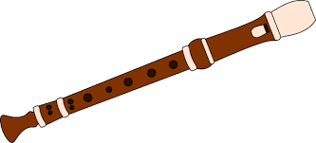
Triangle |  | 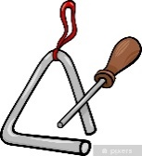
Boomwhacker | 

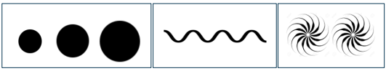
- Children should progress to explore and invent their own symbols, for example:

- Children should follow pictures and symbols to guide singing and playing, e.g. 4 dots = 4 taps on the drum.
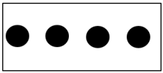

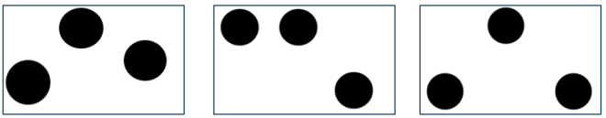
- They should recognise dot notation and match it to 3-note tunes played on tuned percussion, for example:

- Children should use notation to perform word-pattern chants (e.g. ca-ter-pil-lar crawl, fish and chips); create, retain and perform their own rhythm patterns.

- Use graphic symbols, dot notation and stick notation, as appropriate, to keep a record of composed pieces.

- Read and respond to chanted rhythm patterns, and represent them with stick notation including crotchets, quavers and crotchets rests.
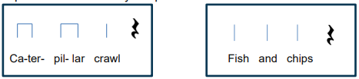

LKS2 Years 3 and 4 - Graphic and Rhythm Notation
- Children should use listening skills to correctly order phrases using dot notation, showing different arrangements of notes C-D-E/do-re-mi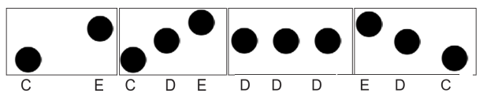

- Introduce the stave, lines and spaces and clef.
- Use dot notation to show higher and lower pitch.
- Understand the differences between minims, crotchets, paired quavers and rests.
- Arrange individual notation cards of known note values (i.e. minim, crotchet, crotchet rest and paired quavers) to create sequences of 2-, 3- or 4-beat phrases, arranged into bars.
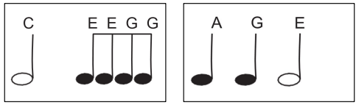

- Combine known rhythmic notation with letter names to create short pentatonic phrases using a limited range of 5 pitches suitable for the instruments being learnt.
- Follow and perform simple rhythmic scores to a steady beat.
- Read and perform pitch notation within a defined range (e.g. C–G/do–so).
- Capture and record creative ideas using any of: graphic symbols, rhythm notation, staff notation and technology.

UKS2 Years 5 and 6 - Staff Notation and Time Signatures
Reading notation
- Further understand the differences between semibreves, minims, crotchets and crotchet rests, paired quavers and semiquavers.
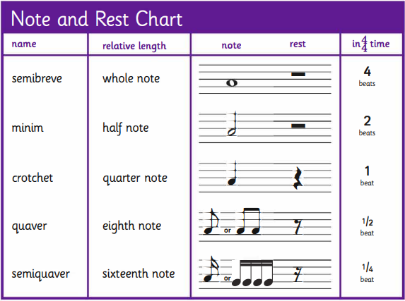

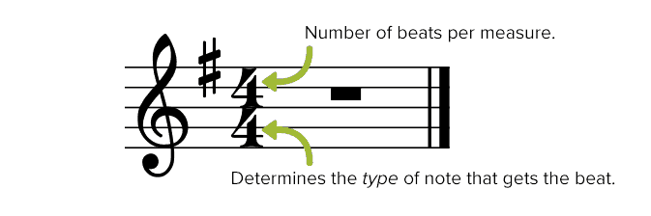
- Children should learn to understand the differences between 2/4, 3/4 and 4/4 time signatures.

- Understand 5-line stave as way of representing pitch: link sound with symbol for rises and falls of pitch with note position on the stave, working up and down from one chosen home note.
- Identify notes on specific lines or spaces on the stave with the relevant letter names for pitch.
- Understand how rhythm and pitch can both be represented on a 5-line stave.

- Read and perform pitch notation within an octave (e.g. C–C′/do–do).
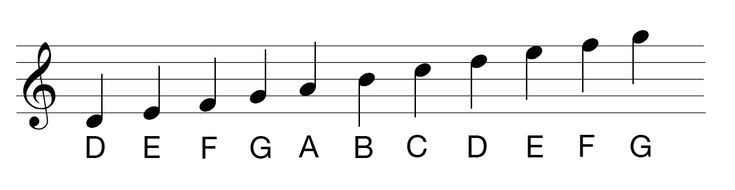

- Recognise signs for sharp, flat and natural notes.

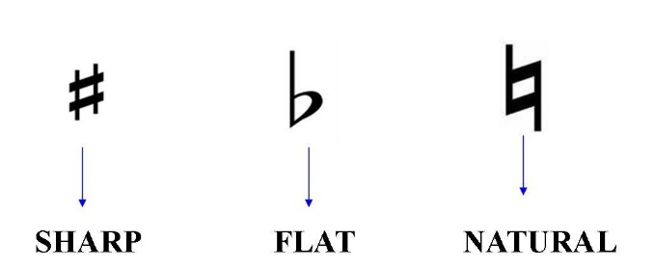

Instrumental performance
- Capture and record creative ideas using any of the following: graphic symbols, rhythm notation and time signatures, staff notation and technology.
- Play melodies on tuned percussion, melodic instruments or keyboards, following staff notation written on one stave and using notes within the Middle C–C′/do–do range.
- This should initially be done as a whole class with greater independence gained each lesson through smaller group performance.
- Play a melody following staff notation written on one stave and using notes within an octave range (do–do); make decisions about dynamic range, including very loud (ff), very quiet (pp), moderately loud (mf) and moderately quiet (mp).
- Read and play confidently from rhythm notation cards and rhythmic scores in up to 4 parts that contain known rhythms and note durations.
- Read and play from notation a four-bar phrase, confidently identifying note names and durations.

