  
  

What's on

Having trouble viewing this email? View it as a Web page.
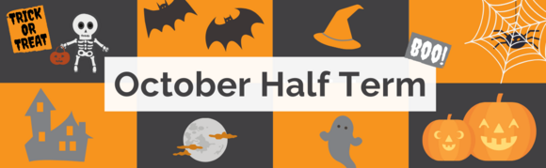

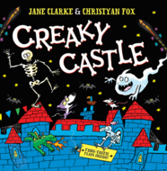

Creaky Castle with Jane Clarke
Mansfield Central and Worksop library
Thursday 31 October
Children: £3, accompanying adults free.
Booking required
A session of frightful fun and bat making based on her picture book, Creaky Castle, illustrated by Christyan Fox.

Find out more about events and book on

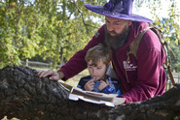

Half term Halloween trail
Sherwood Forest
Saturday 19 October until Sunday 3 November
10am until 3pm
£3.50, booking not required
Well, helpfully, there is a trail of clues to crack along the path through the ancient oak trees of Robin Hood’s Forest.
Study each puzzle along the way to work out the answers, and then the culprit’s identify will be revealed!
Head back to the Visitor Centre for clever clogs points and a well-earned reward.

See other events at Sherwood Forest

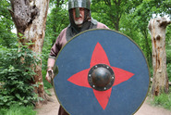

Myths and Legends with the Master at Arms
Sherwood Forest
Saturday 19 and 26 October
1pm until 2.30pm
Booking required
Adults: £7.50 (£6 RSPB members) Children: £7.50 (£6 RSPB members)
This walk will take you on a journey through the forest, hearing the tales of its most legendary inhabitant and medieval life. The walk will last approximately 90 minutes, and please bring suitable clothing and footwear.

Find out more and book on

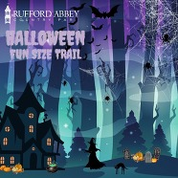

Rufford's fun size Halloween trail
Rufford Country Park
Saturday 19 October until Sunday 3 November
10am until 3pm
Free
Booking not required
Step into our spine-tingling indoor exhibit – Rufford’s Fun Size Halloween Trail. But beware, you’ll want to bring a friend, because things might get spooky!
Perfect for little ghouls and ghosts, this trail promises eerie surprises around every corner. The best part? Entry is completely free! Just head to the Stables Courtyard to begin your haunted adventure.

See other events at Rufford Country Park

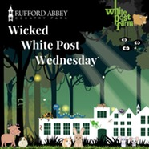

Wicked White Post Wednesday
Rufford Country Park
Wednesday 30 October
10am until 3pm
£3 per child
Get ready for a spooky and fun-filled time with some creepy (and irresistibly cute) creatures from White Post Farm!
Meet their expert handlers, who will be on hand to answer all your questions and share fascinating facts about these amazing animals. It’s an unforgettable experience you won’t want to miss!

Find out more



Spooky Nets at Adventures
Adventures
Thursday 31 October
Friday 1 and Saturday 2 of November
5:00pm – 6:00pm (Ideal for ages 3-8)
6:30pm – 7:30pm (Ideal for ages 5+)
£15 per person
Get ready for Spooky Nets in our Net Park-where things have got a little bit spooky (but not too spooky) just in time for Halloween!
Join us for bouncy, spooky fun in our Halloween-themed tree house and walkways. With face painting and party bags, it’s the perfect evening out for the whole family and you can book on here.

Explore other events at Adventures

Contact Us

